|  |
| --- |
|  |
| Capstone Project Document |

SUPER SHIPPER SYSTEM

Software Requirement Specification

|  |  |  |
| --- | --- | --- |
| **Super Shipper System** | | |
| **Group Members** | Le Van Quy Hoang | SE90184 |
| Tran Dinh Hoang Huy | SE90201 |
| Nguyen Khac Hoang | SE02564 |
| Kieu Cao Khanh | SE02960 |
| Nguyen Van Quyen | SE02884 |
| Nguyen Thi Hong Nhung | SE02437 |
| **Supervisor** | Mr. Tran Binh Duong | |
| **Project code** | 3S | |

**- Hanoi, 09/2015 -**

TABLE OF CONTENTS

1.INTRODUCTION 2

1.1. Purpose 2

1.2. Scope 2

1.3. Definition and Acronyms 2

1.4. Overview 2

2.OVERVIEW DESCRIPTION 3

2.1. Product perspective 3

2.2. Product functions 3

2.3. User charactistics 3

2.4. Constraint 3

2.5. Assumption and dependencies 4

2.6. Activity Diagram 4

2.7. State Machine Diagram 5

2.8. Entity Relationship Diagram 6

3.FUNCTIONAL REQUIREMENTS 7

3.1. Web application for Admin 7

3.1.1. User Case Diagram 7

3.1.2. Functions 8

*UC-101: Login* 8

*UC-102: Logout* 10

*UC-103: Change password* 11

*UC-104: Forgot password* 14

*UC- 105: Accept Store* 16

*UC- 106: Search Store* 19

*UC- 107:* *View Store’s list* 21

*UC- 108:* *Block and Unblock store* 23

*UC- 109:* *View Store’s details* 25

*UC- 110:* *Send message to Store* 27

*UC- 111:* *Confirm Store’s payment* 29

*UC- 112:* *View* transaction *history of Store* 32

*UC- 113:* *Add Shipper* 34

*UC- 114:* *View Shipper’s list* 36

*UC- 115:* *View Order’s list* 38

*UC- 117:* *Search Shipper* 40

*UC- 117:* *Search Order* 42

*UC- 118:* *View Shipper’s profile* 44

*UC- 119:* *View Order’s details* 46

*UC- 120:* *Update Shipper* 48

*UC- 121:* *Update Order* 50

*UC- 122:* *Add new Order* 52

*UC- 123:* Export Bill 54

*UC- 124:* *Assign Task* 56

*UC- 125:* *View Dashboard* 58

3.2. Web application for Store 60

3.2.1. User Case Diagram 60

3.2.2. Function 61

*UC-201: Register* 61

*UC-202:* *Login* 64

*UC-203:* *Logout* 66

*UC-204: Change password* 68

*UC-205:* *Forgot password* 71

*UC-206:* *View profile* 73

*UC-207:* *Update profile* 74

*UC-208:* *Create order* 77

*UC-209:* *View order’s list* 80

*UC-210:* *Search orders* 81

*UC-211:* *Cancel order* 83

*UC-212:* *Edit Order* 85

*UC- 213:* *Order’s details* 88

*UC-214:* *View payment history* 89

*UC-215:* *View notifications* 91

*UC-216:* *Rate shipper* 92

*UC-217:* *Send feedback* 95

*UC-218:* *View Homepage* 97

3.3. Mobile application for Shipper 99

3.3.1. User Case Diagram 99

3.3.2. Function 100

*UC-301:* *Login* 100

*UC-302:* *Logout* 103

*UC-303:* *Forgot password* 105

*UC-304:* *Change password* 108

*UC-305:* *View Profile* 111

*UC-306:* *Update Profile* 113

*UC-307:* *Confirm Code* 115

*UC-308:* *Grab order* 118

*UC309: View Orders List* 121

*UC310: Search Order* 123

*UC311: View Order’s Detail* 125

*UC312: Find Best Way* 127

*UC313 Send Issue’s Information* 130

*UC314 Change Working Status* 132

*UC315 View History* 135

4.NON – FUNCTIONAL REQUIREMENTS 138

4.1. Usability 138

4.2 Performance 138

4.3 Reliability 138

4.4 Maintainability 138

4.5 Security 138

**ACRONYMS & ABBREVIATIONS**

| Abbreviations | Description | Note |
| --- | --- | --- |
|  |  |  |
|  |  |  |
|  |  |  |
|  |  |  |
|  |  |  |
|  |  |  |
|  |  |  |
|  |  |  |
|  |  |  |
|  |  |  |
|  |  |  |
|  |  |  |
|  |  |  |
|  |  |  |
|  |  |  |
|  |  |  |
|  |  |  |
|  |  |  |
|  |  |  |
|  |  |  |
|  |  |  |
|  |  |  |
|  |  |  |

# INTRODUCTION

## 1.1. Purpose

This document provides developers, tester, QAs a complete and comprehensive description of both the functional requirement and non-functional requirements of the 3S system. Developers base on this document to develop the system, and testers base on this to assure the quality of the output system. Project manager base on this document to create schedule and assign task to team members.

## 1.2. Scope

This document defines all functional and non-functional requirements for 3S system. Beside, creating the diagrams to helps developers be easy to understand in Software Architecture Design stage.

## 1.3. Definition and Acronyms

## 1.4. Overview

Section 2 of this document provides overall information of the project, while excluding the specific requirements. Instead, it provides the background for those requirements, which are defined in Section 3

Section 3 describes all the requirements in detail, including functional requirements and non-functional requirements. Each function is described based on the following format:

Use Case: the detailed description of all use cases

Screen: The mockup/prototype of the screen which describes the workflow of the Use Case

# OVERVIEW DESCRIPTION

## 2.1. Product perspective

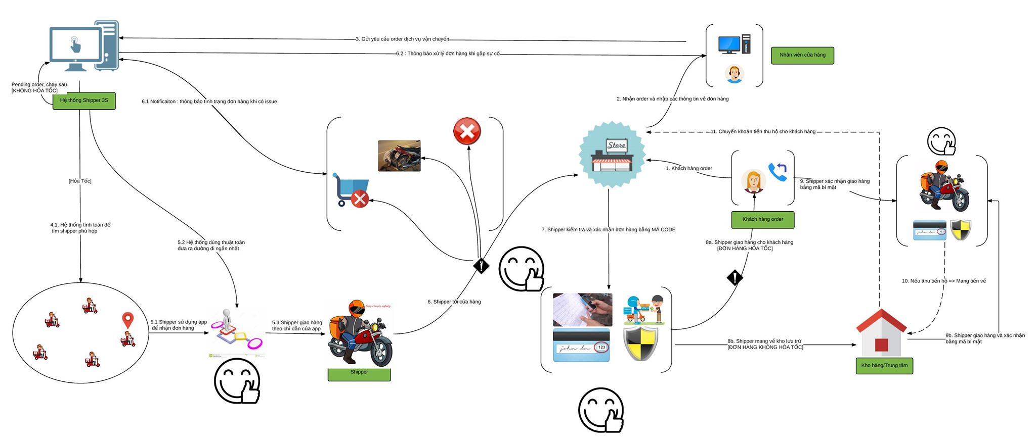The below rich picture describes all perspectives of product:

The product includes 3 types:

* Web Service: This is linking between Web App with Mobile App. Beside, executing logic to response data (JSON) for clients through API.
* Web App: This is an app that supports for 2 types of user
  + Admin: Manage (Shipper, Store), Resolve Issue, Control & Tracking Orders, …
  + Store: Create Order, Find Shipper, Confirm Code, Rate, Send Feedback. …
* Mobile App: This is an app that supports for shipper’s business
  + Shipper: Receive/Reject order, find short path, Send issues message …

## 2.2. Product functions

Refer to Section 3

## 2.3. User characteristics

There are three main actors that system support:

* Store: This system towards the stores which have demand to transport goods to clients but don’t have a team of professional shipper.
* Shipper: They are transformers that enjoy system to get income.
* Administrator: They use all functions that supported by system to manage activities of system.

## 2.4. Constraint

* All products of system have to meets the deadline
* All processes and related documents have to observe procedure of FPT

## 2.5. Assumption and dependencies

* Receive the guidance and good support of teacher
* No one of member got sick in the software development process
* In the development process, no device got fail
* Evert report meets the deadline
* Team member do not conflict and get high responsibility in the working process

## 2.6. Activity Diagram

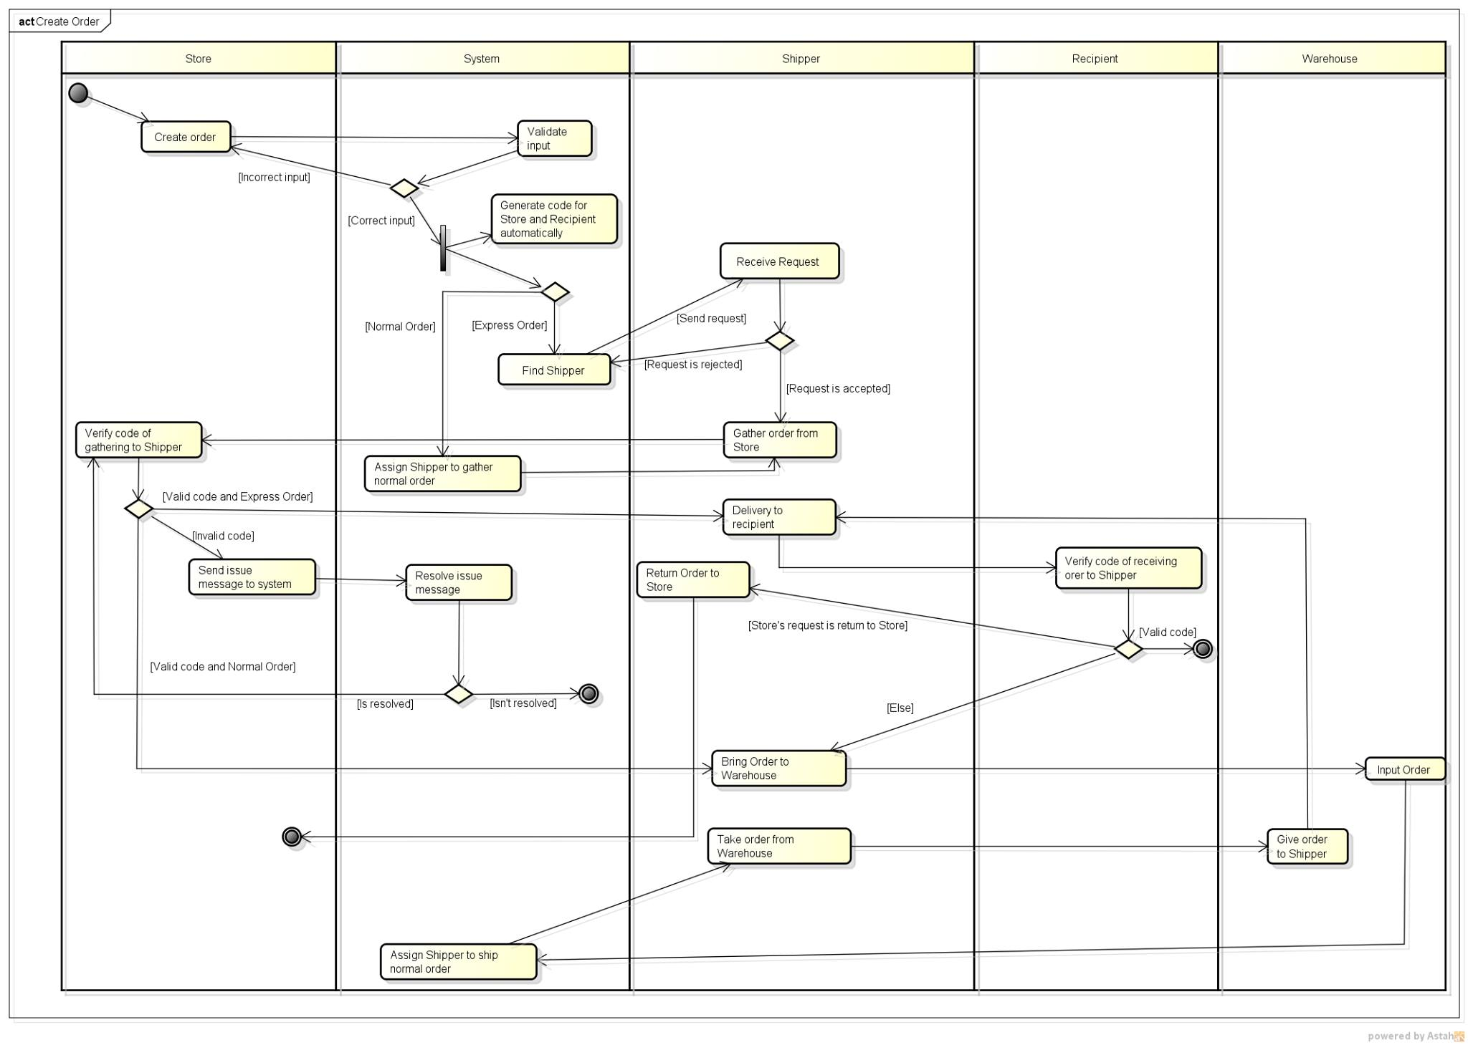This diagram describes the procedure of order

## 2.7. State Machine Diagram

This diagram describes the status of order:

In case express delivery:

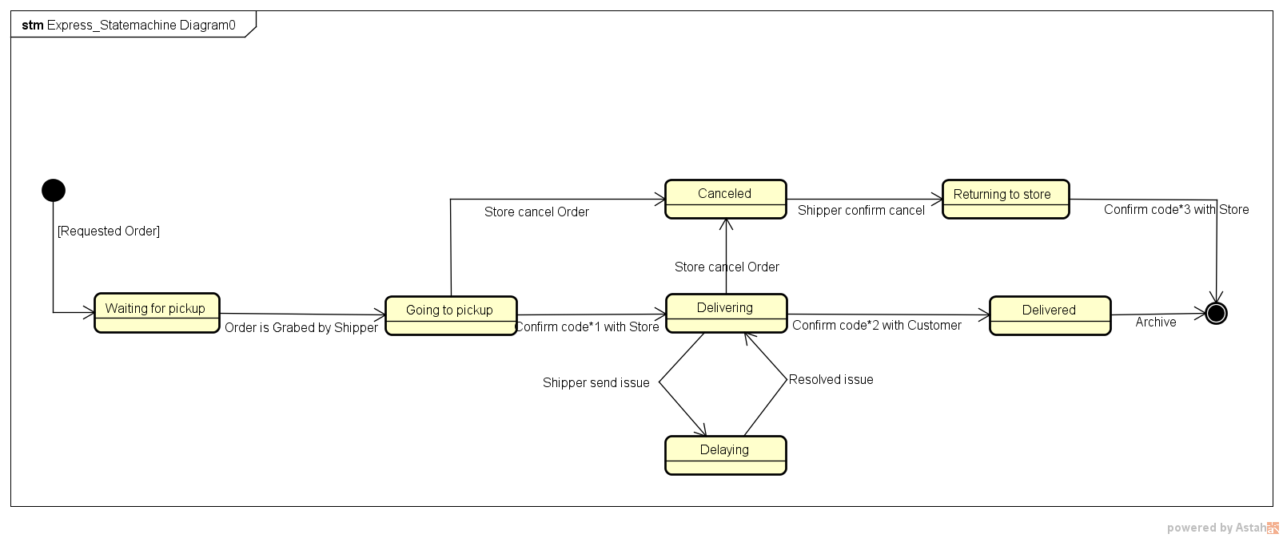

In case normal delivery:

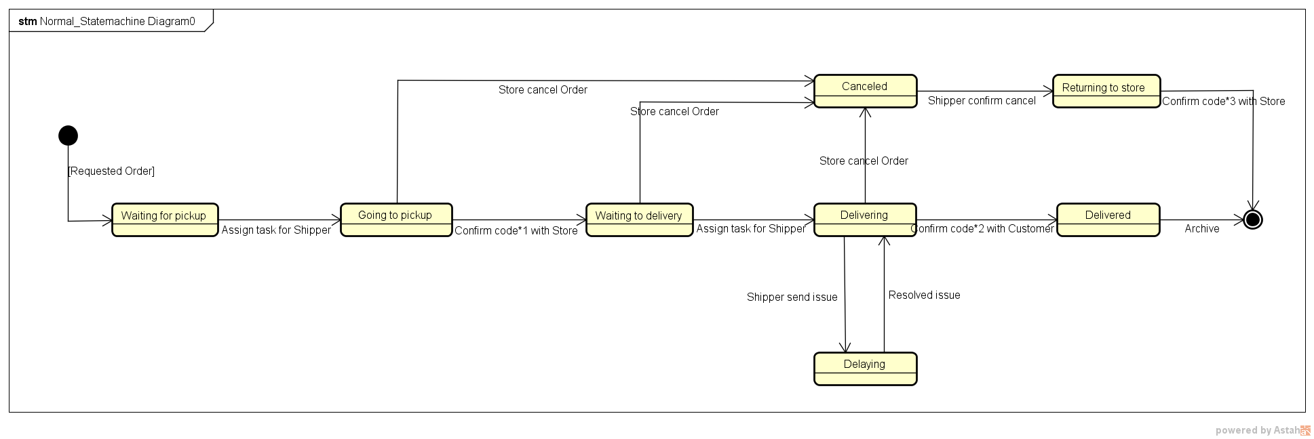

## 2.8. Entity Relationship Diagram

This diagram describes the relationship among entities of system

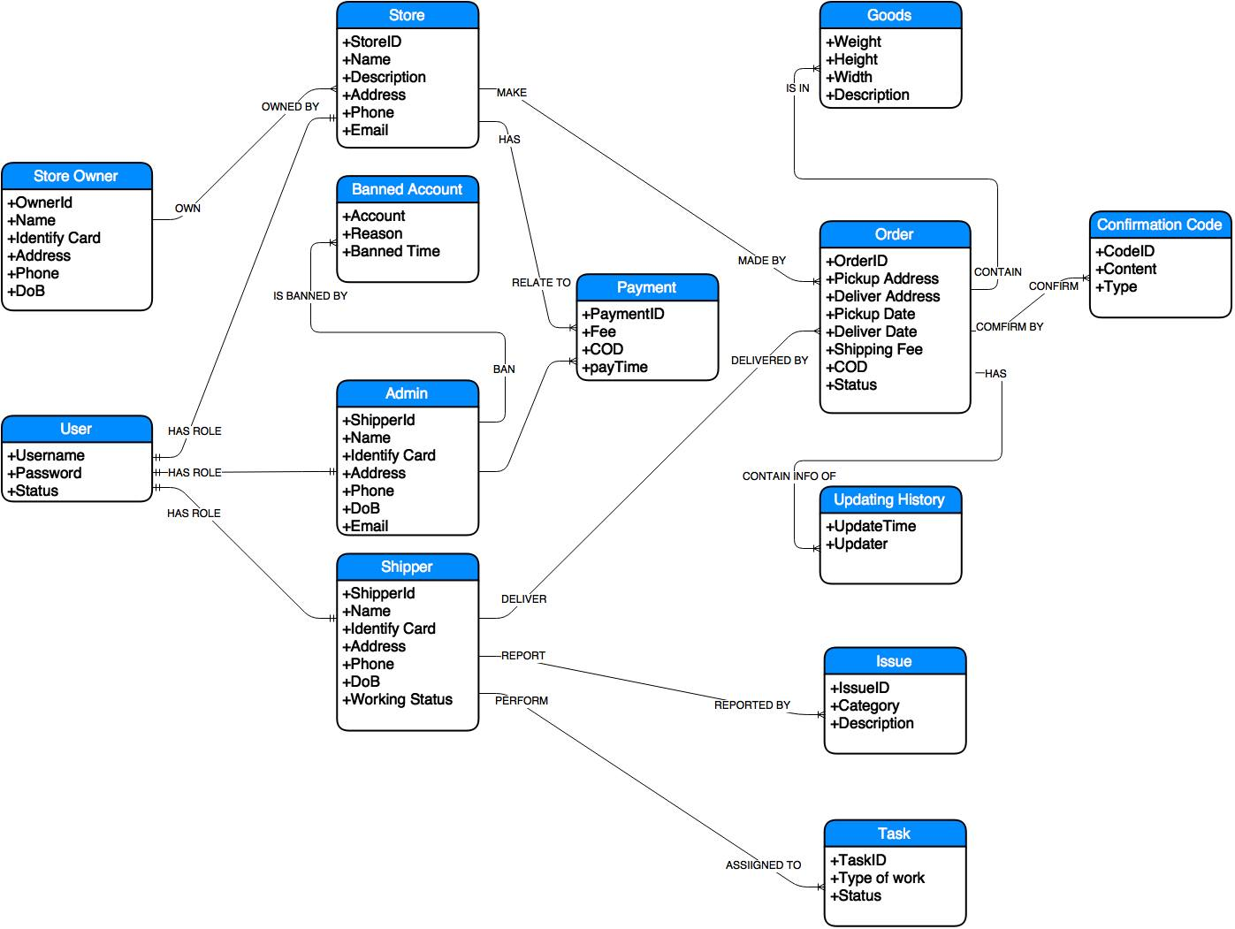

# FUNCTIONAL REQUIREMENTS

## 3.1. Web application for Admin

### 3.1.1. User Case Diagram

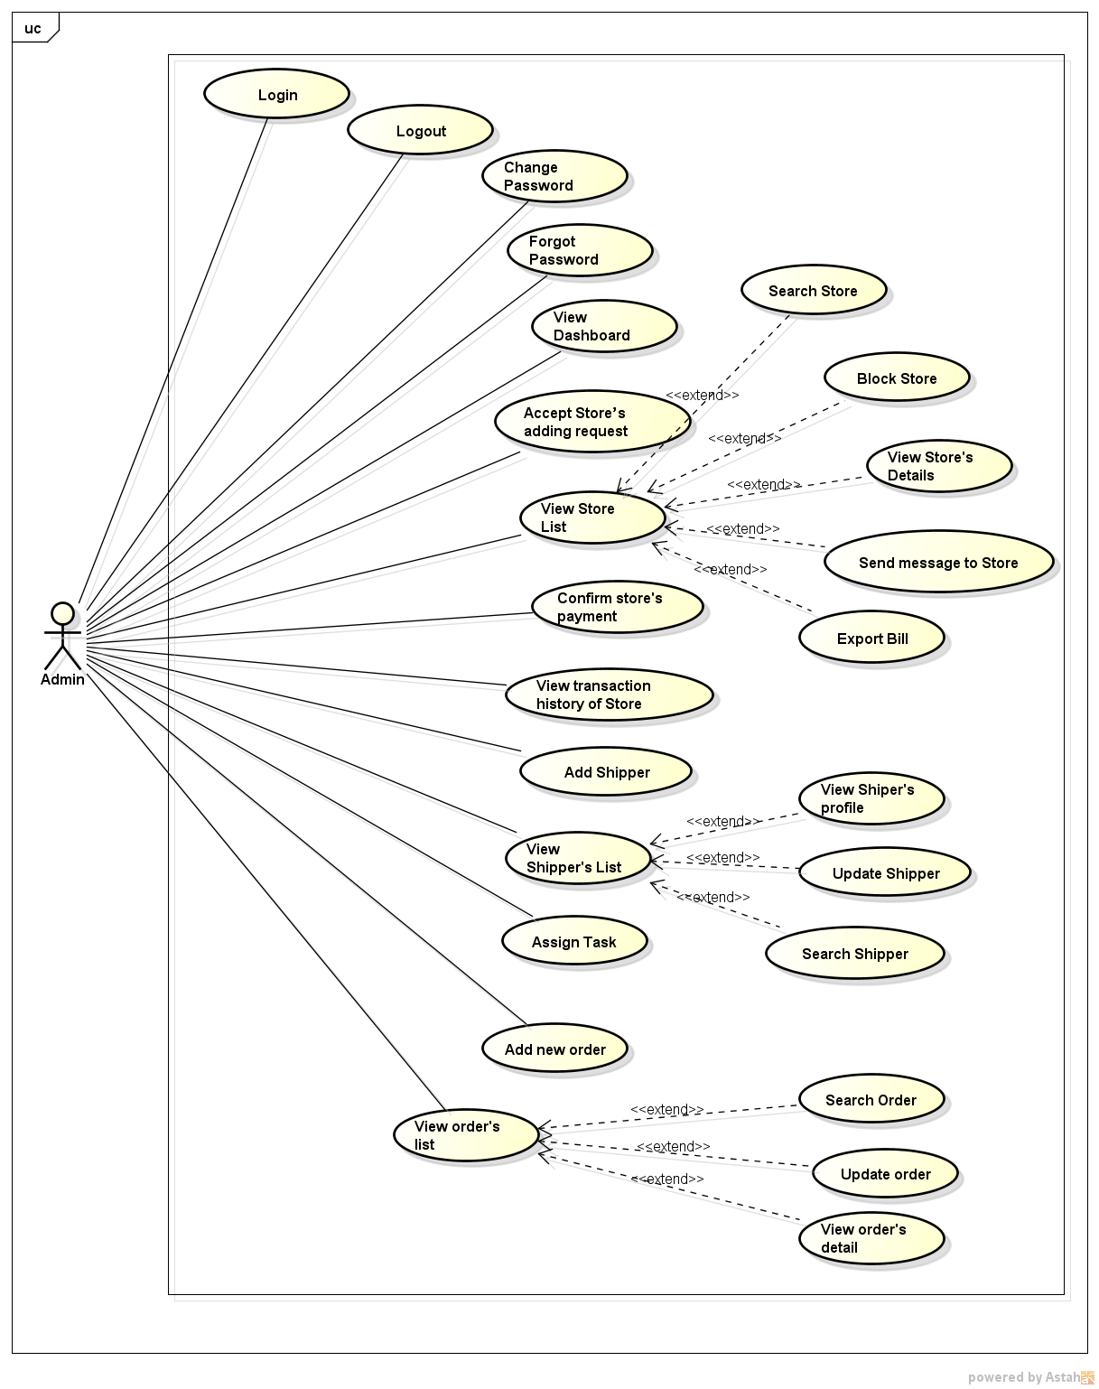

*Figure 11: User case diagram of Web Application for Admin*

### 3.1.2. Functions

###### *UC-101: Login*

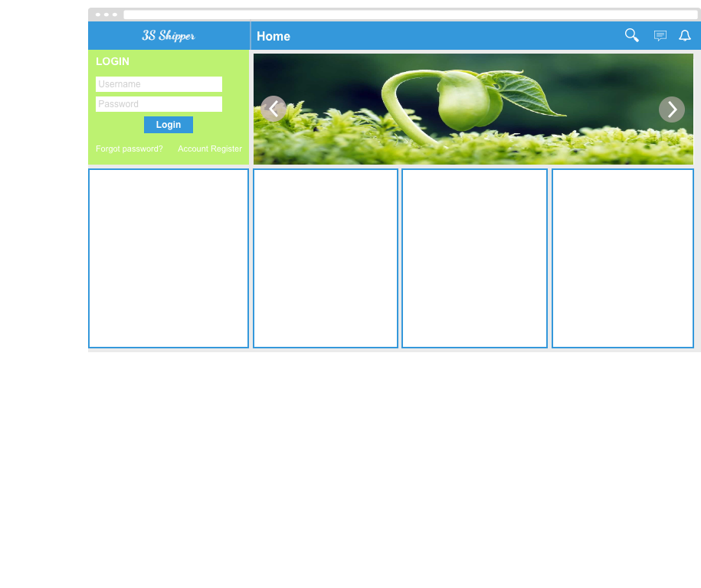

|  |  |  |  |  |
| --- | --- | --- | --- | --- |
| **Use Case ID:** | | UC-101 | | |
| **Use Case Name:** | | Login | | |
| **Created By:** | | HoangNK | **Last Updated By:** | HoangNK |
| **Date Created:** | | 19/09/2015 | **Date Last Updated:** | 20/09/2015 |
| **Actor:** | | Admin | | |
| **Description:** | | Users who are not logged in to system can only view the “Homepage”. Admin needs to logins to system to use functions of system. | | |
| **Triggering event:** | | Admin wants to login to system | | |
| **Preconditions:** | | Admin is on the “Homepage” of 3S website  Admin account must be exits | | |
| **Post conditions:** | | Logs Admin into system  Redirects to “Homepage” screen (Refer to UC-218: View Homepage) and displays as Admin | | |
| **Priority:** | | High | | |
| **Frequency of Use:** | | Sometime | | |
| **Main flow** | | | | |
| Step | Actor | Action | | |
|  | Admin | Enters User name and Password | | |
|  | Admin | Clicks “Login” | | |
|  | System | Check “Username” and “Password” in database. | | |
|  | System | Logs Admin into system | | |
|  | System | Redirects to “Homepage” screen and displays as Admin | | |
| **Alternative:** | | | | |
| **Exceptions:** | | | | |
| EC1 | At step 3 in main flow, if Admin entered wrong User name or Password | | | |
| Step | Actor | Action | | |
| 3.1 | System | Displays message “Username or Password is wrong” | | |
| **Includes:** | | N/A | | |
| **Special Requirements:** | | N/A | | |
| **Notes and Issues:** | | N/A | | |

***Sequence Diagram***

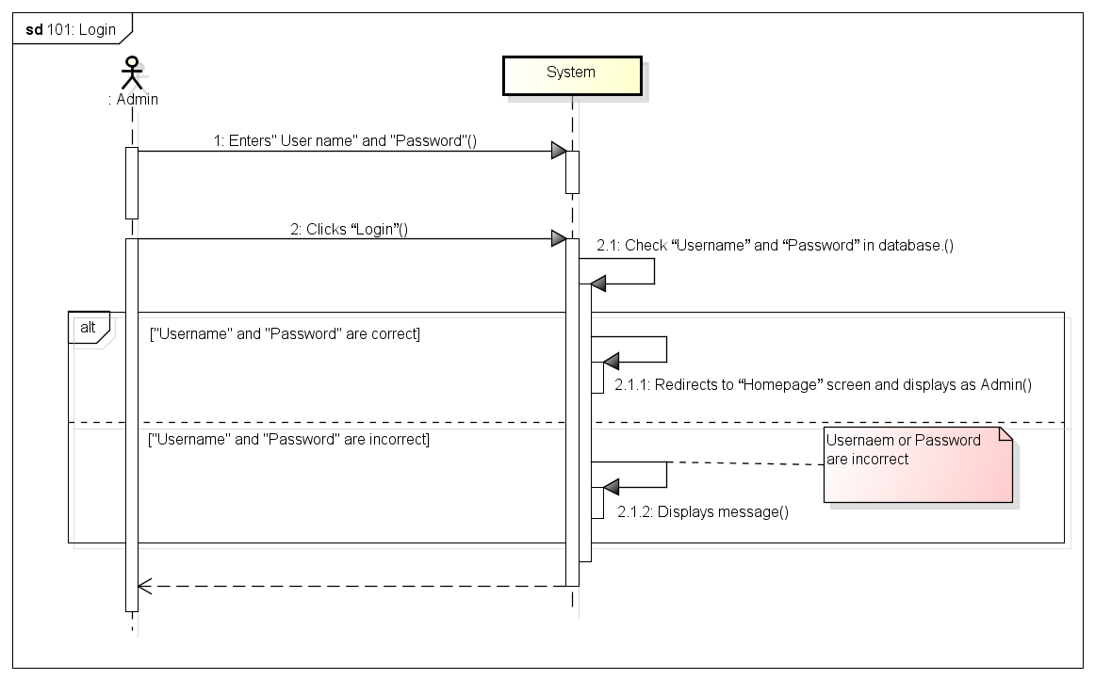

###### *UC-102: Logout*

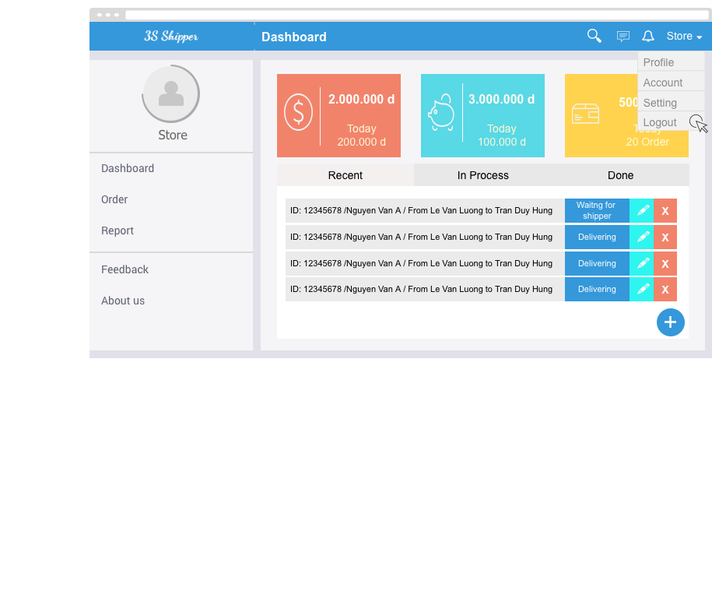

|  |  |  |  |  |
| --- | --- | --- | --- | --- |
| **Use Case ID:** | | UC-203 | | |
| **Use Case Name:** | | Logout | | |
| **Created By:** | | KhanhKC | **Last Updated By:** | KhanhKC |
| **Date Created:** | | 19/09/2015 | **Date Last updated:** | 20/09/2015 |
| **Actor:** | | Admin | | |
| **Description:** | | When Admin logouts from system, Admin will cannot continue using functions of system. Admin needs to login again to be able to use the function of system. | | |
| **Triggering event:** | | Admin wants to logout from system. | | |
| **Preconditions:** | | Admin logged in to system | | |
| **Post conditions:** | | Logs Admin out from system.  Redirects to “Homepage” screen (Refer to UC218: View Homepage) | | |
| **Priority:** | | High | | |
| **Frequency of Use:** | | Often | | |
| **Main flow** | | | | |
| Step | Actor | Action | | |
|  | Admin | Clicks Logout | | |
|  | System | Logouts Admin from system | | |
|  | System | Displays Homepage for Guest | | |
| **Alternative Flows:** | | | | |
| **Exceptions:** | | N/A | | |
| **Includes:** | | N/A | | |
| **Special Requirements:** | | N/A | | |
| **Notes and Issues:** | | N/A | | |

***Sequence Diagram***

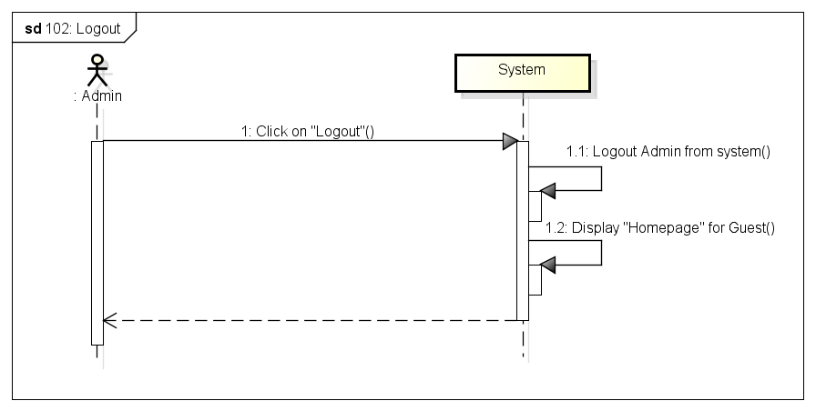

###### *UC-103: Change password*

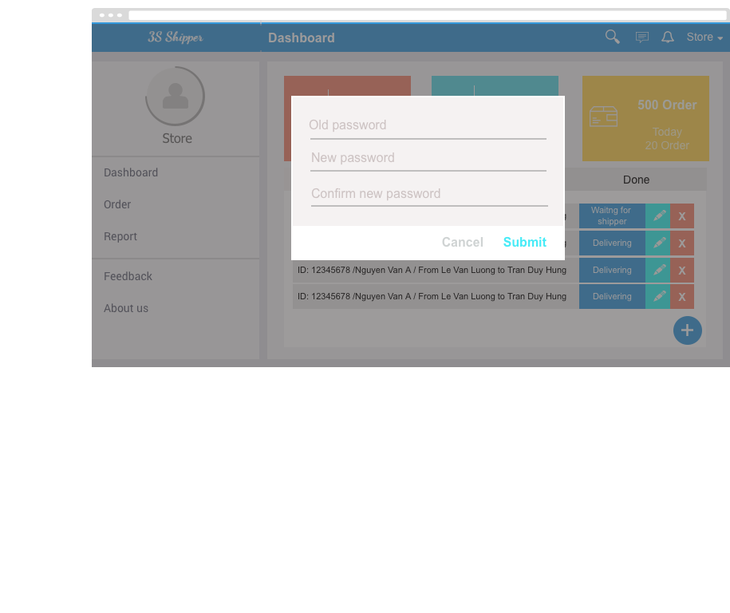

|  |  |  |  |  |
| --- | --- | --- | --- | --- |
| **Use Case ID:** | | UC-204 | | |
| **Use Case Name:** | | Change password | | |
| **Created By:** | | KhanhKC | **Last Updated By:** | KhanhKC |
| **Date Created:** | | 19/09/2015 | **Date Last updated:** | 20/09/2015 |
| **Actor:** | | Admin | | |
| **Description:** | | Admin can change login password but Admin need to remember old password. | | |
| **Triggering event:** | | Admin wants to change password. | | |
| **Preconditions:** | | Admin logged in to system | | |
| **Post conditions:** | | New password has been saved in database. | | |
| **Priority:** | | High | | |
| **Frequency of Use:** | | Sometime | | |
| **Main flow** | | | | |
| Step | Actor | Action | | |
|  | Admin | Clicks “Change password” | | |
|  | System | Displays “Change password” screen includes:  - Old password text box  - New password text box  - Confirm new password text box  - Submit button | | |
|  | Admin | Enters data in fields | | |
|  | Admin | Clicks “Submit” button | | |
|  | System | Validates data | | |
|  | System | Displays “Change password” screen with message “ Changes password successful” | | |
| **Alternative Flows:** | | N/A | | |
| **Exceptions:** | | | | |
| EC1 | At step 4, required fields are not entered | | | |
| Step | Actor | Action | | |
| 4.1 | System | Displays “Change password” screen with error message “*is require” | | |
| EC2 | At step 4, “Old password” is incorrect | | | |
| Step | Actor | Action | | |
| 4.1 | System | Displays “Change password” screen with error message: “Old password is incorrect” | | |
| EC3 | At step 4, confirm new password is not the same with new password | | | |
| Step | Actor | Action | | |
| 4.1 | System | Displays “Change password” screen with error message.” Confirm new password is not the same with new password. Please enter again!” | | |
| **Includes:** | | N/A | | |
| **Special Requirements:** | | Length of “New password” must between 6 and 10. | | |
| **Notes and Issues:** | | N/A | | |

***Sequence Diagram***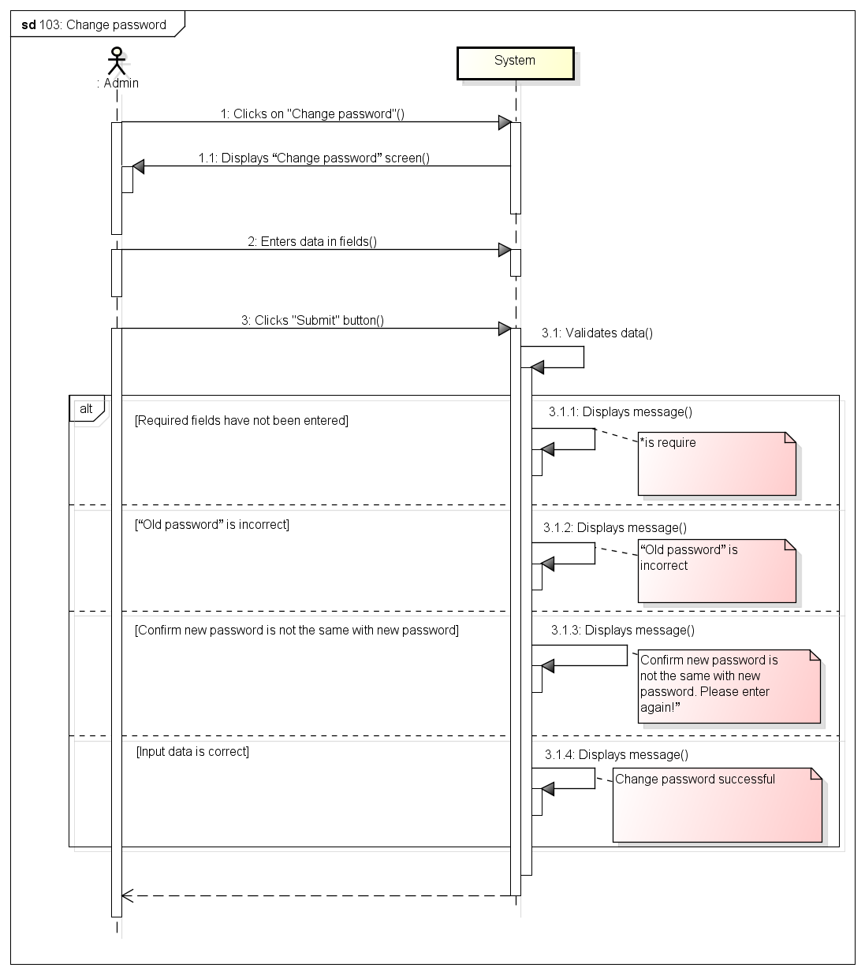

###### *UC-104: Forgot password*

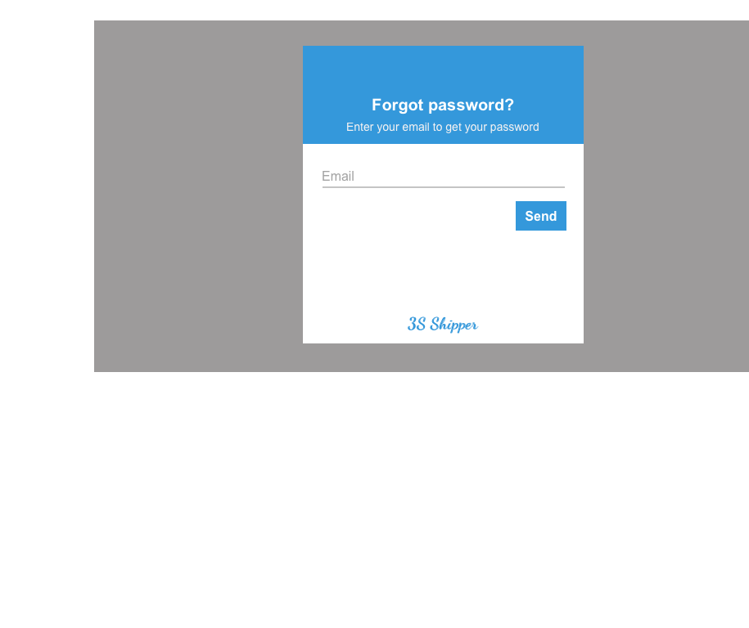

|  |  |  |  |  |
| --- | --- | --- | --- | --- |
| **Use Case ID:** | | UC-205 | | |
| **Use Case Name:** | | Forgot password | | |
| **Created By:** | | KhanhKC | **Last Updated By:** | KhanhKC |
| **Date Created:** | | 19/09/2015 | **Date Last updated:** | 20/09/2015 |
| **Actor:** | | Admin | | |
| **Description:** | | This function help Admin receive their login password when Admin forgot. | | |
| **Triggering event:** | | Admin requests system to receive new password. | | |
| **Preconditions:** | | Admin is on the “Homepage” (Refer to UC-218: View Homepage) | | |
| **Post conditions:** | | - A new password has been updated for Admin  - An email has been send to registered email of Admin include new password. | | |
| **Priority:** | | High | | |
| **Frequency of Use:** | | Sometime | | |
| **Main flow** | | | | |
| Step | Actor | Action | | |
|  | Admin | Clicks “Forgot password” hyperlink on “Login” box | | |
|  | System | Displays “Forgot password” popup includes:  - Email text box  - Submit button | | |
|  | Guest | Enters registered email. | | |
|  | Guest | Clicks “Submit” button | | |
|  | System | Validates data | | |
|  | System | Updates a new password for Admin | | |
|  | System | Sends the new password to registered email of Admin | | |
|  | System | Displays message : “Please check your email to get your new password” | | |
| **Alternative Flows:** | | N/A | | |
| **Exceptions:** | | | | |
| EC1 | At step 3, email are not a registered email | | | |
| Step | Actor | Actor | | |
| 4.1 | System | Displays error message:” Email is not exist” | | |
| **Includes:** | | N/A | | |
| **Special Requirements:** | | N/A | | |
| **Notes and Issues:** | | N/A | | |

***Sequence Diagram***

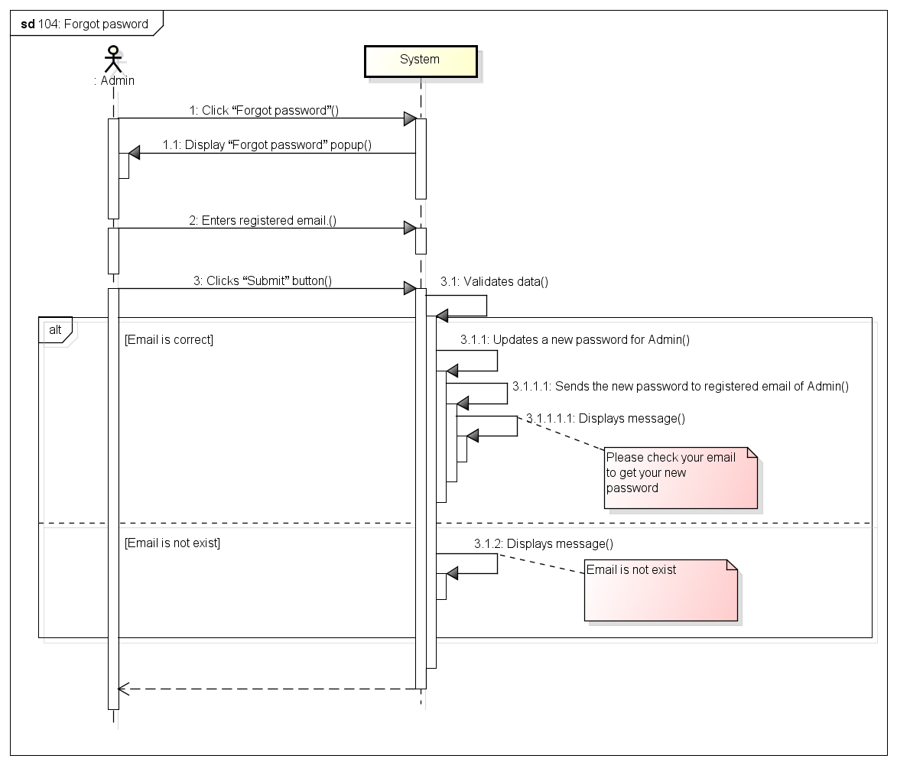

###### *UC- 105: Accept Store*

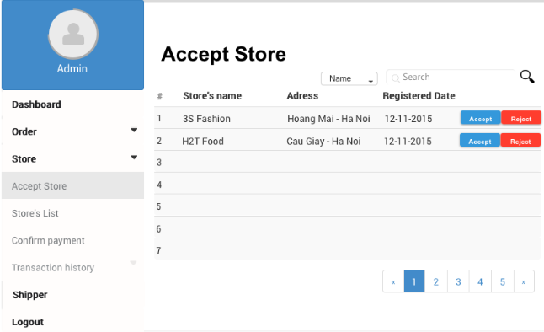

*Figure 11: Screen of Confirm Store’s Adding Request Use case*

|  |  |  |  |  |
| --- | --- | --- | --- | --- |
| **Use Case ID:** | | UC-105 | | |
| **Use Case Name:** | | Accept Store’s adding request | | |
| **Created By:** | | HoangNK | **Last Updated By:** | HoangNK |
| **Date Created:** | | 19/09/2015 | **Date Last updated:** | 24/09/2015 |
| **Actor:** | | Admin | | |
| **Description:** | | If the Store registers to system, an adding request is sent to Admin, after that Admin views list of adding request of the Store then accept or reject to add the Store | | |
| **Triggering Event:** | | Admin wants to accept or reject adding request of Store | | |
| **Preconditions:** | | Admin logged in to system | | |
| **Post conditions:** | | New Store is added to database | | |
| **Priority:** | | High | | |
| **Frequency of Use:** | | Sometime | | |
| **Main flow** | | | | |
| Step | Actor | Action | | |
|  | Admin | Clicks “Store” button in left navigate bar | | |
|  | System | Display “Store” menu includes: Accept Store, Store’s List, Confirm Payment and Transaction History | | |
|  | Admin | Clicks “Accept Store” button | | |
|  | System | Load data of Store's Adding Request and display in “Accept Store” screen includes:   * Search textbox and button * Filter drop-downlist * Registered Store’s basic information with 2 buttons “Accept” and “Reject” in each row in a table | | |
|  | Admin | Clicks “Accept” button to accept to add new Store | | |
|  | System | Display confirm popup includes “Yes” and “No” button | | |
|  | Admin | Confirm by clicksing “Yes” button | | |
|  | System | Close popup and hide this store from list | | |
|  | System | Add new Store to database of System | | |
| **Alternative Flows:** | | N/A | | |
| **Exceptions:** | | | | |
| EC1 | At step 5, Admin reject by clicksing “Reject” button | | | |
| Step | Actor | Action | | |
| 5.1 | System | Delete this store from list and this Store isn’t added to System | | |
| EC2 | At step 7, Admin clicks on “No” button | | | |
| Step | Actor | Action | | |
| 7.1 | System | Close popup and proceed to step 4 | | |
| EC3 | At step 4, system can’t get data from database because the internet or the database disconnect | | | |
| Step | Actor | Action | | |
| 4.1 | System | Show error message: “Failed to load data” | | |
| **Includes:** | | N/A | | |
| **Special Requirements:** | | N/A | | |
| **Notes and Issues:** | | N/A | | |

***Sequence Diagram*** 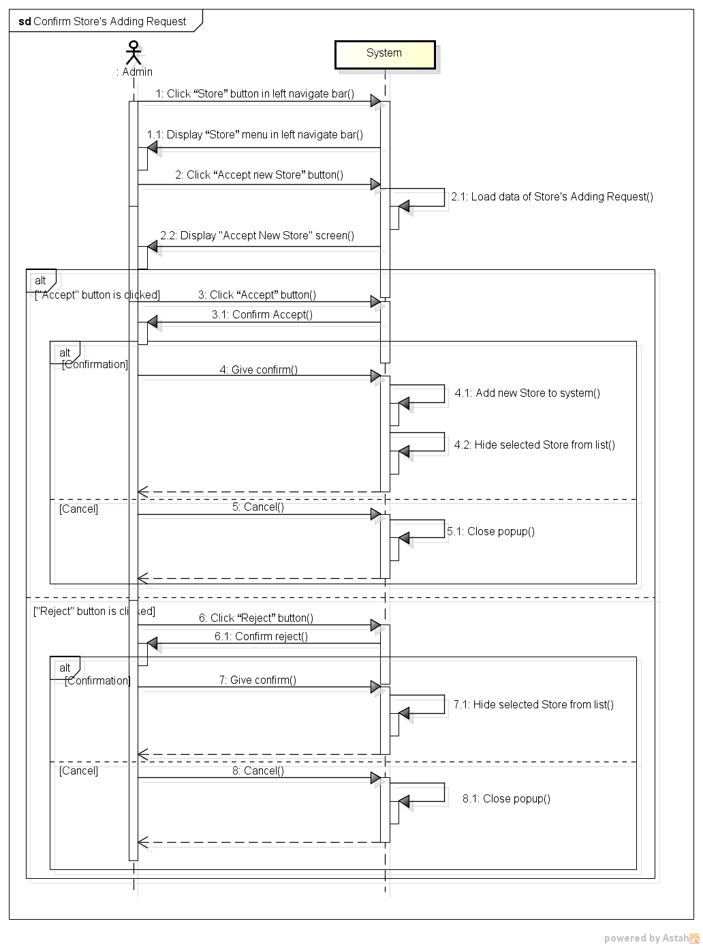

*Figure 11: Sequence Diagram for Confirm Store’s Adding Request Use case*

###### *UC- 106: Search Store*

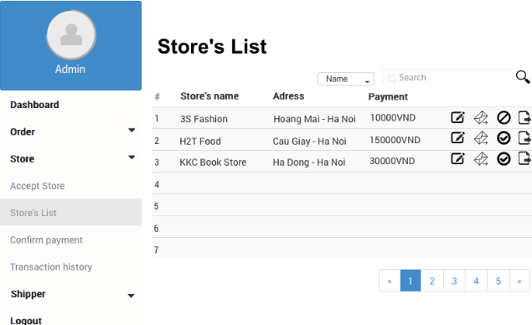

*Figure 11: Screen of Search Store Use case*

|  |  |  |  |  |
| --- | --- | --- | --- | --- |
| **Use Case ID:** | | UC-106 | | |
| **Use Case Name:** | | Search Store | | |
| **Created By:** | | HoangNK | **Last Updated By:** | HoangNK |
| **Date Created:** | | 19/09/2015 | **Date Last updated:** | 24/09/2015 |
| **Actor:** | | Admin | | |
| **Description:** | | Admin wants the system to list all Stores related to a specific keyword and type, after that, Admin can choose a Store to view details, update information and block or unblock this Store. | | |
| **Triggering Event:** | | Admin wants to search store | | |
| **Preconditions:** | | Admin is in view store’s list page ( refer case UC-107 ) | | |
| **Post conditions:** | | Display Store as result of search | | |
| **Priority:** | | High | | |
| **Frequency of Use:** | | Always | | |
| **Main flow** | | | | |
| Step | Actor | Action | | |
|  | Admin | Choose type of searching: Name, Address or Type | | |
|  | Admin | Enter text to “Search” text box | | |
|  | Admin | Clicks “Search” button or press “Enter” | | |
|  | System | Get Store’s data from database and display result on screen includes:   * Search textbox and button * Filter drop-downlist * Related Store’s basic information with 3 buttons Update, Send Message and Block or Unblock in a table | | |
| **Alternative Flows:** | | N/A | | |
| **Exceptions:** | |  | | |
| EC1 | At step 4, system can’t get data from database because the internet or the database disconnect | | | |
| Step | Actor | Action | | |
| 4.1 | System | Show error message: “Failed to load data” | | |
| **Includes:** | | N/A | | |
| **Special Requirements:** | | * Result of search is case insensitive * If Admin doesn’t choose any type, Name will be default type | | |
| **Notes and Issues:** | | N/A | | |

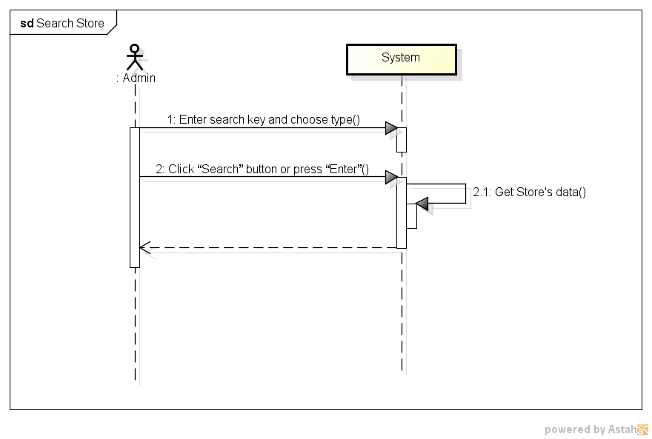

*Figure 11: Sequence Diagram for Search Store Use case*

###### *UC- 107:* *View Store’s list*



*Figure 11: Screen of View Store’s List Use case*

|  |  |  |  |  |
| --- | --- | --- | --- | --- |
| **Use Case ID:** | | UC-107 | | |
| **Use Case Name:** | | View Store’s list | | |
| **Created By:** | | HoangNK | **Last Updated By:** | HoangNK |
| **Date Created:** | | 19/09/2015 | **Date Last updated:** | 19/09/2015 |
| **Actor:** | | Admin | | |
| **Description:** | | Admin views all Store in a table with basic information (address, name, payment,..), so after that, Admin can choose a Store to send message, edit and block or unblock | | |
| **Triggering Event:** | | Admin wants to view all of Store | | |
| **Preconditions:** | | Admin logged in to system | | |
| **Post conditions:** | | List of store is displayed to screen | | |
| **Priority:** | | High | | |
| **Frequency of Use:** | | Always | | |
| **Main flow** | | | | |
| Step | Actor | Action | | |
|  | Admin | Clicks “Store” button in left navigate bar | | |
|  | System | Display “Store” menu in left navigate bar includes: Accept Store, Store’s List, Confirm Payment and Transaction History | | |
|  | Admin | Clicks “Store’s list” button | | |
|  | System | Get Store’s data then display “Store’s List” screen includes:   * Search textbox and button * Filter drop-downlist * All Store’s basic information with 3 icon buttons: Update, Send Message and Block or Unblock | | |
| **Alternative Flows:** | | N/A | | |
| **Exceptions:** | |  | | |
| EC1 | At step 4, system can’t get data from database because the internet or the database disconnect | | | |
| Step | Actor | Action | | |
| 4.1 | System | Show error message: “Failed to load data” | | |
| **Includes:** | | N/A | | |
| **Special Requirements:** | | N/A | | |
| **Notes and Issues:** | | N/A | | |

***Sequence Diagram***

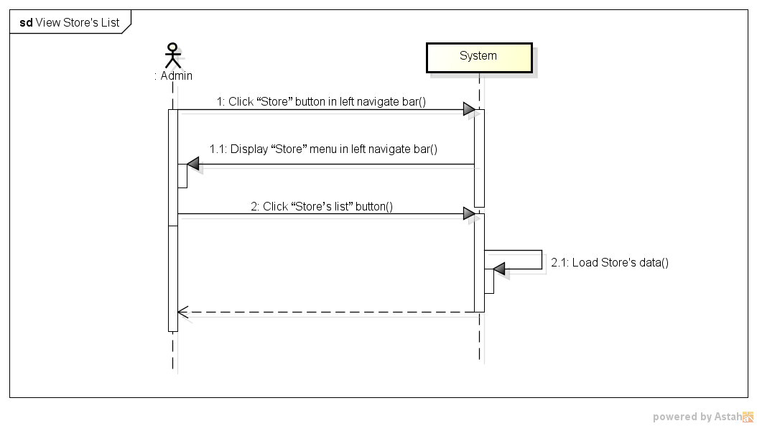

*Figure 11: Sequence Diagram for View Store’s List Use case*

###### *UC- 108:* *Block and Unblock store*

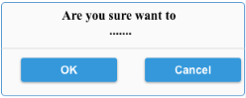

*Figure 11: Screen of Block and Unblock Store Use case*

|  |  |  |  |  |
| --- | --- | --- | --- | --- |
| **Use Case ID:** | | UC-108 | | |
| **Use Case Name:** | | Block and Unblock store | | |
| **Created By:** | | HoangNK | **Last Updated By:** | HoangNK |
| **Date Created:** | | 19/09/2015 | **Date Last updated:** | 24/09/2015 |
| **Actor:** | | Admin | | |
| **Description:** | | Admin bans the store from system if the store has serious breach of contract, so they can’t do any function of system if they were banned. Besides, Admin can unban the Store which is banned to give this Store permission of using Store’s functions | | |
| **Triggering Event:** | | Admin wants to blocks or unblocks store | | |
| **Preconditions:** | | Admin is in view store’s list page ( refer case UC-107 ) | | |
| **Post conditions:** | | Store is blocked or unblocked | | |
| **Priority:** | | Normal | | |
| **Frequency of Use:** | | Sometime | | |
| **Main flow** | | | | |
| Step | Actor | Action | | |
|  | Admin | Clicks “Block”(“Unblock”) button | | |
|  | System | Display confirm popup includes “Yes” and “No” button | | |
|  | Admin | Clicks “Yes” button | | |
|  | System | Hide popup and change store’s status of blocking | | |
|  | System | Store is blocked or unblocked | | |
| **Alternative Flows:** | |  | | |
| AT1 | At step 1, if admin clicks “View store’s details” | | | |
| Step | Actor | Action | | |
| 1 | Admin | Clicks Store’s name in row (hyperlink) | | |
| 2 | System | Display “View Store’s details” screen | | |
| 3 | Admin | Clicks “Block” (“Unblock”) button below avatar | | |
| 4 | System | Go to step 2 of main flow and continue | | |
| **Exceptions:** | | | | |
| EC1 | At step 2, Admin clicks on “No” button | | | |
| Step | Actor | Action | | |
| 2.1 | System | Close popup | | |
|  |  |  | | |
| **Includes:** | | N/A | | |
| **Special Requirements:** | | N/A | | |
| **Notes and Issues:** | | N/A | | |

***Sequence Diagram***

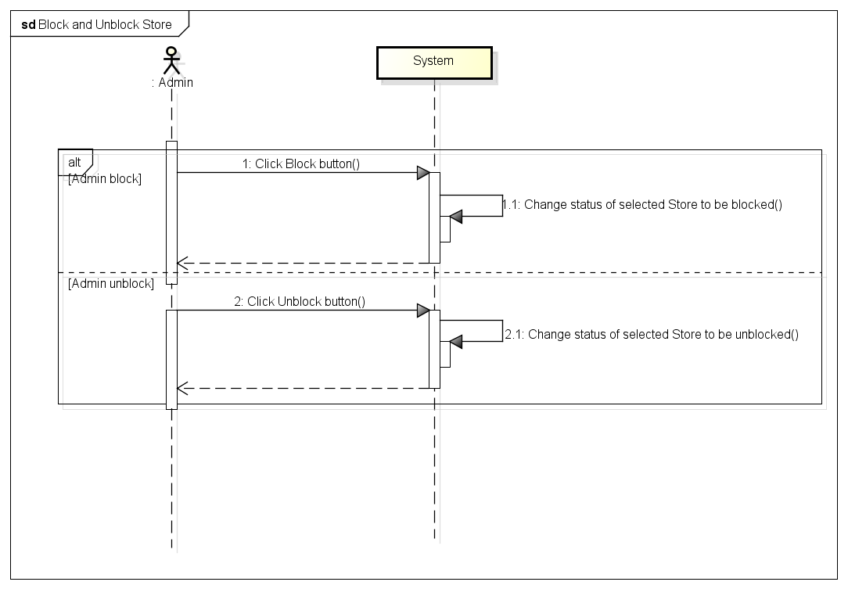

*Figure 11: Sequence Diagram for Block and Unblock Store Use case*

###### *UC- 109:* *View Store’s details*

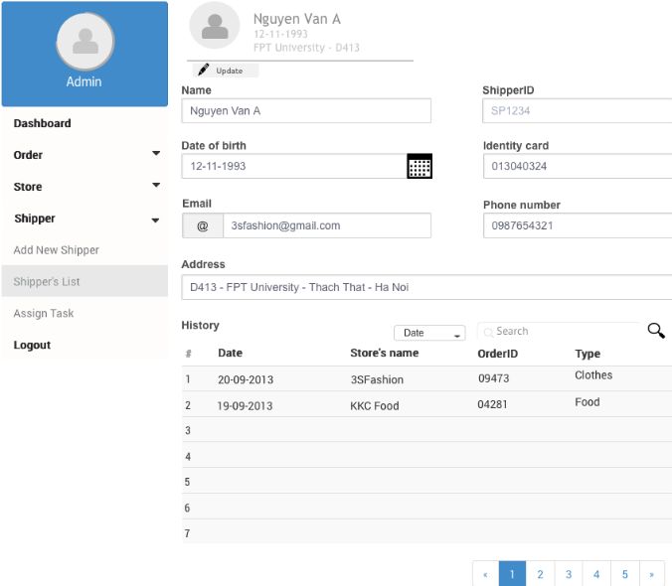

*Figure 11: Screen of View Store’s Details Use case*

|  |  |  |  |  |
| --- | --- | --- | --- | --- |
| **Use Case ID:** | | UC-109 | | |
| **Use Case Name:** | | View Store’s details | | |
| **Created By:** | | HoangNK | **Last Updated By:** | HoangNK |
| **Date Created:** | | 19/09/2015 | **Date Last updated:** | 24/09/2015 |
| **Actor:** | | Admin | | |
| **Description:** | | Admin views all Store’s details (address, name, registered date, phone number, store’s manager, payment, identity card, bank’s account information,…), so after that, Admin can send message, edit and block or unblock this Store | | |
| **Triggering Event:** | | Admin wants to view all information of a Store | | |
| **Preconditions:** | | Admin is in view store’s list page ( refer case UC-107 ) | | |
| **Post conditions:** | | Details of Store are displayed | | |
| **Priority:** | | Normal | | |
| **Frequency of Use:** | | Sometime | | |
| **Main flow** | | | | |
| Step | Actor | Action | | |
|  | Admin | Clicks Store’s name in row (hyperlink) | | |
|  | System | Load data of selected Store and display “View Store’s details” screen includes store’s details includes: address, name, registered date, phone number, store’s manager, payment, identity card, bank’s account information,… | | |
| **Alternative Flows:** | | N/A | | |
| **Exceptions:** | | N/A | | |
| **Includes:** | | N/A | | |
| **Special Requirements:** | | N/A | | |
| **Notes and Issues:** | | N/A | | |

***Sequence Diagram***

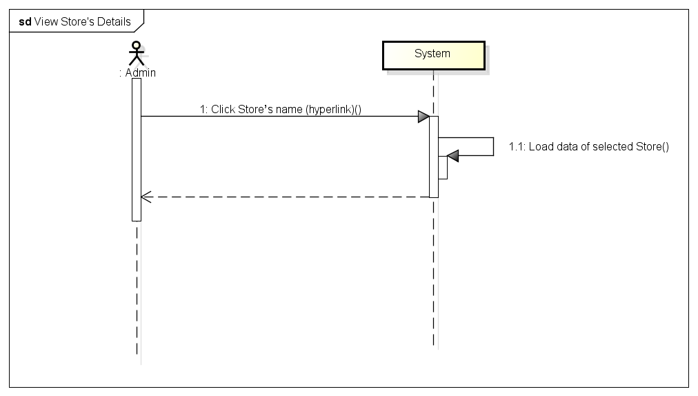

*Figure 11: Sequence Diagram for View Store’s Details Use case*

###### *UC- 110:* *Send message to Store*

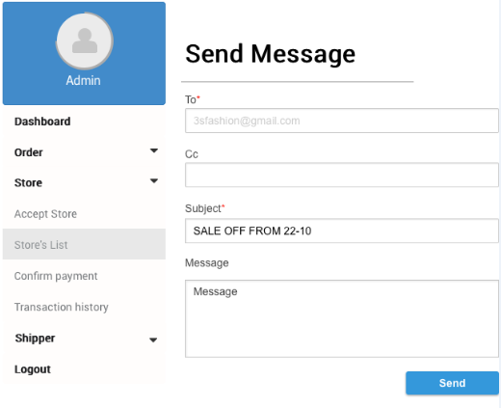

*Figure 11: Screen of Send Message to Store Use case*

|  |  |  |  |  |
| --- | --- | --- | --- | --- |
| **Use Case ID:** | | UC-110 | | |
| **Use Case Name:** | | Send message to Store | | |
| **Created By:** | | HoangNK | **Last Updated By:** | HoangNK |
| **Date Created:** | | 19/09/2015 | **Date Last updated:** | 19/09/2015 |
| **Actor:** | | Admin | | |
| **Description:** | | Admin create a message with Store’s name, subject and content to send to a Store or a lot of Stores (by entering store’s name to Cc textbox) in order to notify the Store’s about news, changes,… | | |
| **Triggering Event:** | | Admin wants to send message to the Store | | |
| **Preconditions:** | | Admin is in view store’s list page ( refer case UC-107 ) | | |
| **Post conditions:** | | A message is sent to the Store | | |
| **Priority:** | | Normal | | |
| **Frequency of Use:** | | Sometime | | |
| **Main flow** | | | | |
| Step | Actor | Action | | |
|  | Admin | Clicks “Send message” button | | |
|  | System | Display “Send message” screen with send message form includes: store’s name and cc, subject and content | | |
|  | Admin | Fill information in textbox | | |
|  | Admin | Clicks “Send” button | | |
|  | System | Validate input | | |
|  | System | Send this message to store and show the result of sending to Admin by message: ‘The message has been sent” | | |
| **Alternative Flows:** | |  | | |
| AT1 | At step 1, if admin clicks “View store’s details” | | | |
| Step | Actor | Action | | |
| 1 | Admin | Clicks Store’s name in row (hyperlink) | | |
| 2 | System | Display “View Store’s details” screen | | |
| 3 | Admin | Clicks “Send message” button below avatar | | |
| 4 | System | Go to step 2 of main flow and continue | | |
| **Exceptions:** | | | | |
| EC1 | At step 5, if admin doesn’t type anything in Subject textbox or Content textbox | | | |
| Step | Actor | Action | | |
| 5.1 | System | Notify by error message in screen “*is require” | | |
| EC2 | At step 6, if message can’t send to Store | | | |
| Step | Actor | Action | | |
| 5.1 | System | Notify by error message in screen “Can’t send to Store, please try again!!” | | |
| **Includes:** | | N/A | | |
| **Special Requirements:** | | * Message content must be longer than 20 characters * The field with ‘*’ can’t be blank | | |
| **Notes and Issues:** | | N/A | | |

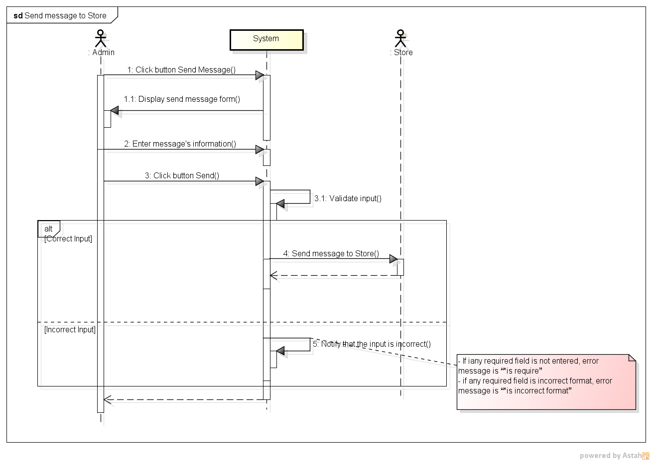***Sequence Diagram***

*Figure 11: Sequence Diagram for Send Message to Store Use case*

###### *UC- 111:* *Confirm Store’s payment*

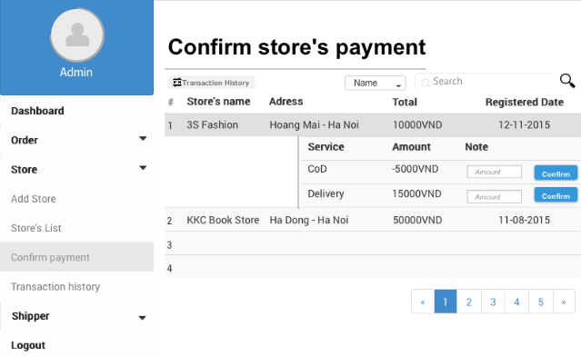

*Figure 11: Screen of Confirm Store’s Payment Use case*

2

|  |  |  |  |  |
| --- | --- | --- | --- | --- |
| **Use Case ID:** | | UC-111 | | |
| **Use Case Name:** | | Confirm Store’s payment | | |
| **Created By:** | | HoangNK | **Last Updated By:** | HoangNK |
| **Date Created:** | | 19/09/2015 | **Date Last updated:** | 24/09/2015 |
| **Actor:** | | Admin | | |
| **Description:** | | After receiving and sending money to the Store, admin updates Store’s payment by confirming amount of money of transactions | | |
| **Triggering Event:** | | Admin wants to confirms the store’s payment | | |
| **Preconditions:** | | Admin logged in to system | | |
| **Post conditions:** | | Payment of this store is updated in database | | |
| **Priority:** | | High | | |
| **Frequency of Use:** | | Always | | |
| **Main flow** | | | | |
| Step | Actor | Action | | |
|  | Admin | Clicks “Store” button in left navigate bar | | |
|  | System | Display “Store” menu in left navigate bar includes: Accept Store, Store’s List, Confirm Payment and Transaction History | | |
|  | Admin | Clicks “Confirm store’s payment” button | | |
|  | System | Display “Confirm store’s payment” screen includes:   * Search textbox and button * Filter drop-downlist * Store’s basic information, total payment in each row of a table * List of total payment of delivery service and cash on delivery service, an amount textbox and Confirm button when Admin clicks Store’s name(hyperlink) | | |
|  | Admin | Enter payment in “Payment” textbox | | |
|  | Admin | Clicks “Confirm” button | | |
|  | System | Give confirm by displaying confirm popup includes “Yes” and “No” button | | |
|  | Admin | Clicks “Yes” button | | |
|  | System | Update payment of this store to database | | |
| **Alternative Flows:** | |  | | |
| AT1 | At step 3, if admin clicks “Store’s list” button | | | |
| Step | Actor | Action | | |
| 3 | Admin | Clicks “Store’s list” button | | |
| 4 | System | Display “View Store’s details” screen | | |
| 5 | System | Display “Store’s List” screen | | |
| 6 | Admin | Clicks Store’s name in row (hyperlink) | | |
| 7 | System | Display “View Store’s details” screen includes store’s details | | |
| 8 | Admin | Clicks “Confirm store’s payment” button | | |
| 9 | System | Go to step 4 of main flow | | |
| **Exceptions:** | | N/A | | |
| **Includes:** | | N/A | | |
| **Special Requirements:** | | * When Admin clicks Store’s name (hyperlink), some rows will be displayed below with incomplete transaction * If the payment is negative, this is payment that the system needs to pay for the Store * If the payment is positive, this is payment that the Store needs to pay for the system * Default value of amount textbox is 0 * The value of amount textbox is only number and absolute value must be less than amount of payment | | |
| **Notes and Issues:** | | N/A | | |

***Sequence Diagram***

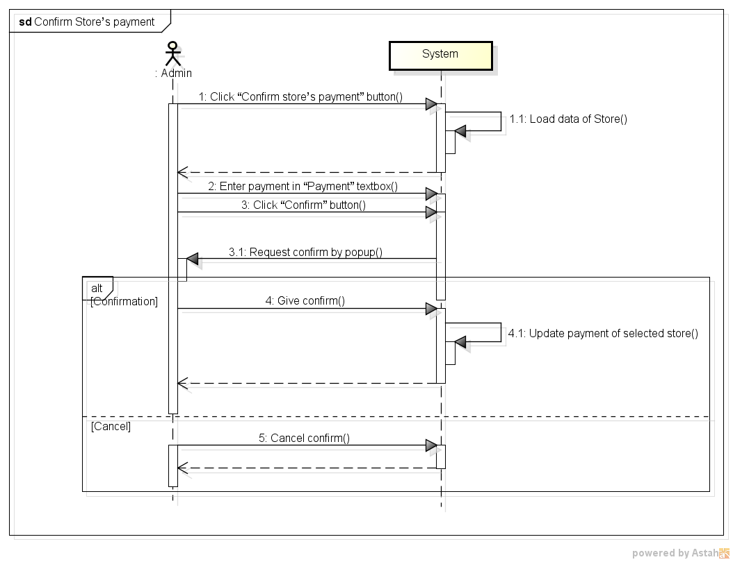

*Figure 11: Sequence Diagram for Confirm Store’s Payment Use case*

###### *UC- 112:* *View* transaction *history of Store*

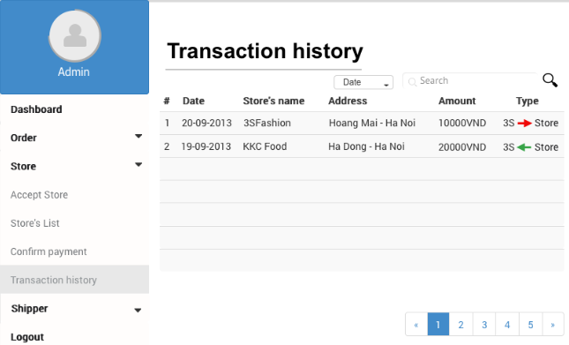

*Figure 11: Screen of View Transaction History of Store Use case*

|  |  |  |  |  |
| --- | --- | --- | --- | --- |
| **Use Case ID:** | | UC-112 | | |
| **Use Case Name:** | | View transaction history of Store | | |
| **Created By:** | | HoangNK | **Last Updated By:** | HoangNK |
| **Date Created:** | | 19/09/2015 | **Date Last updated:** | 19/09/2015 |
| **Actor:** | | Admin | | |
| **Description:** | | Admin wants the system to list all Store’s transaction with basic information (store’s name, address, amount of money, type,..) | | |
| **Triggering Event:** | | Admin wants to view transaction history of Stores | | |
| **Preconditions:** | | Admin logged in to system | | |
| **Post conditions:** | | List of transaction history of Store is displayed | | |
| **Priority:** | | Normal | | |
| **Frequency of Use:** | | Sometime | | |
| **Main flow** | | | | |
| Step | Actor | Action | | |
|  | Admin | Clicks “Store” button in left navigate bar | | |
|  | System | Display “Store” menu in left navigate bar includes: Accept Store, Store’s List, Confirm Payment and Transaction History | | |
|  | Admin | Clicks “Transaction history” button | | |
|  | System | Load data of transaction and display “Transaction history” screen includes   * Search textbox and button * Filter drop-downlist * Basic information of transaction in a table | | |
| **Alternative Flows:** | | | | |
| AT1 | At step 3, if admin clicks “Store’s list” button | | | |
| Step | Actor | Action | | |
| 3 | Admin | Clicks “Store’s list” button | | |
| 4 | System | Display “View Store’s details” screen | | |
| 5 | System | Display “Store’s List” screen | | |
| 6 | Admin | Clicks Store’s name in row (hyperlink) | | |
| 7 | System | Display “View Store’s details” screen includes store’s details | | |
| 8 | Admin | Clicks “Transaction history” button | | |
| 9 | System | Go to step 4 of main flow | | |
| **Exceptions:** | | N/A | | |
| **Includes:** | | N/A | | |
| **Special Requirements:** | | N/A | | |
| **Notes and Issues:** | | N/A | | |

***Sequence Diagram***

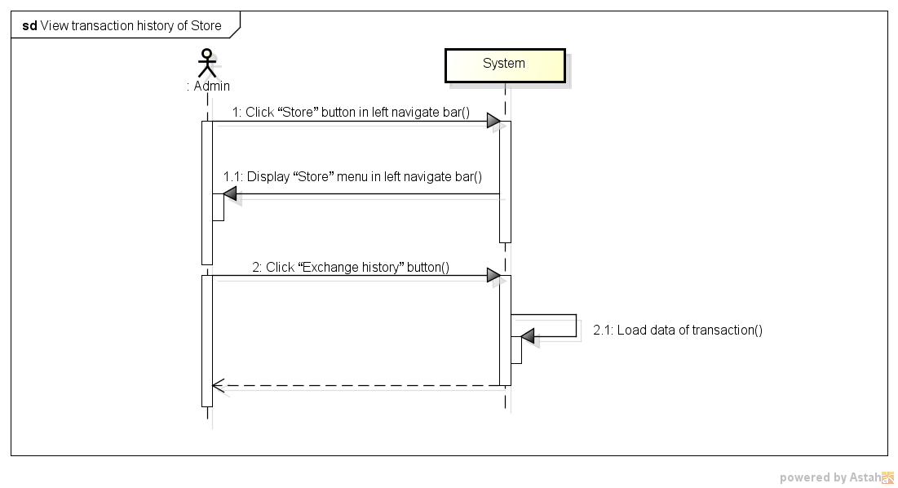

*Figure 11: Sequence Diagram for View Transaction history of Store Use case*

###### *UC- 113:* *Add Shipper*

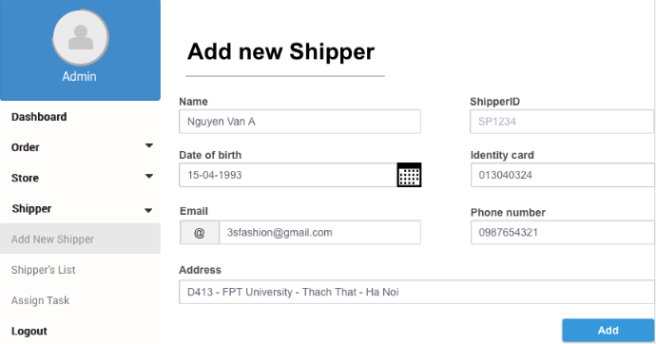

*Figure 11: Screen of Add Shipper Use case*

|  |  |  |  |  |
| --- | --- | --- | --- | --- |
| **Use Case ID:** | | UC-113 | | |
| **Use Case Name:** | | Add New Shipper | | |
| **Created By:** | | HoangNK | **Last Updated By:** | HoangNK |
| **Date Created:** | | 19/09/2015 | **Date Last updated:** | 19/09/2015 |
| **Actor:** | | Admin | | |
| **Description:** | | Admin create new account to new Shipper with basic information of Shipper: name, date of birth, email, phone number, identity card, address,… | | |
| **Triggering Event:** | | Admin wants to adds a new Shipper to system | | |
| **Preconditions:** | | Admin logged in to system | | |
| **Post conditions:** | | New Shipper and new account for this Shipper are added to database | | |
| **Priority:** | | High | | |
| **Frequency of Use:** | | Often | | |
| **Main flow** | | | | |
| Step | Actor | Action | | |
|  | Admin | Clicks “Shipper” button in left navigate bar | | |
|  | System | Display “Shipper” menu in left navigate bar includes Add New Shipper, Shipper’s List and Assign Task | | |
|  | Admin | Clicks “Add new Shipper” button | | |
|  | System | Display “Add new Shipper” form includes textbox of : name, date of birth, email, phone number, identity card, address | | |
|  | Admin | Enter new Shipper’s information into fields | | |
|  | Admin | Clicks “Add” button | | |
|  | System | Validate input | | |
|  | System | Add new Shipper and new account of this Shipper to database then redirects to “Shipper’s List” page | | |
| **Alternative Flows:** | | N/A | | |
| **Exceptions:** | | | | |
| EC1 | At step 7, if any required field is not entered | | | |
| Step | Actor | Action | | |
| 7.1 | System | Notify in screen by error message “*is require” | | |
| EC2 | At step 7, if any required field is incorrect format | | | |
| Step | Actor | Action | | |
| 7.1 | System | Notify in screen by error message “*is incorrect format” | | |
| EC3 | At step 7, if identity card or email has been already existed | | | |
| Step | Actor | Action | | |
| 7.1 | System | Notify in screen by error message “* has been already existed” | | |
| **Includes:** | | N/A | | |
| **Special Requirements:** | | * ShipperID will be generated automatically by system * Default account and password for new Shipper is shipperID, Shipper can change them by mobile app later * The field with ‘*’ can’t be blank | | |
| **Notes and Issues:** | | N/A | | |

***Sequence Diagram***

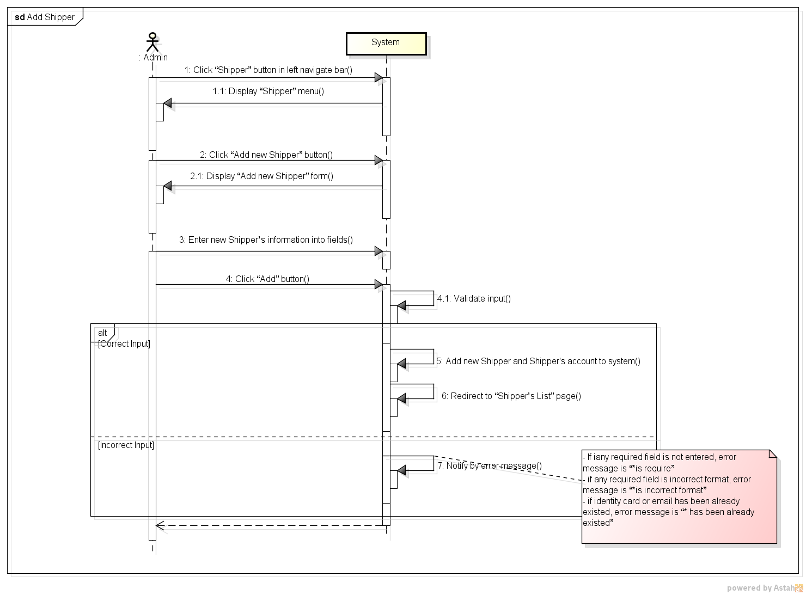

*Figure 11: Sequence Diagram for Add Shipper Use case*

###### *UC- 114:* *View Shipper’s list*

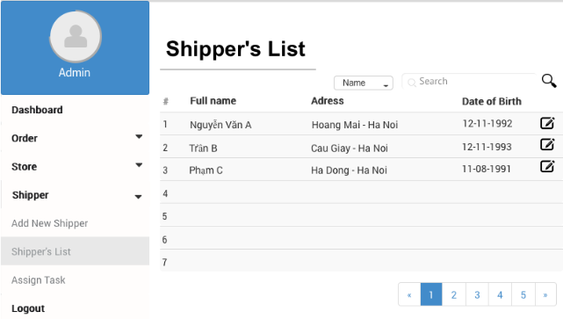

*Figure 11: Screen of View Shipper’s List Use case*

|  |  |  |  |  |
| --- | --- | --- | --- | --- |
| **Use Case ID:** | | UC-114 | | |
| **Use Case Name:** | | View Shipper’s list | | |
| **Created By:** | | HoangNK | **Last Updated By:** | HoangNK |
| **Date Created:** | | 19/09/2015 | **Date Last updated:** | 19/09/2015 |
| **Actor:** | | Admin | | |
| **Description:** | | Admin views all Shipper in a table with basic information (address, name, date of birth,..), so after that, Admin can choose a Shipper to update information | | |
| **Triggering Event:** | | Admin wants to view all Shipper | | |
| **Preconditions:** | | Admin logged in to system | | |
| **Post conditions:** | | List of shipper is displayed | | |
| **Priority:** | | High | | |
| **Frequency of Use:** | | Always | | |
| **Main flow** | | | | |
| Step | Actor | Action | | |
|  | Admin | Clicks “Shipper” button in left navigate bar | | |
|  | System | Display “Shipper” menu in left navigate bar includes Add New Shipper, Shipper’s List and Assign Task | | |
|  | Admin | Clicks “Shipper’s list” button | | |
|  | System | Load Shipper's data and display “Shipper’s List” screen includes:   * Search textbox and button * Filter drop-downlist * All Shipper’s basic information with Update icon buttons | | |
| **Alternative Flows:** | | **N/A** | | |
| **Exceptions:** | | **N/A** | | |
| **Includes:** | | N/A | | |
| **Special Requirements:** | | * The default Shipper’s list is ordered by Name | | |
| **Notes and Issues:** | | N/A | | |

***Sequence Diagram***

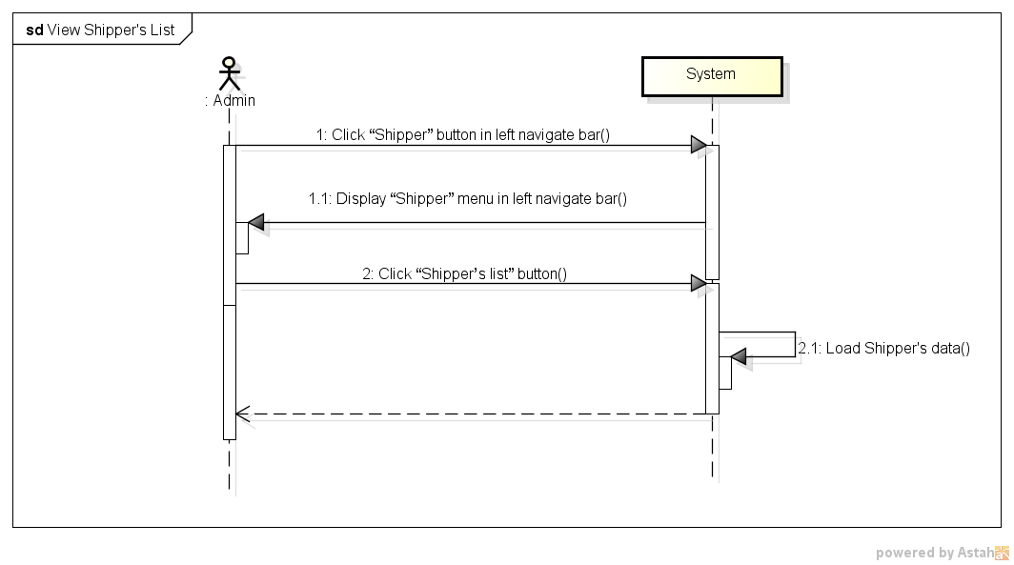

*Figure 11: Sequence Diagram for View Shipper List Use case*

###### *UC- 115:* *View Order’s list*

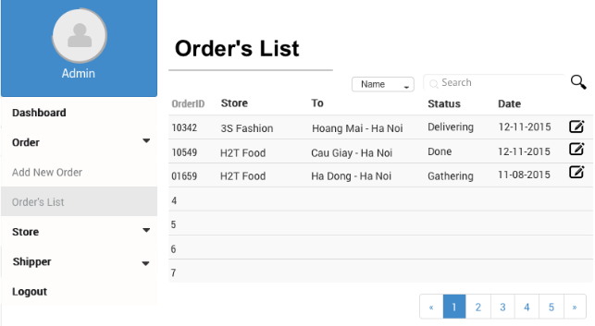

*Figure 11: Screen of View Order’s List Use case*

|  |  |  |  |  |
| --- | --- | --- | --- | --- |
| **Use Case ID:** | | UC-115 | | |
| **Use Case Name:** | | View Order’s list | | |
| **Created By:** | | HoangNK | **Last Updated By:** | HoangNK |
| **Date Created:** | | 19/09/2015 | **Date Last updated:** | 19/09/2015 |
| **Actor:** | | Admin | | |
| **Description:** | | Admin views all Order in a table with basic information (orderID, store’s name, recipient’s address, status, date,..), so after that, Admin can choose an Order to update information | | |
| **Triggering Event:** | | Admin wants to view all Orders | | |
| **Preconditions:** | | Admin logged in to system | | |
| **Post conditions:** | | List of order is displayed | | |
| **Priority:** | | High | | |
| **Frequency of Use:** | | Always | | |
| **Main flow** | | | | |
| Step | Actor | Action | | |
|  | Admin | Clicks “Order” button in left navigate bar | | |
|  | System | Display “Order” menu in left navigate bar includes Add Add New Order, Order’s List | | |
|  | Admin | Clicks “Order’s list” button | | |
|  | System | Load Order's data and display “Order’s List” screen includes   * Search textbox and button * Filter drop-downlist * All Order’s basic information with Update icon buttons | | |
| **Alternative Flows:** | | **N/A** | | |
| **Exceptions:** | | **N/A** | | |
| **Includes:** | | N/A | | |
| **Special Requirements:** | | * The default Order’s list is ordered by Date | | |
| **Notes and Issues:** | | N/A | | |

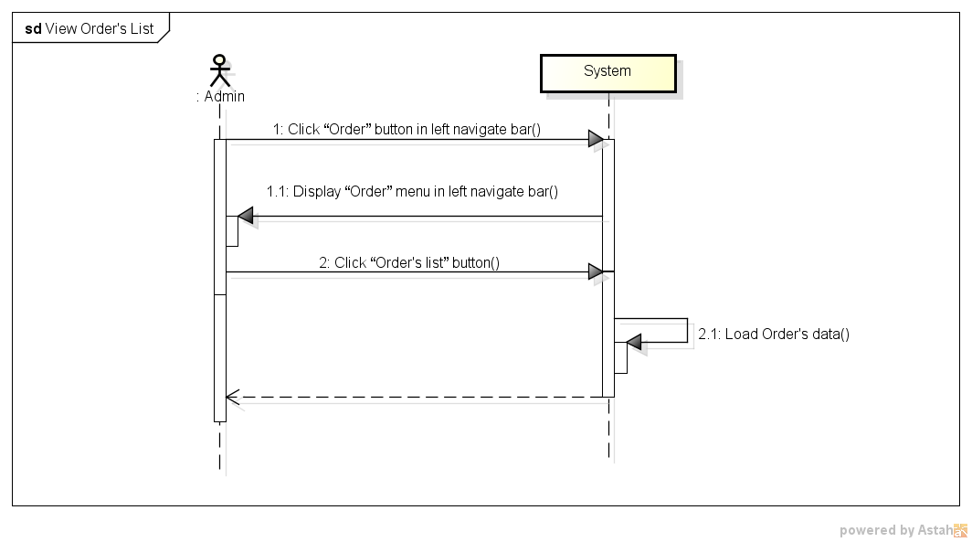***Sequence Diagram***

*Figure 11: Sequence Diagram for View Order’s List Use case*

###### *UC- 117:* *Search Shipper*



*Figure 11: Screen of Search Shipper Use case*

|  |  |  |  |  |
| --- | --- | --- | --- | --- |
| **Use Case ID:** | | UC-116 | | |
| **Use Case Name:** | | Search Shipper | | |
| **Created By:** | | HoangNK | **Last Updated By:** | HoangNK |
| **Date Created:** | | 19/09/2015 | **Date Last updated:** | 19/09/2015 |
| **Actor:** | | Admin | | |
| **Description:** | | Admin wants the system to list all Shipper related to a specific keyword and type, after that, Admin can choose a Shipper to update information | | |
| **Triggering Event:** | | Admin wants to search Shipper | | |
| **Preconditions:** | | Admin is in view shipper’s list page ( refer case UC-114 ) | | |
| **Post conditions:** | | Display Shipper as result of search | | |
| **Priority:** | | High | | |
| **Frequency of Use:** | | Always | | |
| **Main flow** | | | | |
| Step | Actor | Action | | |
|  | Admin | Choose type of Shipper: Name, Address or ID | | |
|  | Admin | Enter text to “Search” text box | | |
|  | Admin | Clicks “Search” button or press “Enter” | | |
|  | System | Get Shipper's data and display result on screen includes:   * Search textbox and button * Filter drop-downlist * Related Shipper’s basic information with Update icon button | | |
| **Alternative Flows:** | | N/A | | |
| **Exceptions:** | | N/A | | |
| EC1 | At step 3, Admin doesn’t choose any type | | | |
| Step | Actor | Action | | |
| 3.1 | System | Set Name is default type | | |
| **Includes:** | | N/A | | |
| **Special Requirements:** | | * Result of search is case insensitive * Types of search are Name, Address and ID | | |
| **Notes and Issues:** | | N/A | | |

***Sequence Diagram***

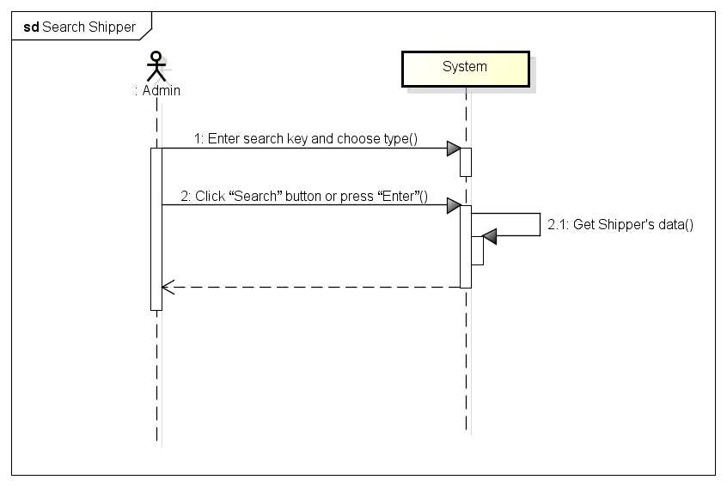

*Figure 11: Sequence Diagram for Search Shipper Use case*

###### *UC- 117:* *Search Order*



*Figure 11: Screen of Search Order Use case*

|  |  |  |  |  |
| --- | --- | --- | --- | --- |
| **Use Case ID:** | | UC-117 | | |
| **Use Case Name:** | | Search Order | | |
| **Created By:** | | HoangNK | **Last Updated By:** | HoangNK |
| **Date Created:** | | 19/09/2015 | **Date Last updated:** | 19/09/2015 |
| **Actor:** | | Admin | | |
| **Description:** | | Admin wants the system to list all Order related to a specific keyword and type, after that, Admin can choose an Order to update information | | |
| **Triggering Event:** | | Admin wants to search Order | | |
| **Preconditions:** | | Admin is in view order’s list page ( refer case UC-115 ) | | |
| **Post conditions:** | | Display Order as result of search | | |
| **Priority:** | | High | | |
| **Frequency of Use:** | | Always | | |
| **Main flow** | | | | |
| Step | Actor | Action | | |
|  | Admin | Choose type of Order: Type, Address, Date, Store’s name or Shipper’s name | | |
|  | Admin | Enter text to “Order” text box | | |
|  | Admin | Clicks “Order” button or press “Enter” | | |
|  | System | Get Shipper's data and display result on screen includes   * Search textbox and button * Filter drop-downlist * Related Order’s basic information with Update icon button | | |
| **Alternative Flows:** | | N/A | | |
| **Exceptions:** | | N/A | | |
| EC1 | At step 3, Admin doesn’t choose any type | | | |
| Step | Actor | Action | | |
| 3.1 | System | Set All is default type | | |
| **Includes:** | | N/A | | |
| **Special Requirements:** | | * Result of search is case insensitive * Types of search are Name, Address and ID | | |
| **Notes and Issues:** | | N/A | | |

***Sequence Diagram***

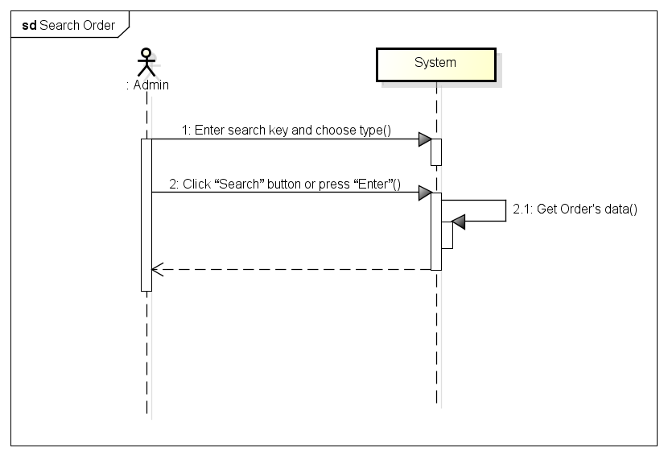

*Figure 11: Sequence Diagram for Search Order Use case*

###### *UC- 118:* *View Shipper’s profile*

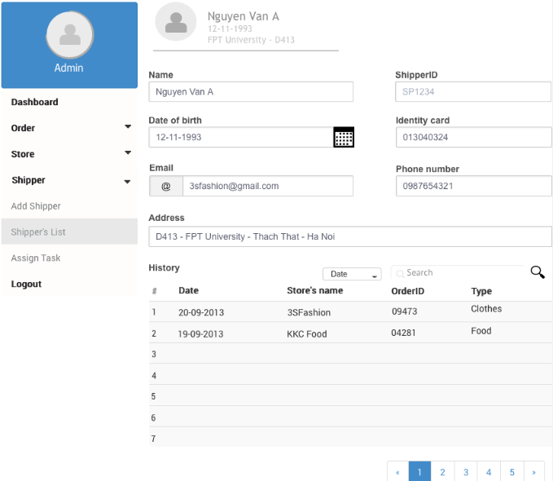

|  |  |  |  |  |
| --- | --- | --- | --- | --- |
| **Use Case ID:** | | UC-118 | | |
| **Use Case Name:** | | View Shipper’s profile | | |
| **Created By:** | | HoangNK | **Last Updated By:** | HoangNK |
| **Date Created:** | | 19/09/2015 | **Date Last updated:** | 24/09/2015 |
| **Actor:** | | Admin | | |
| **Description:** | | Admin views all Shipper’s details (address, name, date of birth, phone number, email, address, shipping history…), so after that, Admin can update Shipper information | | |
| **Triggering Event:** | | Admin wants to view profile of a Shipper | | |
| **Preconditions:** | | Admin is in view shipper’s list page ( refer case UC-114 ) | | |
| **Post conditions:** | | Profile of Shipper is displayed | | |
| **Priority:** | | Normal | | |
| **Frequency of Use:** | | Sometime | | |
| **Main flow** | | | | |
| Step | Actor | Action | | |
|  | Admin | Clicks Shipper’s name in row (hyperlink) | | |
|  | System | Load data of selected Shipper and display “View Shipper’s profile” screen includes information of address, name, date of birth, phone number, email, address, shipping history… and Update button | | |
| **Alternative Flows:** | | N/A | | |
| **Exceptions:** | | N/A | | |
| **Includes:** | | N/A | | |
| **Special Requirements:** | | N/A | | |
| **Notes and Issues:** | | N/A | | |

***Sequence Diagram***

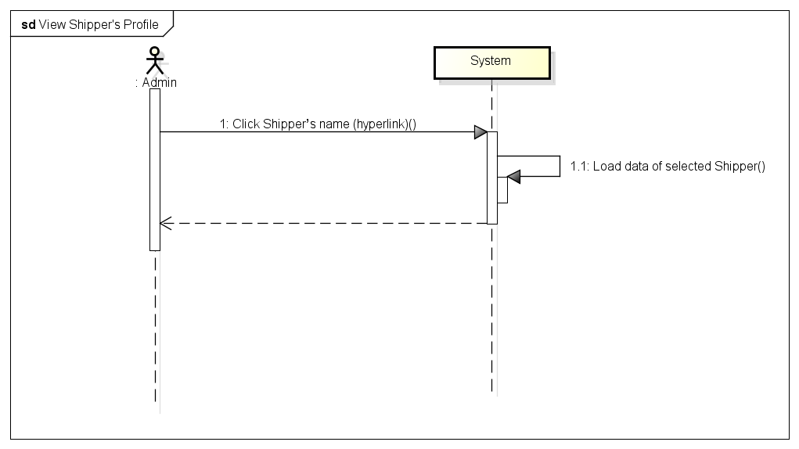

*Figure 11: Sequence Diagram of View Shipper’s Profile Use case*

###### *UC- 119:* *View Order’s details*

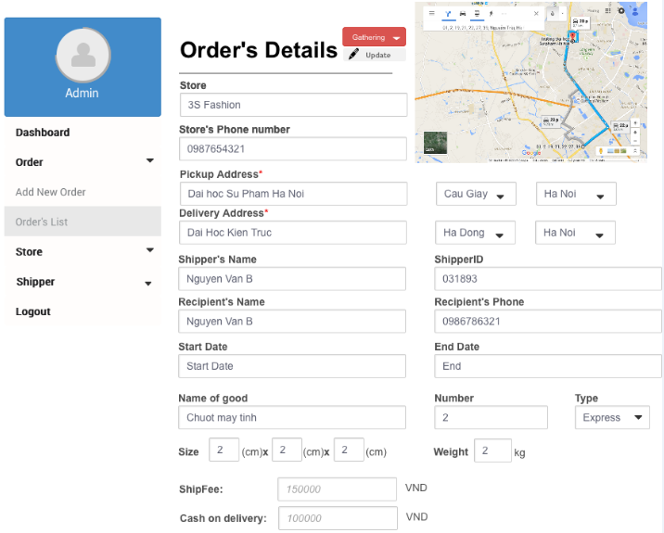

|  |  |  |  |  |
| --- | --- | --- | --- | --- |
| **Use Case ID:** | | UC-119 | | |
| **Use Case Name:** | | View Order’s details | | |
| **Created By:** | | HoangNK | **Last Updated By:** | HoangNK |
| **Date Created:** | | 19/09/2015 | **Date Last updated:** | 19/09/2015 |
| **Actor:** | | Admin | | |
| **Description:** | | Admin views all Order’s details (status of the order , store’s name, pickup and delivery address and date, shipper’s name, recipient’s name, recipient’s phone, goods, type of delivery, size, fee, cash on delivery, …), so after that, Admin can update Shipper information | | |
| **Triggering Event:** | | Admin wants to view all information of the Order | | |
| **Preconditions:** | | Admin is in view shipper’s list page ( refer case UC-115) | | |
| **Post conditions:** | | Details of Order is displayed | | |
| **Priority:** | | Normal | | |
| **Frequency of Use:** | | Sometime | | |
| **Main flow** | | | | |
| Step | Actor | Action | | |
|  | Admin | Clicks Order’s name in row (hyperlink) | | |
|  | System | Load data of selected Order and display to “View Order’s details” screen includes information of status of the order , store’s name, pickup and delivery address and date, shipper’s name, recipient’s name, recipient’s phone, goods, type of delivery, size, fee, cash on delivery, … | | |
| **Alternative Flows:** | | N/A | | |
| **Exceptions:** | | N/A | | |
| **Includes:** | | N/A | | |
| **Special Requirements:** | | N/A | | |
| **Notes and Issues:** | | N/A | | |

***Sequence Diagram***

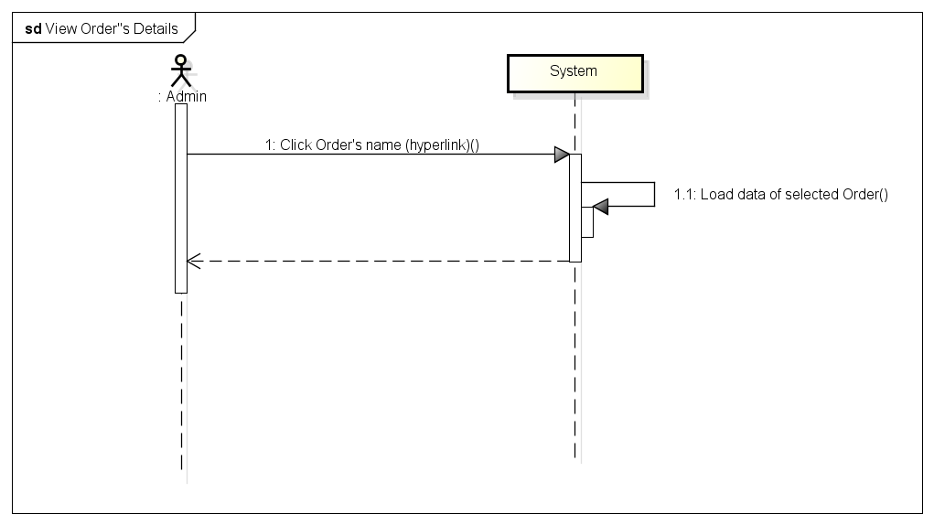

*Figure 11: Sequence Diagram for View Order Details Use case*

###### *UC- 120:* *Update Shipper*

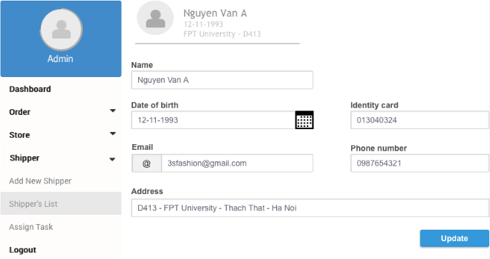

|  |  |  |  |  |
| --- | --- | --- | --- | --- |
| **Use Case ID:** | | UC-120 | | |
| **Use Case Name:** | | Update Shipper | | |
| **Created By:** | | HoangNK | **Last Updated By:** | HoangNK |
| **Date Created:** | | 19/09/2015 | **Date Last updated:** | 19/09/2015 |
| **Actor:** | | Admin | | |
| **Description:** | | Admin modifies an existed Shipper with related information about name, date of birth, identity card, email, phone number, address,.. | | |
| **Triggering Event:** | | Admin wants to update Shipper’s information | | |
| **Preconditions:** | | Admin is in view shipper’s list page ( refer case UC-114) | | |
| **Post conditions:** | | Information of Shipper is updated in database | | |
| **Priority:** | | Normal | | |
| **Frequency of Use:** | | Sometime | | |
| **Main flow** | | | | |
| Step | Actor | Action | | |
|  | Admin | Clicks icon “Update” button | | |
|  | System | Get data of selected Shipper and display “Update Shipper” screen includes textbox of information about name, date of birth, identity card, email, phone number, address,.. | | |
|  | Admin | Enter new information to fields then clicks “Update” button | | |
|  | System | Validate input | | |
|  | System | Update Shipper’s new information to database then redirects to Shipper’s profile page | | |
| **Alternative Flows:** | |  | | |
| AT1 | At step 1, if admin clicks “View Shipper’s profile” | | | |
| Step | Actor | Action | | |
| 1 | Admin | Clicks Shipper’s name in row (hyperlink) | | |
| 2 | System | Display “View Shipper’s profile” screen | | |
| 3 | Admin | Clicks “Update” button below avatar | | |
| 4 | System | Go to step 6 of main flow and continue | | |
| **Exceptions:** | | | | |
| EC1 | At step 4, if any required field is not entered | | | |
| Step | Actor | Action | | |
| 4.1 | System | Notify by error message in screen “* is required” | | |
| EC2 | At step 4, if any entered field is incorrect format | | | |
| Step | Actor | Action | | |
| 4.1 | System | Notify by error message in screen “* is incorrect format” | | |
| **Includes:** | | N/A | | |
| **Special Requirements:** | | * The field with ‘*’ can’t be blank | | |
| **Notes and Issues:** | | N/A | | |

***Sequence Diagram***

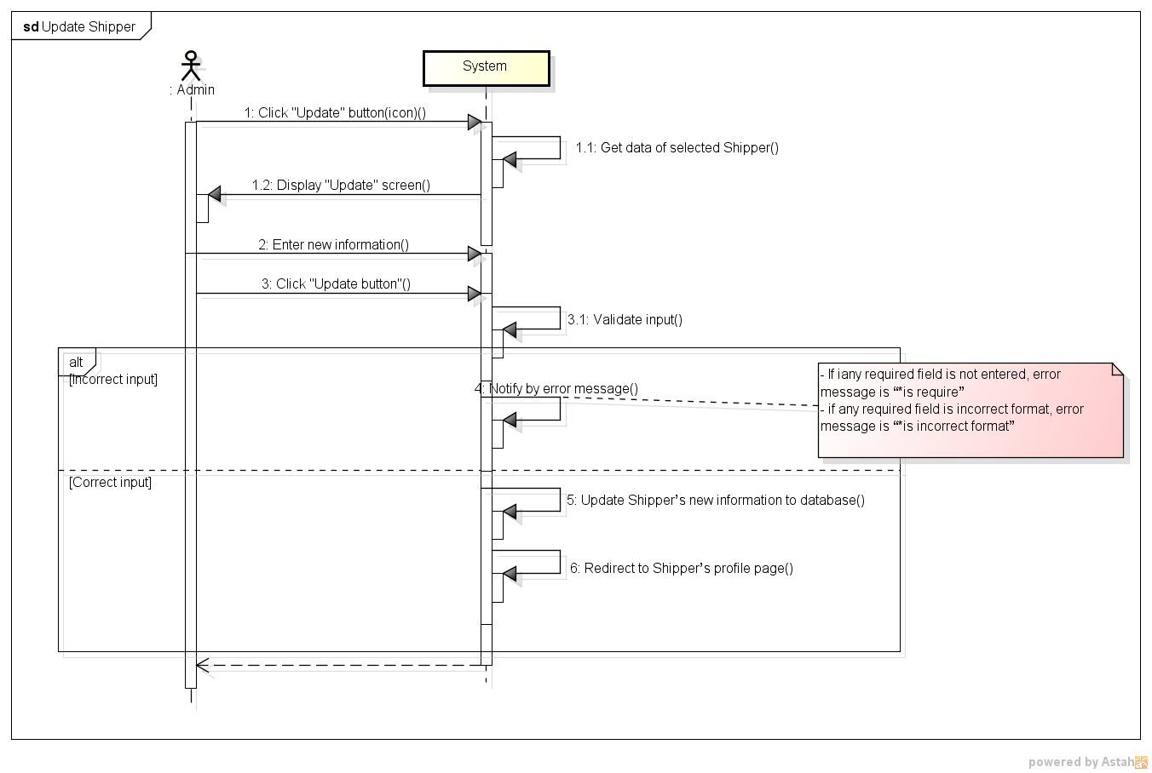

*Figure 11: Sequence Diagram for Update Shipper Use case*

###### *UC- 121:* *Update Order*

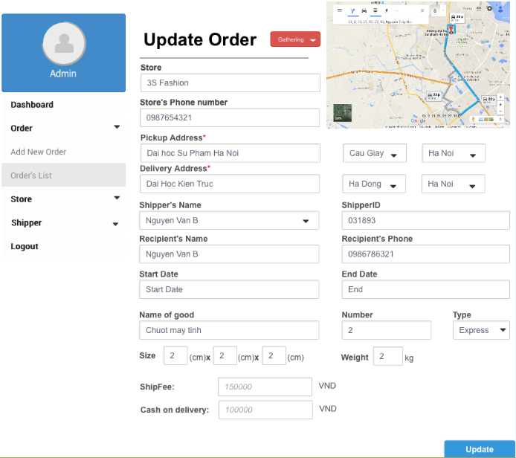

|  |  |  |  |  |
| --- | --- | --- | --- | --- |
| **Use Case ID:** | | UC-121 | | |
| **Use Case Name:** | | Update Order | | |
| **Created By:** | | HoangNK | **Last Updated By:** | HoangNK |
| **Date Created:** | | 19/09/2015 | **Date Last updated:** | 19/09/2015 |
| **Actor:** | | Admin | | |
| **Description:** | | Admin modifies an existed Order with related information about status of the order, store’s name, pickup and delivery address and date, shipper’s name, recipient’s name, recipient’s phone, goods, type of delivery, size, fee, cash on delivery, … | | |
| **Triggering Event:** | | Admin wants to update Order’s information | | |
| **Preconditions:** | | Admin is in view shipper’s list page ( refer case UC-115) | | |
| **Post conditions:** | | Information of Order is updated | | |
| **Priority:** | | Normal | | |
| **Frequency of Use:** | | Sometime | | |
| **Main flow** | | | | |
| Step | Actor | Action | | |
|  | Admin | Clicks “Update” button | | |
|  | System | Get data of selected Order and display “Update Order” screen includes textbox of status of the order, store’s name, pickup and delivery address and date, shipper’s name, recipient’s name, recipient’s phone, goods, type of delivery, size, fee, cash on delivery, … and Update button | | |
|  | Admin | Enter new information to fields then clicks “Update” button | | |
|  | System | Validate input | | |
|  | System | Update Order’s new information to database then redirects to Order’s details page | | |
| **Alternative Flows:** | |  | | |
| AT1 | At step 1, if admin clicks “View Order’s details” | | | |
| Step | Actor | Action | | |
| 1 | Admin | Clicks Order’s name in row (hyperlink) | | |
| 2 | System | Display “View Order’s details” screen | | |
| 3 | Admin | Clicks “Update” button below avatar | | |
| 4 | System | Go to step 6 of main flow and continue | | |
| **Exceptions:** | | | | |
| EC1 | At step 4, if any required field is not entered | | | |
| Step | Actor | Action | | |
| 4.1 | System | Notify by error message “* is required” in screen | | |
| EC2 | At step 4, if any entered field is incorrect format | | | |
| Step | Actor | Action | | |
| 4.1 | System | Notify by error message “* is incorrect format” in screen | | |
| **Includes:** | | N/A | | |
| **Special Requirements:** | | * The field with ‘*’ can’t be blank | | |
| **Notes and Issues:** | | N/A | | |

***Sequence Diagram***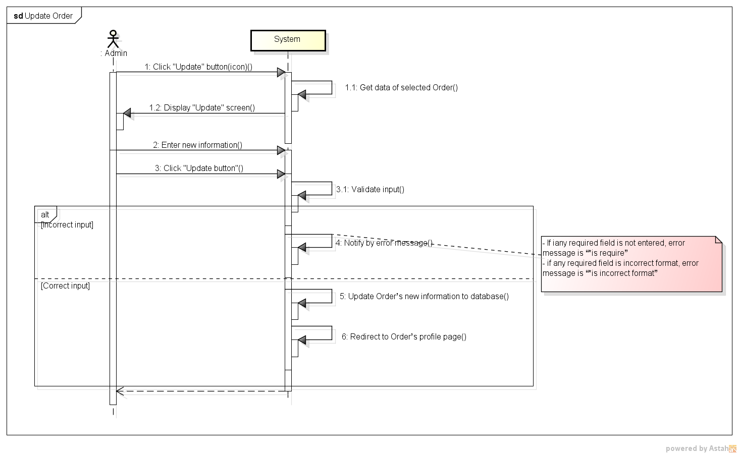

*Figure 11: Sequence Diagram for Update Order Use case*

###### *UC- 122:* *Add new Order*

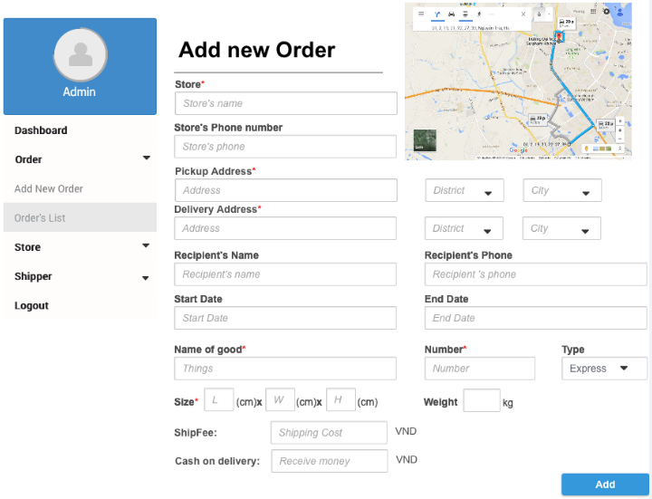

|  |  |  |  |  |
| --- | --- | --- | --- | --- |
| **Use Case ID:** | | UC-122 | | |
| **Use Case Name:** | | Add Order | | |
| **Created By:** | | HoangNK | **Last Updated By:** | HoangNK |
| **Date Created:** | | 19/09/2015 | **Date Last updated:** | 19/09/2015 |
| **Actor:** | | Admin | | |
| **Description:** | | Admin creates a new Order for Store with related information | | |
| **Triggering Event:** | | Admin wants to add a new Order to system | | |
| **Preconditions:** | | Admin logged in to system | | |
| **Post conditions:** | | New Order is added to database | | |
| **Priority:** | | Low | | |
| **Frequency of Use:** | | Sometime | | |
| **Main flow** | | | | |
| Step | Actor | Action | | |
|  | Admin | Clicks “Order” button in left navigate bar | | |
|  | System | Display “Order” menu includes Add New Order, Order’s List | | |
|  | Admin | Clicks “Add new Order” button | | |
|  | System | Display “Add new Order” form includes textbox of store’s name, pickup and delivery address and date, shipper’s name, recipient’s name, recipient’s phone, goods, type of delivery, size, fee, cash on delivery, … and Add button | | |
|  | Admin | Enter new Order’s information into fields | | |
|  | Admin | Clicks “Add” button to add new Order | | |
|  | System | Validate input | | |
|  | System | Add new Shipper to database then redirects to “Shipper’s List” page | | |
| **Alternative Flows:** | | N/A | | |
| **Exceptions:** | | | | |
| EC1 | At step 7, if any required field is not entered | | | |
| Step | Actor | Action | | |
| 7.1 | System | Notify in screen by error message “*is require” | | |
| EC2 | At step 8, if any entered field is incorrect format | | | |
| Step | Actor | Action | | |
| 7.2 | System | Notify in screen by error message “* is incorrect format” | | |
| **Includes:** | | N/A | | |
| **Special Requirements:** | | * When Admin enters existed Store’s name, store’s address and phone will be generated automatically * The field with ‘*’ can’t be blank | | |
| **Notes and Issues:** | | N/A | | |

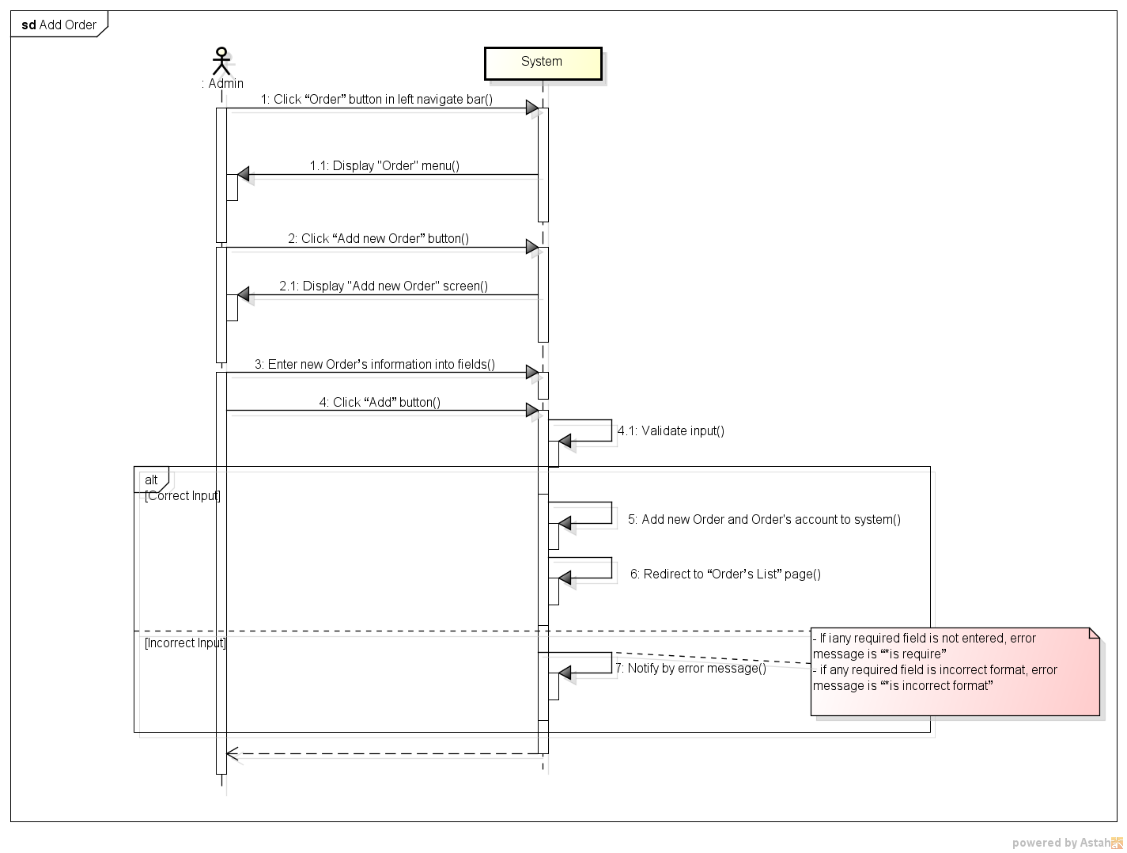***Sequence Diagram***

*Figure 11: Sequence Diagram for Add Order Use case*

###### *UC- 123:* Export Bill



|  |  |  |  |  |
| --- | --- | --- | --- | --- |
| **Use Case ID:** | | UC-123 | | |
| **Use Case Name:** | | Export Bill | | |
| **Created By:** | | HoangNK | **Last Updated By:** | HoangNK |
| **Date Created:** | | 19/09/2015 | **Date Last updated:** | 19/09/2015 |
| **Actor:** | | Admin | | |
| **Description:** | | Admin chooses store to export to pdf file to print or send to Store, the content of pdf file contains transaction history of this Store so it can show to store how much money that store needs to pay | | |
| **Triggering Event:** | | Admin wants to export bills to pdf file | | |
| **Preconditions:** | | Admin is in view store’s list page ( refer case UC-107 ) | | |
| **Post conditions:** | | An PDF file is exported | | |
| **Priority:** | | Medium | | |
| **Frequency of Use:** | | Sometime | | |
| **Main flow** | | | | |
| Step | Actor | Action | | |
|  | Admin | Clicks icon “Export” button | | |
|  | System | Show File Chooser dialog for Admin | | |
|  | Admin | Choose location (directory) for exported file | | |
|  | System | Export these orders to PDF file to location | | |
| **Alternative Flows:** | | N/A | | |
| **Exceptions:** | | | | |
| EC1 | At step 3, if Admin doesn’t choose any folder | | | |
| Step | Actor | Action | | |
| 3.1 | System | Stop exporting file | | |
| **Includes:** | | N/A | | |
| **Special Requirements:** | | * Exported file must be in pdf format * System must display only directory for saving exported file | | |
| **Notes and Issues:** | | N/A | | |

***Sequence Diagram***

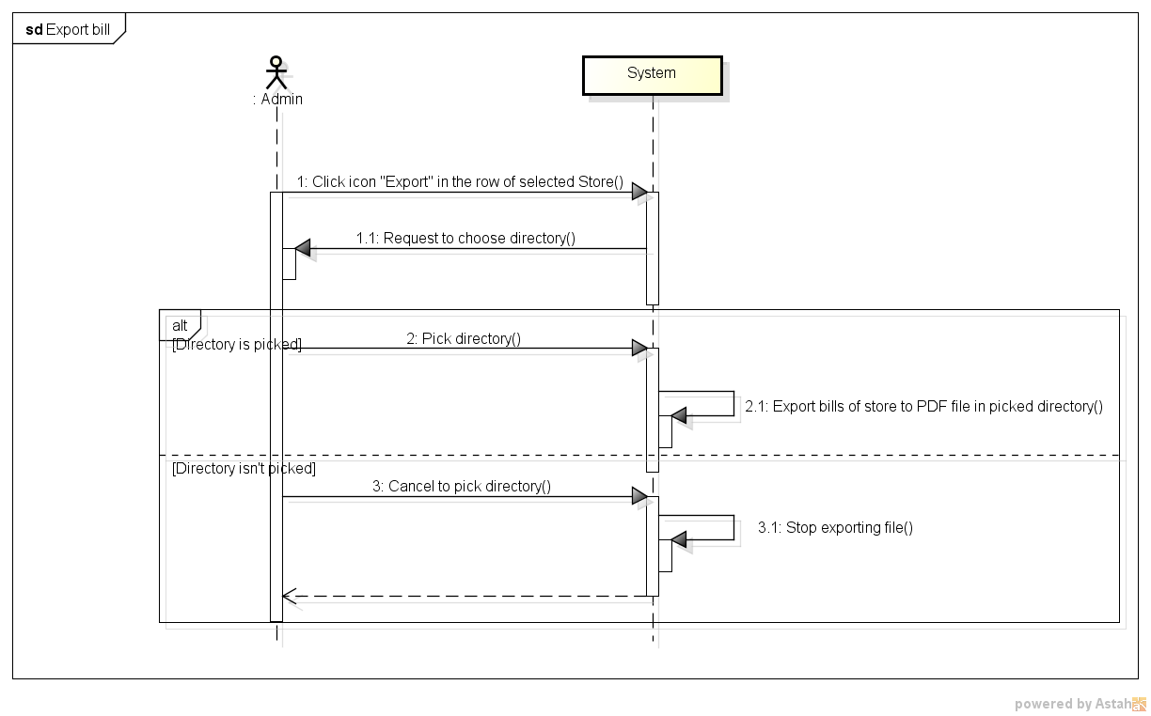

*Figure 11: Sequence Diagram for Export bill Use case*

###### *UC- 124:* *Assign Task*

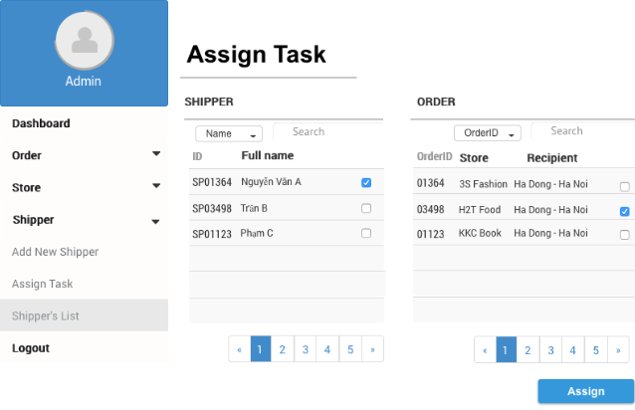

|  |  |  |  |  |
| --- | --- | --- | --- | --- |
| **Use Case ID:** | | UC-124 | | |
| **Use Case Name:** | | Assign Task | | |
| **Created By:** | | HoangNK | **Last Updated By:** | HoangNK |
| **Date Created:** | | 19/09/2015 | **Date Last updated:** | 19/09/2015 |
| **Actor:** | | Admin | | |
| **Description:** | | Admin assigns orders which hasn’t been assign for any Shipper to available Shipper | | |
| **Triggering Event:** | | Admin wants to assign task for Shipper | | |
| **Preconditions:** | | Admin logged in to system | | |
| **Post conditions:** | | Task is assigned for Shipper | | |
| **Priority:** | | High | | |
| **Frequency of Use:** | | Often | | |
| **Main flow** | | | | |
| Step | Actor | Action | | |
|  | Admin | Clicks “Shipper” button in left navigate bar | | |
|  | System | Display “Shipper” menu in left navigate bar includes Add Shipper, Assign Task, Shipper’s List | | |
|  | Admin | Clicks “Assign Task” button | | |
|  | System | Get data of Order and Shipper then display “Assign Task” screen includes:   * 2 table of available Shipper and Order with basic information and a checkbox * Search textbox and Filter on each table | | |
|  | Admin | Pick a Shipper in Shipper’s list then pick Order for this Shipper in Order’s list then clicks “Assign” button | | |
|  | System | Hide picked orders from Order’s list and update Shipper’s information in database | | |
| **Alternative Flows:** | | **N/A** | | |
| **Exceptions:** | | | | |
| EC1 | At step 5, if Admin doesn’t pick any order | | | |
| Step | Actor | Action | | |
| 5.1 | System | Order isn’t active to pick and “Assign” button isn’t active to clicks | | |
| EC2 | At step 5, if Admin checks a picked order | | | |
| Step | Actor | Action | | |
| 5.2 | System | Order is showed in order's list | | |
| **Includes:** | | N/A | | |
| **Special Requirements:** | | * Available Shippers are displayed in Shipper’s list * Available Orders are displayed in Order’s list | | |
| **Notes and Issues:** | | N/A | | |

***Sequence Diagram***

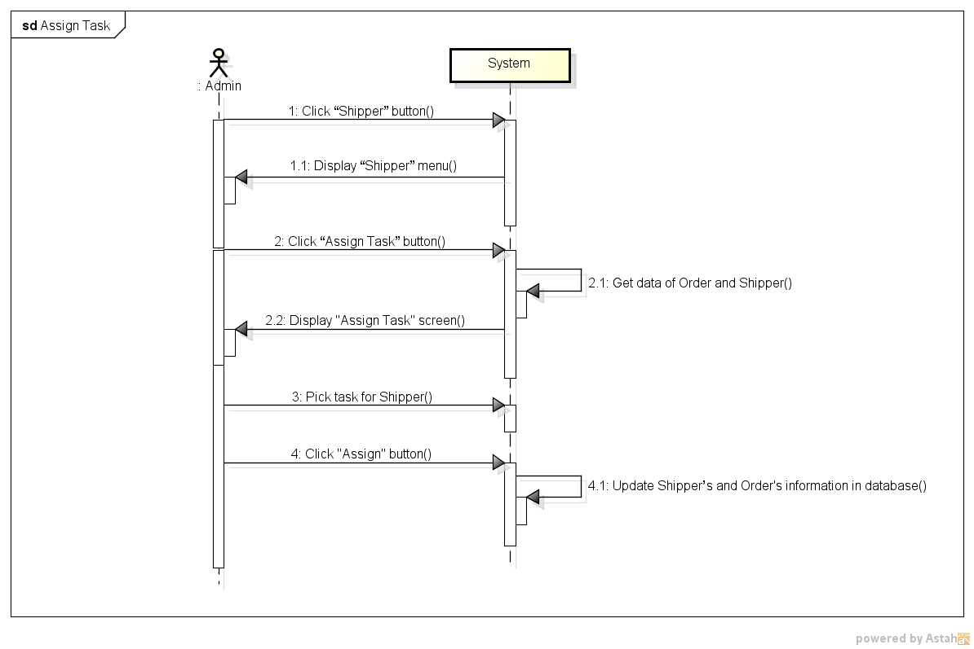

*Figure 11: Sequence Diagram for Assign Task Use case*

###### *UC- 125:* *View Dashboard*

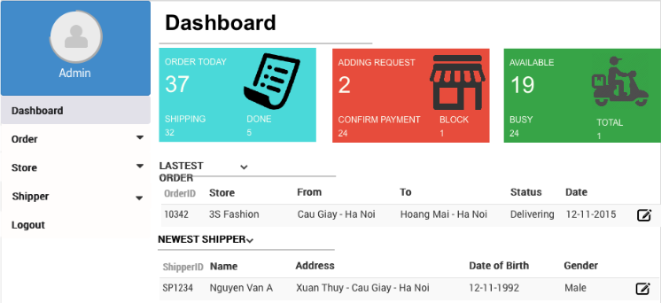

|  |  |  |  |  |
| --- | --- | --- | --- | --- |
| **Use Case ID:** | | UC-125 | | |
| **Use Case Name:** | | View dashboard | | |
| **Created By:** | | HoangNK | **Last Updated By:** | HoangNK |
| **Date Created:** | | 19/09/2015 | **Date Last updated:** | 19/09/2015 |
| **Actor:** | | Admin | | |
| **Description:** | | A view of some statistics about order, shipper, store and other information (latest order, newest shipper,…) is displayed to Admin so Admin has a general view about order, store and shipper | | |
| **Triggering Event:** | | Admin wants to dashboard with the statistics | | |
| **Preconditions:** | | Admin logged in to system | | |
| **Post conditions:** | | Dashboard screen with statistics is displayed | | |
| **Priority:** | | Normal | | |
| **Frequency of Use:** | | Sometime | | |
| **Main flow** | | | | |
| Step | Actor | Action | | |
|  | Admin | Clicks “Dashboard” button in left navigate bar | | |
|  | System | Display “Dashboard” screen includes:   * Statistics of order, shipper and store in box * Latest information about order, shipper in table | | |
| **Alternative Flows:** | | N/A | | |
| **Exceptions:** | | N/A | | |
| **Includes:** | | N/A | | |
| **Special Requirements:** | | N/A | | |
| **Notes and Issues:** | | N/A | | |

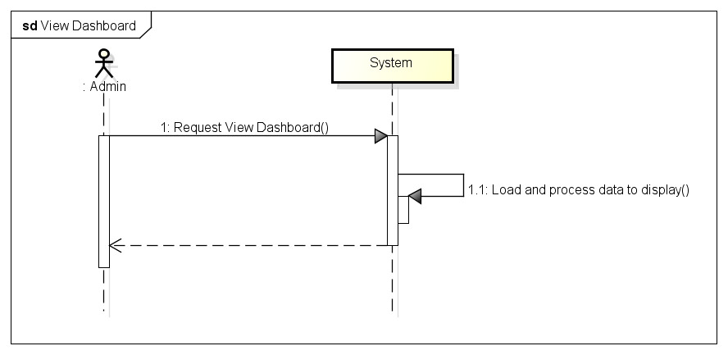***Sequence Diagram***

*Figure 11: Sequence Diagram for View Dashboard Use case*

## 3.2. Web application for Store

### 3.2.1. User Case Diagram

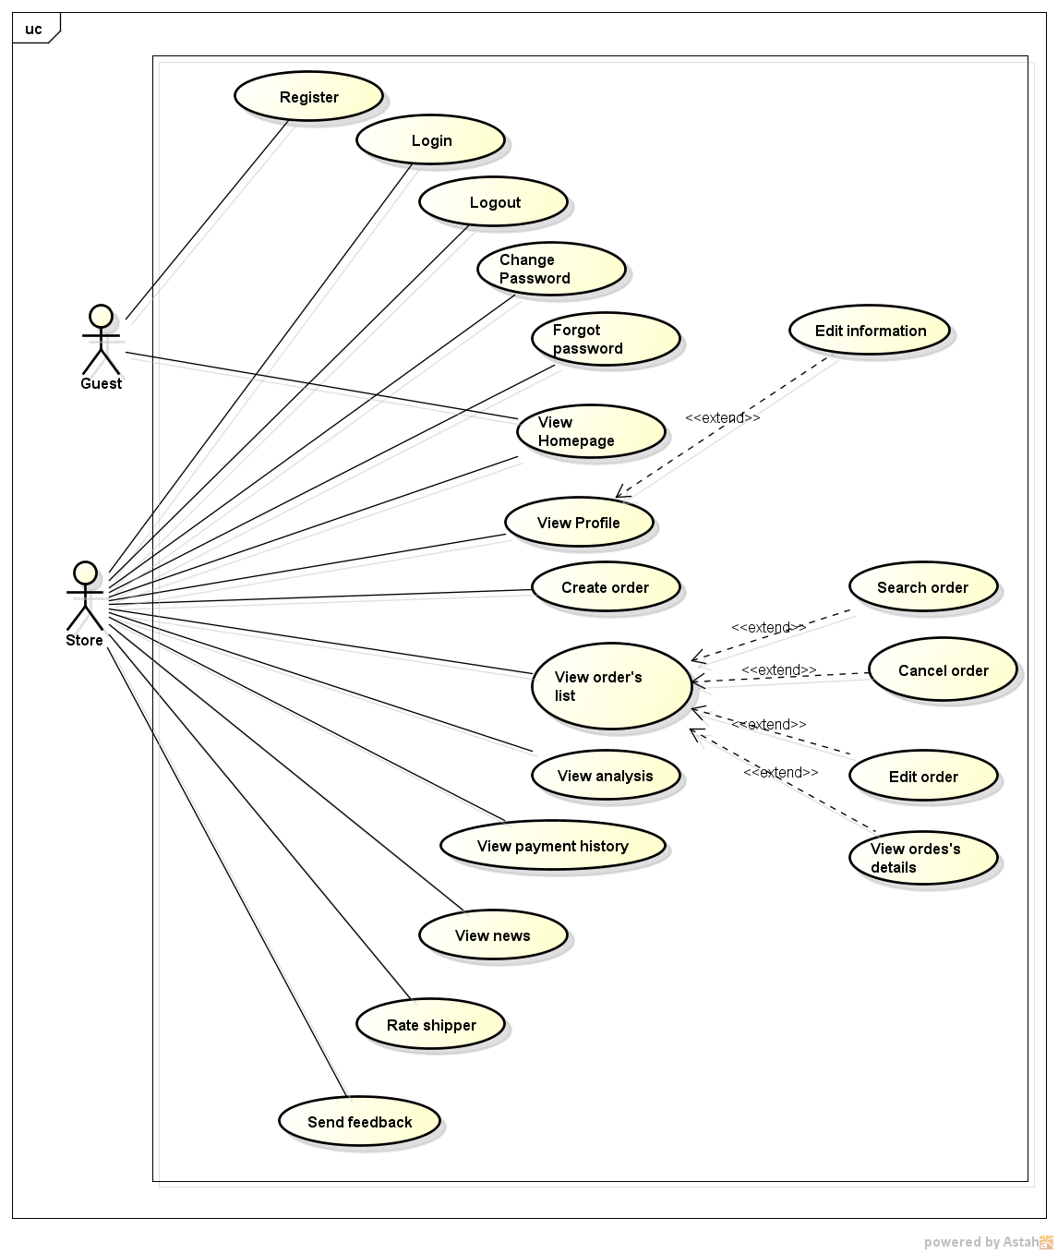

### 3.2.2. Function

###### *UC-201: Register*

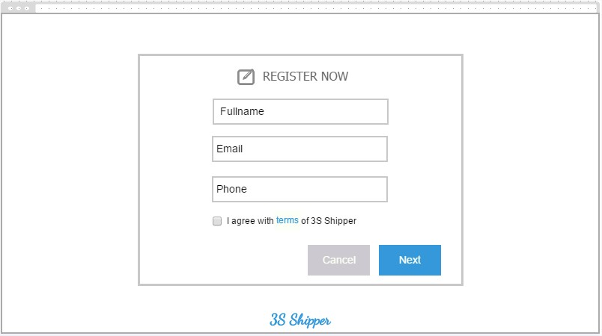

|  |  |  |  |  |
| --- | --- | --- | --- | --- |
| **Use Case ID:** | | UC-201 | | |
| **Use Case Name:** | | Register | | |
| **Created By:** | | KhanhKC | **Last Updated By:** | KhanhKC |
| **Date Created:** | | 19/09/2015 | **Date Last updated:** | 20/09/2015 |
| **Actor:** | | Guest | | |
| **Description:** | | Visitor can creates new account to use more function as a registered Store | | |
| **Triggering event:** | | Guest wants to register a new account. | | |
| **Preconditions:** | | Guest on 3S website | | |
| **Post conditions:** | | - Account’s information have been saved to database  - Confirm email have been send to Guest  - | | |
| **Priority:** | | Normal | | |
| **Frequency of Use:** | | Sometime | | |
| **Main flow** | | | | |
| Step | Actor | Action | | |
|  | Guest | Clicks “Register” | | |
|  | System | Displays “Register” screen includes:  - Full name  - Email text box  - Phone number text box  - Register button  - Cancel button  - “I agree with term of 3S Shipper” check box  - Terms hyperlink. | | |
|  | Guest | Enters data in fields | | |
|  | Guest | Clicks “Register” | | |
|  | System | Validate entered data. | | |
|  | System | Sends confirm email to Guest | | |
|  | System | Displays “Confirm Registered” message. “Thank you for register. Your request has been send to admin. Please wait for activation” | | |
| **Alternative Flows:** | | N/A | | |
| **Exceptions:** | | | | |
| EC1 | Store Clicks “Cancel” button | | | |
| Step | Actor | Action | | |
| 1.1 | Store | Clicks “Cancel” button. | | |
| 1.1 | System | Displays “Confirm” popup | | |
| 1.2 | Store | Clicks “Yes” button | | |
| 1.3 | System | Displays “Homepage” for Guest | | |
| EC2 | At step 1.2, Store Clicks on “No” button. | | | |
| Step | Actor | Action | | |
| 1.2.1 | Store | Clicks “No” button. | | |
| 1.2.2 | System | Closes popup. | | |
| EC3 | At step 4, required fields are not entered | | | |
| Step | Actor | Action | | |
| 4.1 | Store | Clicks “Register” button | | |
| 4.2 | System | Displays error message on “Register” screen “*is require” | | |
| EC4 | At step 5, entered data are wrong type of data | | | |
| Step | Actor | Action | | |
| 4.1 | Store | Clicks “Register” button | | |
| 4.2 | System | Displays error message at wrong fields: “Wrong format of data” | | |
| **Includes:** | | N/A | | |
| **Special Requirements:** | | * Username must not yet exist in database. * Length of Phone must between 8 and 11. * Email must be under the standard format. | | |
| **Notes and Issues:** | | N/A | | |

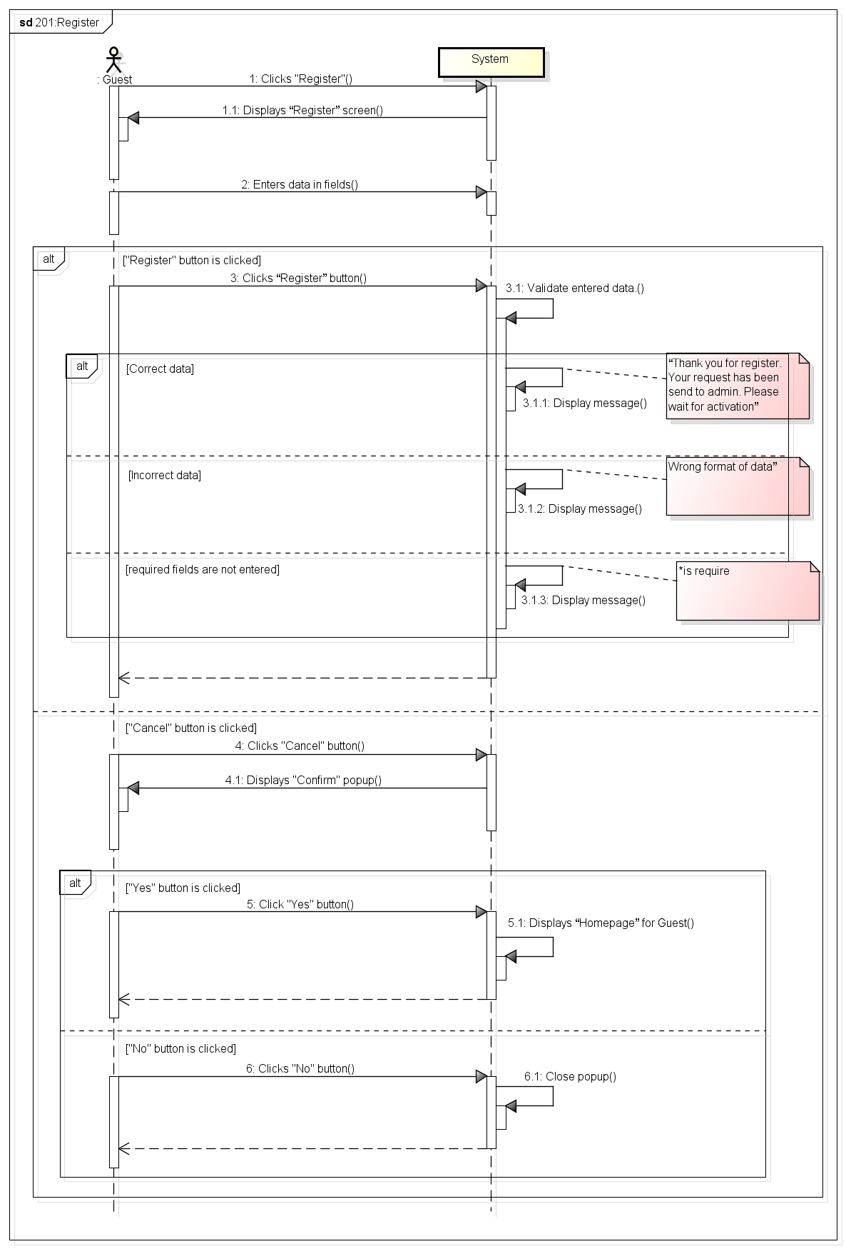***Sequence Diagram***

###### *UC-202:* *Login*



|  |  |  |  |  |
| --- | --- | --- | --- | --- |
| **Use Case ID:** | | UC-202 | | |
| **Use Case Name:** | | Login | | |
| **Created By:** | | KhanhKC | **Last Updated By:** | KhanhKC |
| **Date Created:** | | 19/09/2015 | **Date Last Updated:** | 20/09/2015 |
| **Actor:** | | Store | | |
| **Description:** | | Users who are not logged in to system can only view the “Homepage”. Store needs to logins to system to use functions of system. | | |
| **Triggering event:** | | Store wants to login to system | | |
| **Preconditions:** | | Store is on the “Homepage” of 3S website  Store account must be exits | | |
| **Post conditions:** | | Logs Store into system  Redirects Store to “Homepage” screen (Refer to UC-218: View Homepage) and displays as Store | | |
| **Priority:** | | High | | |
| **Frequency of Use:** | | Sometime | | |
| **Main flow** | | | | |
| Step | Actor | Action | | |
|  | Store | Enters User name and Password | | |
|  | Store | Clicks “Login” | | |
|  | System | Check “Username” and “Password” in database. | | |
|  | System | Logs Store into system | | |
|  | System | Redirects to “Homepage” screen and displays as Store | | |
| **Alternative:** | | | | |
| **Exceptions:** | | | | |
| EC1 | At step 3 in main flow, if Store entered wrong User name or Password | | | |
| Step | Actor | Action | | |
| 3.1 | System | Displays message “Username or Password is wrong” | | |
| **Includes:** | | N/A | | |
| **Special Requirements:** | | N/A | | |
| **Notes and Issues:** | | N/A | | |

***Sequence Diagram***

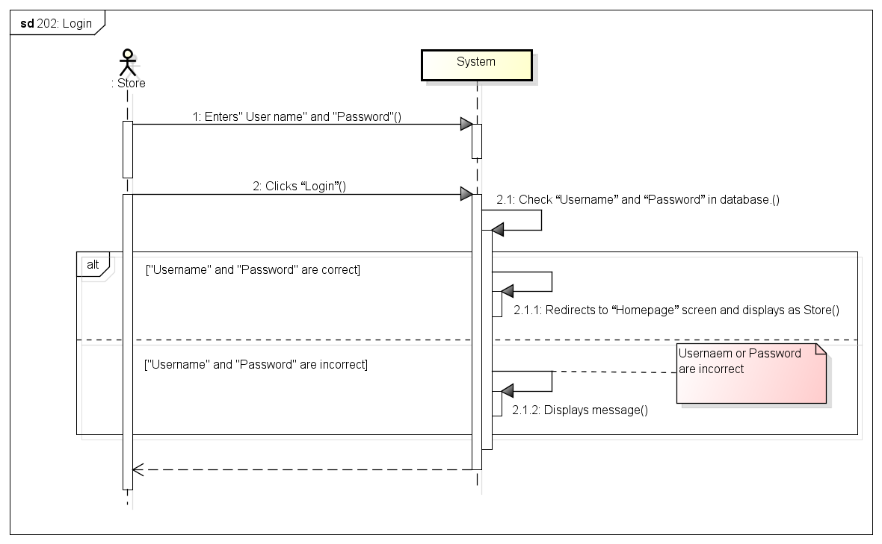

###### *UC-203:* *Logout*



|  |  |  |  |  |
| --- | --- | --- | --- | --- |
| **Use Case ID:** | | UC-203 | | |
| **Use Case Name:** | | Logout | | |
| **Created By:** | | KhanhKC | **Last Updated By:** | KhanhKC |
| **Date Created:** | | 19/09/2015 | **Date Last updated:** | 20/09/2015 |
| **Actor:** | | Store | | |
| **Description:** | | When Store logouts from system, Store will cannot continue using functions of system. Store needs to login again to be able to use the function of system. | | |
| **Triggering event:** | | Store wants to logout from system. | | |
| **Preconditions:** | | Store logged in to system | | |
| **Post conditions:** | | Logs Store out from system.  Redirects Store to “Login” screen | | |
| **Priority:** | | High | | |
| **Frequency of Use:** | | Often | | |
| **Main flow** | | | | |
| Step | Actor | Action | | |
|  | Store | Clicks Logout | | |
|  | System | Logouts Store from system | | |
|  | System | Displays Homepage for Guest | | |
| **Alternative Flows:** | | | | |
| **Exceptions:** | | N/A | | |
| **Includes:** | | N/A | | |
| **Special Requirements:** | | N/A | | |
| **Notes and Issues:** | | N/A | | |

***Sequence Diagram***

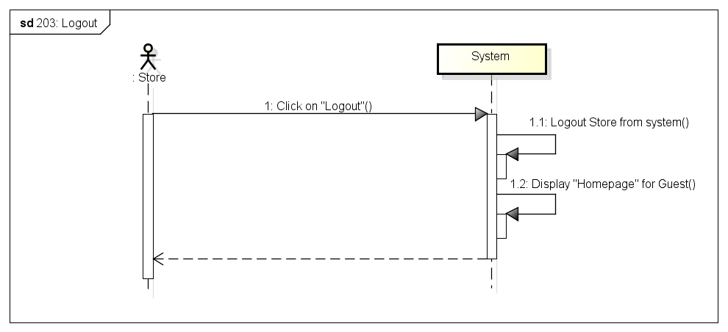

###### *UC-204: Change password*



|  |  |  |  |  |
| --- | --- | --- | --- | --- |
| **Use Case ID:** | | UC-204 | | |
| **Use Case Name:** | | Change password | | |
| **Created By:** | | KhanhKC | **Last Updated By:** | KhanhKC |
| **Date Created:** | | 19/09/2015 | **Date Last updated:** | 20/09/2015 |
| **Actor:** | | Store | | |
| **Description:** | | Store can change login password but Store need to remember old password. | | |
| **Triggering event:** | | Store wants to change password. | | |
| **Preconditions:** | | Store logged in to system | | |
| **Post conditions:** | | New password has been saved in database. | | |
| **Priority:** | | High | | |
| **Frequency of Use:** | | Sometime | | |
| **Main flow** | | | | |
| Step | Actor | Action | | |
|  | Store | Clicks “Change password” | | |
|  | System | Displays “Change password” screen includes:  - Old password text box  - New password text box  - Confirm new password text box  - Submit button | | |
|  | Store | Enters data in fields | | |
|  | Store | Clicks “Submit” button | | |
|  | System | Validates data | | |
|  | System | Displays “Change password” screen with message “ Changes password successful” | | |
| **Alternative Flows:** | | N/A | | |
| **Exceptions:** | | | | |
| EC1 | At step 4, required fields are not entered | | | |
| Step | Actor | Action | | |
| 4.1 | System | Displays “Change password” screen with error message “*is require” | | |
| EC2 | At step 4, “Old password” is incorrect | | | |
| Step | Actor | Action | | |
| 4.1 | System | Displays “Change password” screen with error message: “Old password is incorrect” | | |
| EC3 | At step 4, confirm new password is not the same with new password | | | |
| Step | Actor | Action | | |
| 4.1 | System | Displays “Change password” screen with error message.” Confirm new password is not the same with new password. Please enter again!” | | |
| **Includes:** | | N/A | | |
| **Special Requirements:** | | Length of “New password” must between 6 and 10. | | |
| **Notes and Issues:** | | N/A | | |

***Sequence Diagram***

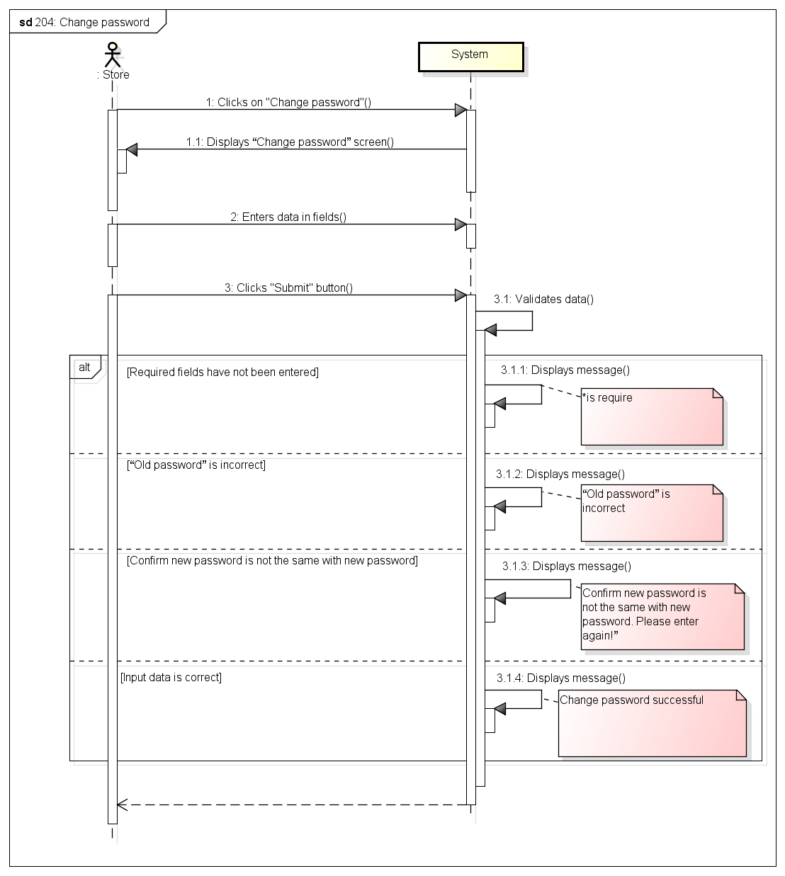

###### *UC-205:* *Forgot password*



|  |  |  |  |  |
| --- | --- | --- | --- | --- |
| **Use Case ID:** | | UC-205 | | |
| **Use Case Name:** | | Forgot password | | |
| **Created By:** | | KhanhKC | **Last Updated By:** | KhanhKC |
| **Date Created:** | | 19/09/2015 | **Date Last updated:** | 20/09/2015 |
| **Actor:** | | Store | | |
| **Description:** | | This function help Store receive their login password when Store forgot. | | |
| **Triggering event:** | | Store requests system to receive new password. | | |
| **Preconditions:** | | Store is on the “Login” popup (Refer to UC-202: Login) | | |
| **Post conditions:** | | - A new password has been updated for Store  - An email has been send to registered email of Store include new password. | | |
| **Priority:** | | High | | |
| **Frequency of Use:** | | Sometime | | |
| **Main flow** | | | | |
| Step | Actor | Action | | |
|  | Store | Clicks “Forgot password” hyperlink on “Login” popup | | |
|  | System | Displays “Forgot password” popup includes:  - Email text box  - Submit button | | |
|  | Guest | Enters registered email. | | |
|  | Guest | Clicks “Submit” button | | |
|  | System | Validates data | | |
|  | System | Updates a new password for Store | | |
|  | System | Sends the new password to registered email of Store | | |
|  | System | Displays message : “Please check your email to get your new password” | | |
| **Alternative Flows:** | | N/A | | |
| **Exceptions:** | | | | |
| EC1 | At step 3, email are not a registered email | | | |
| Step | Actor | Actor | | |
| 4.1 | System | Displays error message:” Email is not exist” | | |
| **Includes:** | | N/A | | |
| **Special Requirements:** | | N/A | | |
| **Notes and Issues:** | | N/A | | |

***Sequence Diagram***

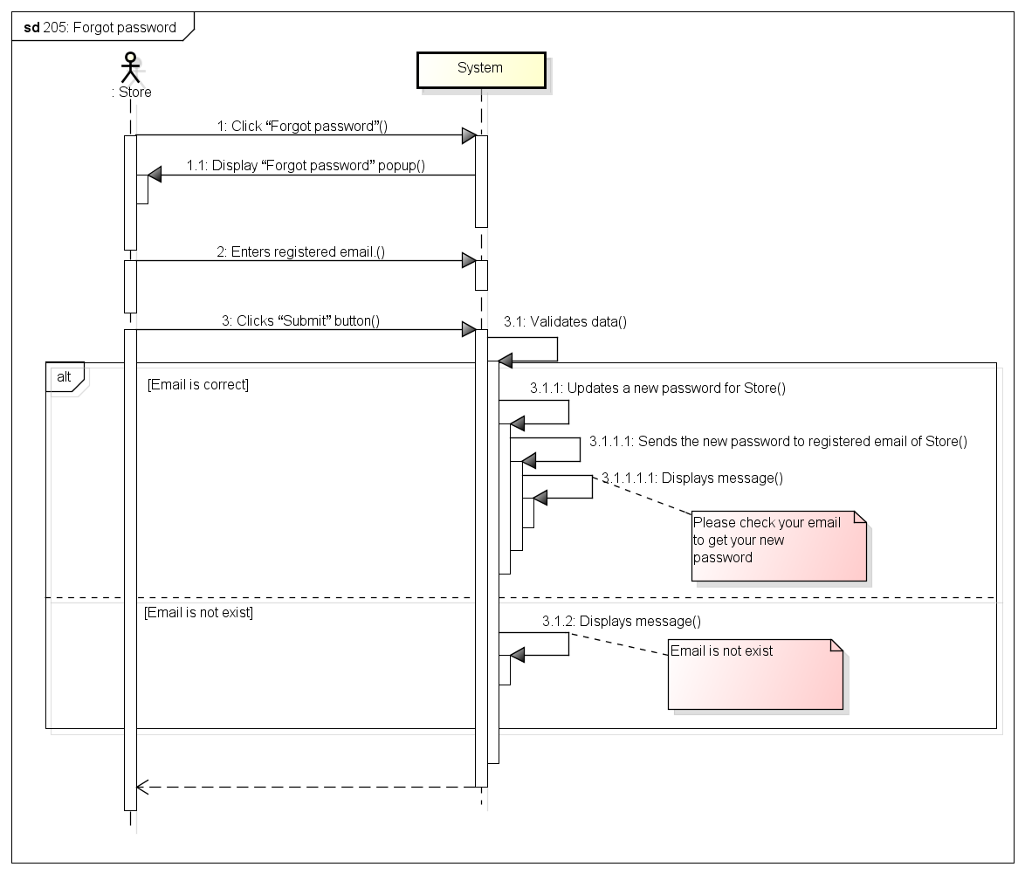

###### *UC-206:* *View profile*

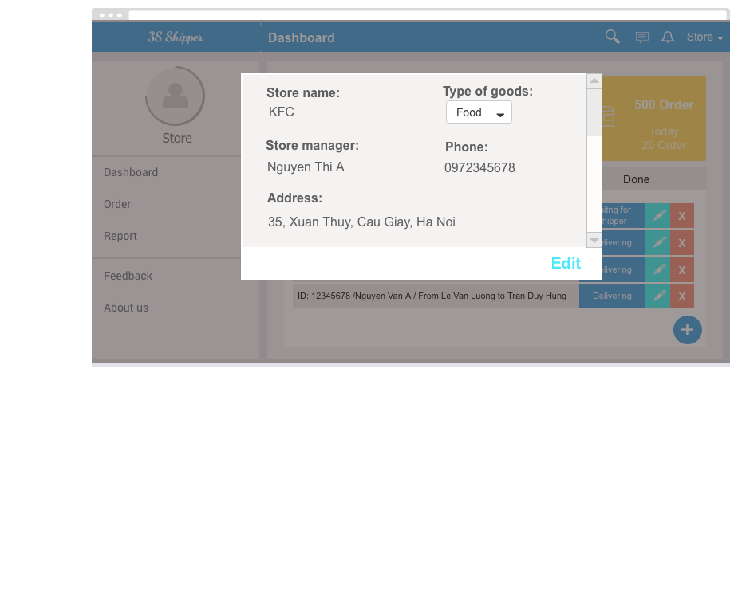

|  |  |  |  |  |
| --- | --- | --- | --- | --- |
| **Use Case ID:** | | UC-206 | | |
| **Use Case Name:** | | View profile | | |
| **Created By:** | | KhanhKC | **Last Updated By:** | KhanhKC |
| **Date Created:** | | 19/09/2015 | **Date Last updated:** | 20/09/2015 |
| **Actor:** | | Store | | |
| **Description:** | | “View profile” screen Displays detail information of Store such as Store name; type of goods, Store address…and a “Edit” button that help Store edits those information. | | |
| **Triggering event:** | | Store wants to view profile. | | |
| **Preconditions:** | | Store logged into system. | | |
| **Post conditions:** | | “Profile” screen are displayed | | |
| **Priority:** | | Normal | | |
| **Frequency of Use:** | | Sometime | | |
| **Main flow** | | | | |
| Step | Actor | Action | | |
|  | Store | Clicks on “Profile” hyperlink. | | |
|  | System | Loads data | | |
|  | System | Displays “Profile” screen includes details information of Store | | |
| **Alternative Flows:** | | N/A | | |
| **Exceptions:** | | N/A | | |
| **Includes:** | | N/A | | |
| **Special Requirements:** | | N/A | | |
| **Notes and Issues:** | | N/A | | |

***Sequence Diagram***

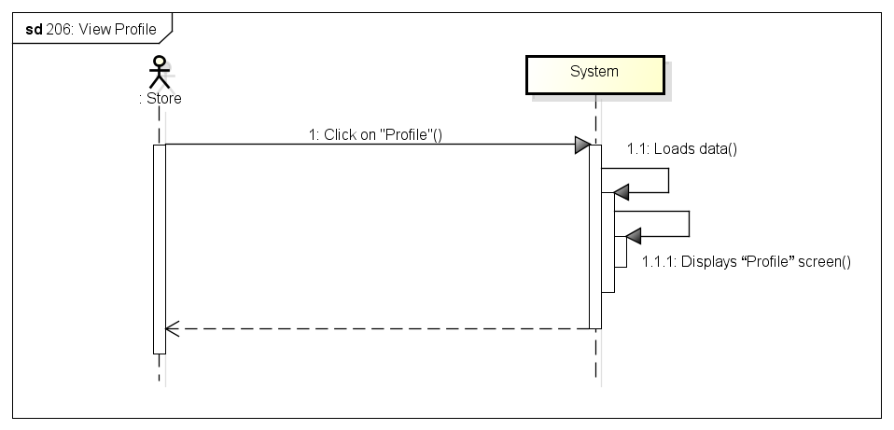

###### Default-6-Edit-profile-29069614*UC-207:* *Update profile*

|  |  |  |  |  |
| --- | --- | --- | --- | --- |
| **Use Case ID:** | | UC-207 | | |
| **Use Case Name:** | | Update profile | | |
| **Created By:** | | KhanhKC | **Last Updated By:** | KhanhKC |
| **Date Created:** | | 19/09/2015 | **Date Last updated:** | 20/09/2015 |
| **Actor:** | | Store | | |
| **Description:** | | Store can edit detail information such as: Store name; type of goods; Store address… This information will be updated to database. | | |
| **Triggering event:** | | Store wants to update profile. | | |
| **Preconditions:** | | Store are on “Profile” screen | | |
| **Post conditions:** | | New profile have been displays on “Profile screen” and updated in database. | | |
| **Priority:** | | Normal | | |
| **Frequency of Use:** | | Sometime | | |
| **Main flow** | | | | |
| Step | Actor | Action | | |
|  | Store | Clicks “Update profile” button on “Profile” screen | | |
|  | System | Enable fields on profile screen. | | |
|  | Store | Enters data in fields | | |
|  | Store | Clicks “Submit” button | | |
|  | System | Validates entered data. | | |
|  | System | Updates data to database | | |
|  | System | Displays “View Profile” screen. (Refer to UC-206: View Profile” | | |
| **Alternative Flows:** | | N/A | | |
| **Exceptions:** | | | | |
| EC1 | At step 3, require fields are empty | | | |
| Step | Actor | Action | | |
| 4.1 | System | Displays error message at empty fields: “* is require” | | |
| EC2 | At step 4, Store Clicks “Cancel” button | | | |
| Step | Actor | Action | | |
| 4.1 | System | Displays “View profile” screen (Refer to UC-206: View Profile” | | |
| **Includes:** | | N/A | | |
| **Special Requirements:** | | N/A | | |
| **Notes and Issues:** | |  | | |

***Sequence Diagram***

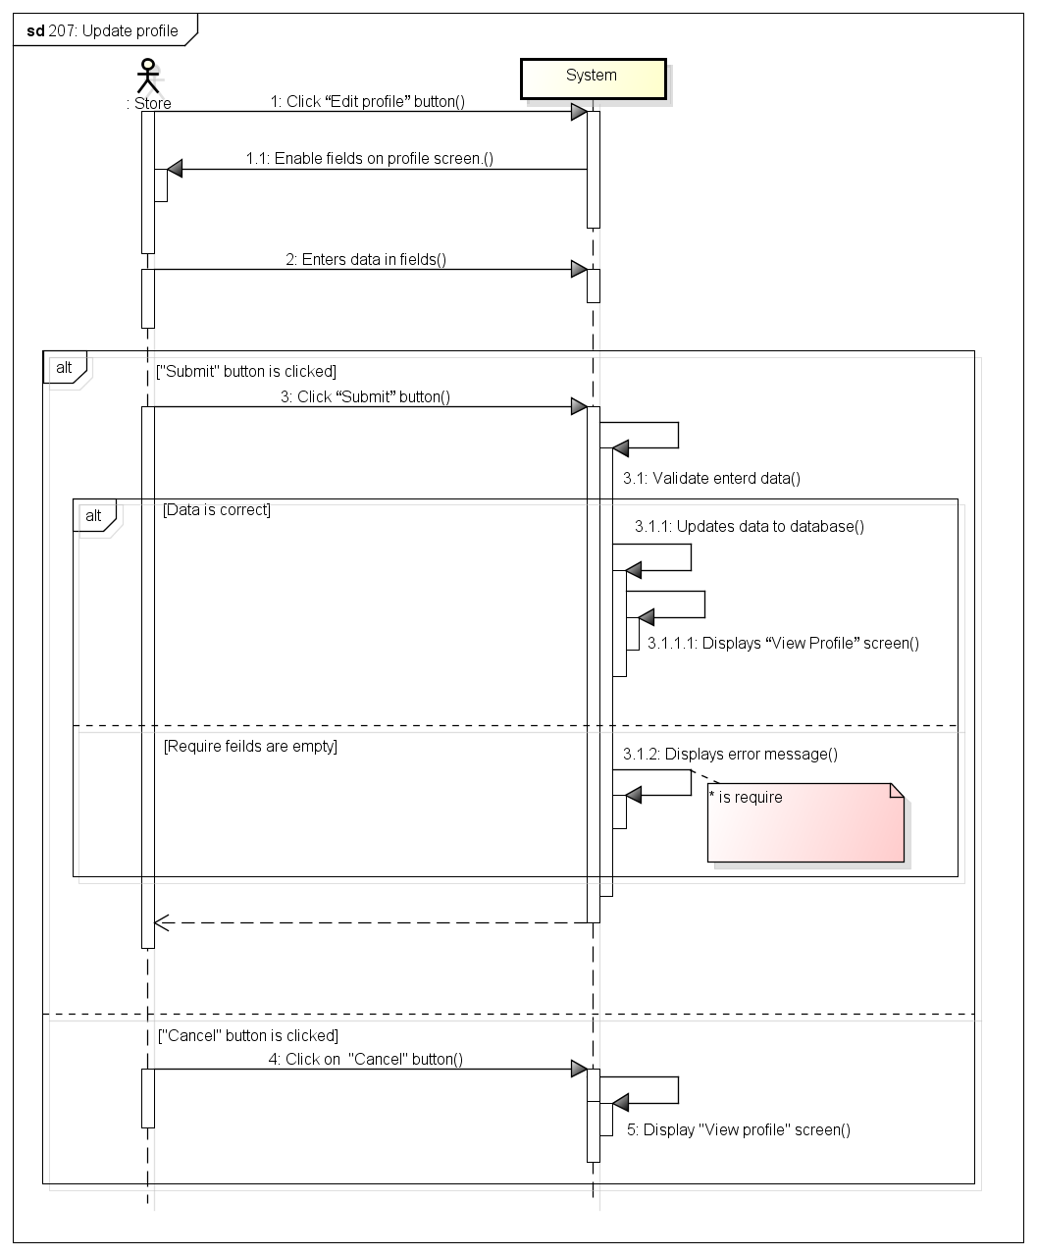

###### *UC-208:* *Create order*

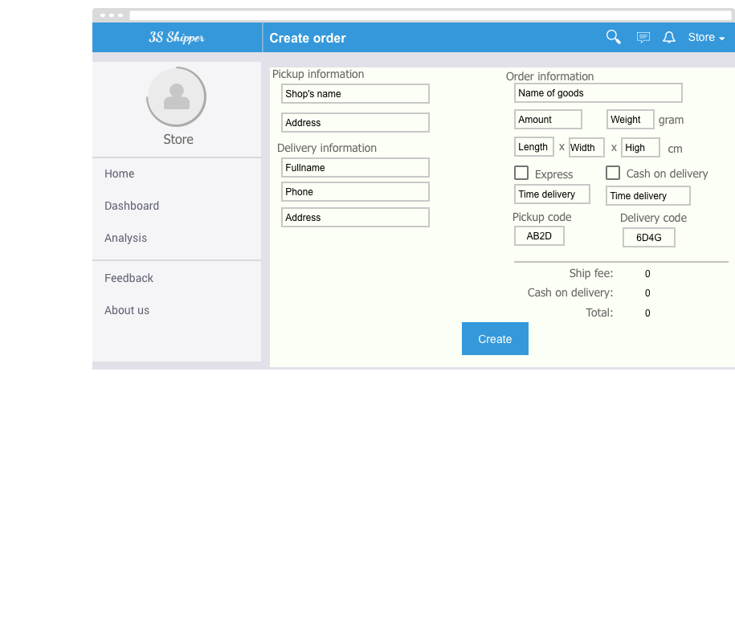

|  |  |  |  |  |
| --- | --- | --- | --- | --- |
| **Use Case ID:** | | UC-208 | | |
| **Use Case Name:** | | Create order | | |
| **Created By:** | | KhanhKC | **Last Updated By:** | KhanhKC |
| **Date Created:** | | 19/09/2015 | **Date Last updated:** | 20/09/2015 |
| **Actor:** | | Store | | |
| **Description:** | | Store creates an order to requests delivery service from system | | |
| **Triggering event:** | | Store wants to create a new order. | | |
| **Preconditions:** | | Store are logged into system. | | |
| **Post conditions:** | | Order information have been send to system and saved to database. | | |
| **Priority:** | | High | | |
| **Frequency of Use:** | | Always | | |
| **Main flow** | | | | |
| Step | Actor | Action | | |
|  | Store | Clicks “Create order” button | | |
|  | System | Displays “Create order” screen includes:  - “From” text box  - “Pick up locations” text box  - “To” text box  - “Delivery address” text box  - “Phone” text box  - “Weight” text box  - “Size” text box  - “Vehicle” drop down list  - “Express” checkbox  - “Delivery Time” time picker  - “Pick up Time” time picker  - “Cash on delivery” check box  - “ Amount of money” text box  - “Submit” button  - “Cancel” button | | |
|  | Store | Enters data in fields | | |
|  | Store | Clicks “Submit” button | | |
|  | System | Validate data | | |
|  | System | Updates data to database | | |
|  | System | Displays “Order details” screen (Refer to UC-213: Order’s details) | | |
| **Alternative Flows:** | | | | |
| AT1 | At step 3, Store checks on “Express” check box. | | | |
| Step | Actor | Action | | |
| 3.1 | System | Disables “Time delivery” text box | | |
| **Exceptions:** | | | | |
| EC1 | At step 4, required fields are empty | | | |
| Step | Actor | Action | | |
| 4.1 | System | Displays Register screen with error message “*is require” | | |
| EC3 | At step 4, Store Clicks “Cancel” button | | | |
| Step | Actor | Action | | |
| 4.1 | System | Redirects Store to “Order’s list screen | | |
| **Includes:** | | N/A | | |
| **Special Requirements:** | | N/A | | |
| **Notes and Issues:** | | N/A | | |

***Sequence Diagram***

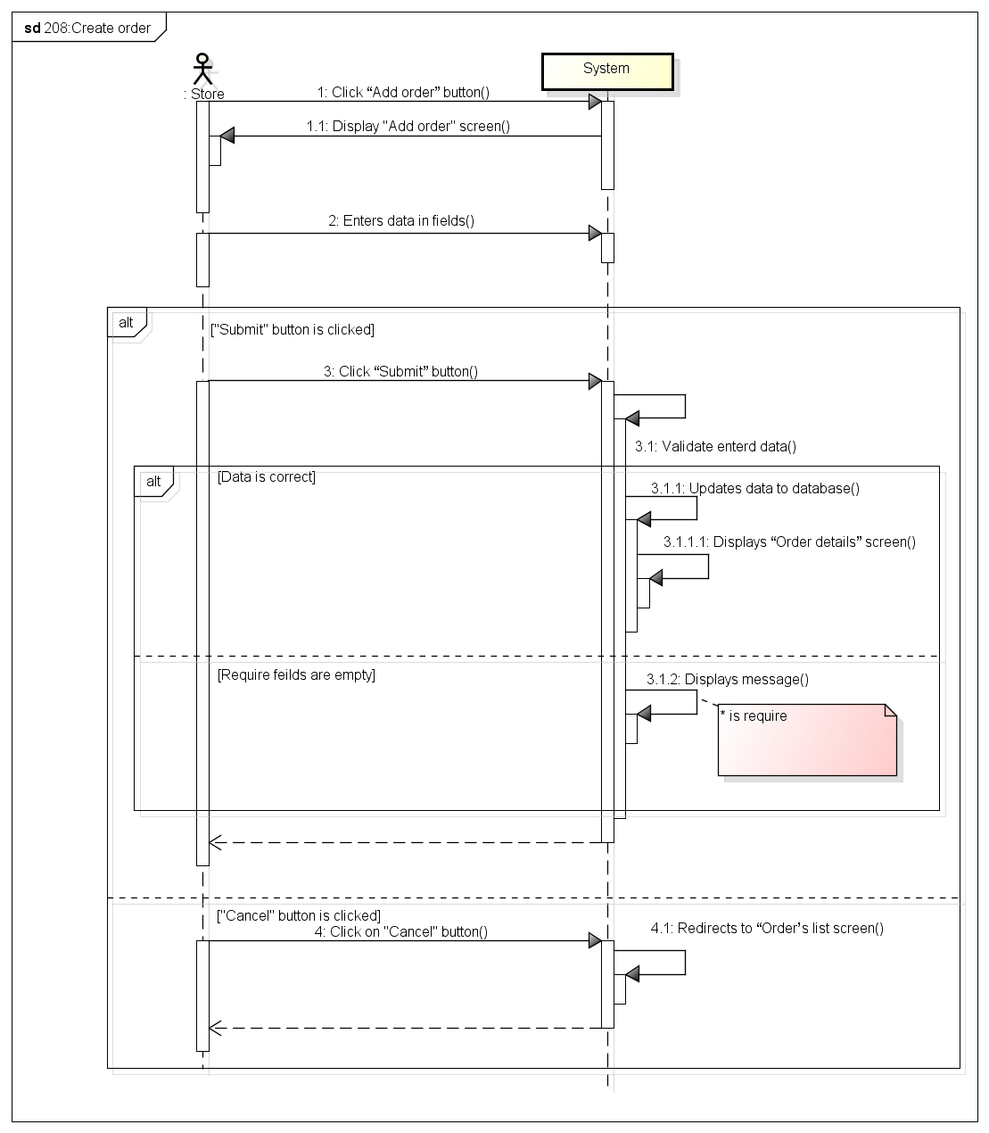

###### *UC-209:* *View order’s list*

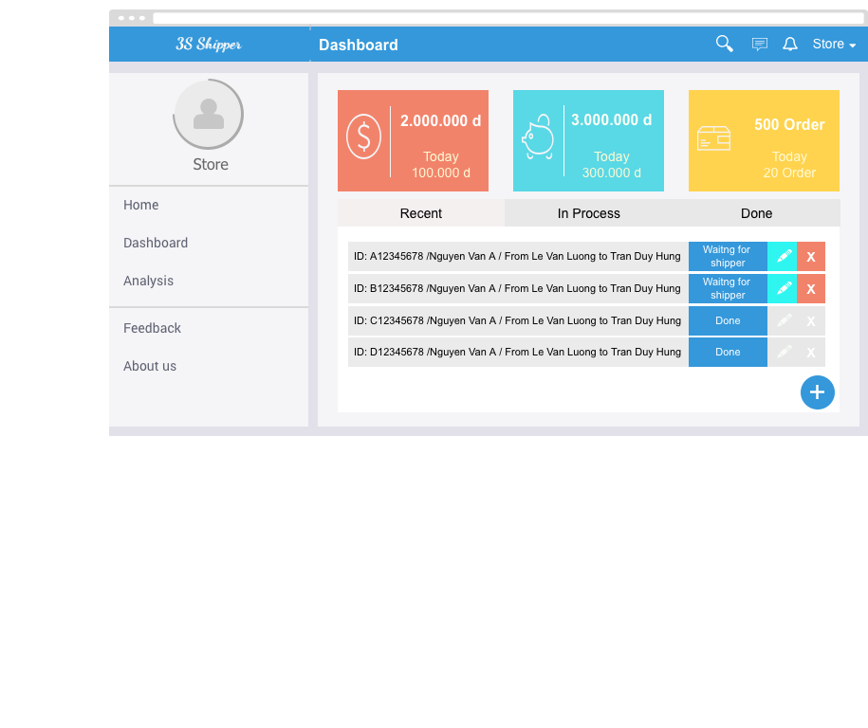

|  |  |  |  |  |
| --- | --- | --- | --- | --- |
| **Use Case ID:** | | UC-209 | | |
| **Use Case Name:** | | View order’s list | | |
| **Created By:** | | KhanhKC | **Last Updated By:** | KhanhKC |
| **Date Created:** | | 19/09/2015 | **Date Last updated:** | 20/09/2015 |
| **Actor:** | | Store | | |
| **Description:** | | “View order’s list” screen Displays list of all order created by Store with brief information of orders and function buttons that help Store cancels and edits information of orders. | | |
| **Triggering event:** | | Store wants to view list of order. | | |
| **Preconditions:** | | Store logged into system. | | |
| **Post conditions:** | | “Order’s list” screen are displayed | | |
| **Priority:** | | High | | |
| **Frequency of Use:** | | Always | | |
| **Main flow** | | | | |
| Step | Actor | Action | | |
|  | Store | Clicks on “Order’s list” menu | | |
|  | System | Loads data | | |
|  | System | Displays “Order’s list” screen | | |
| **Alternative Flows:** | | N/A | | |
| **Exceptions:** | | N/A | | |
| **Includes:** | | N/A | | |
| **Special Requirements:** | | N/A | | |
| **Notes and Issues:** | | N/A | | |

***Sequence Diagram***

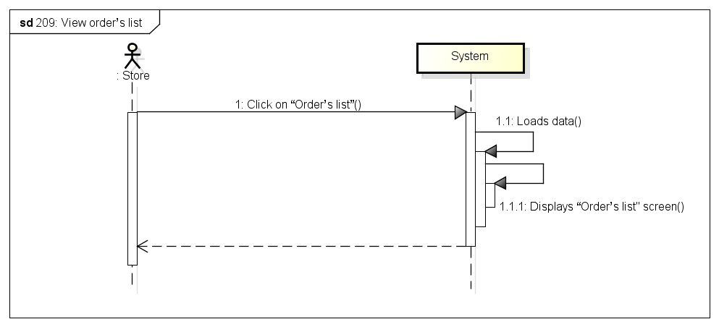

###### *UC-210:* *Search orders*

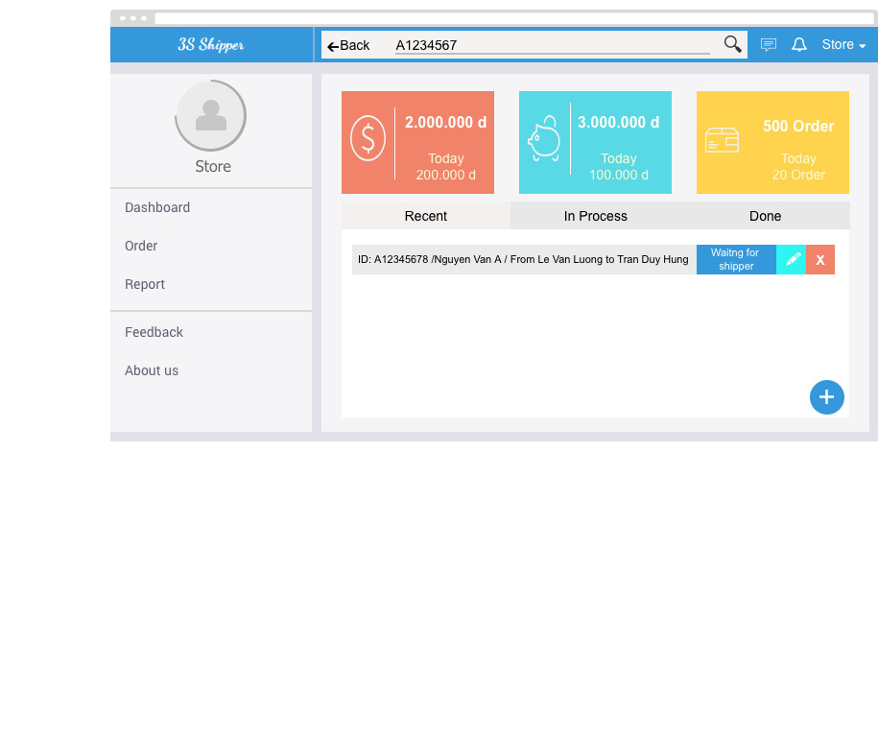

|  |  |  |  |  |
| --- | --- | --- | --- | --- |
| **Use Case ID:** | | UC-210 | | |
| **Use Case Name:** | | Search orders | | |
| **Created By:** | | KhanhKC | **Last Updated By:** | KhanhKC |
| **Date Created:** | | 19/09/2015 | **Date Last updated:** | 20/09/2015 |
| **Actor:** | | Store | | |
| **Description:** | | Store can use order’s code to search orders in list of orders that were created by Store | | |
| **Triggering event:** | | Store wants to search order | | |
| **Preconditions:** | | Store is on “Order’s list” screen. (Refer to UC-209: View order’s list) | | |
| **Post conditions:** | | Searched result are displayed on screen. | | |
| **Priority:** | | High | | |
| **Frequency of Use:** | | Often | | |
| **Main flow** | | | | |
| Step | Actor | Action | | |
|  | Store | Clicks on “Search” button | | |
|  | Store | Enters code | | |
|  | Store | Clicks on “Search” button | | |
|  | System | Loads data | | |
|  | System | Displays searched result on screen. | | |
| **Alternative Flows:** | | N/A | | |
| **Exceptions:** | | N/A | | |
| **Includes:** | | N/A | | |
| **Special Requirements:** | | N/A | | |
| **Notes and Issues:** | | N/A | | |

***Sequence Diagram***

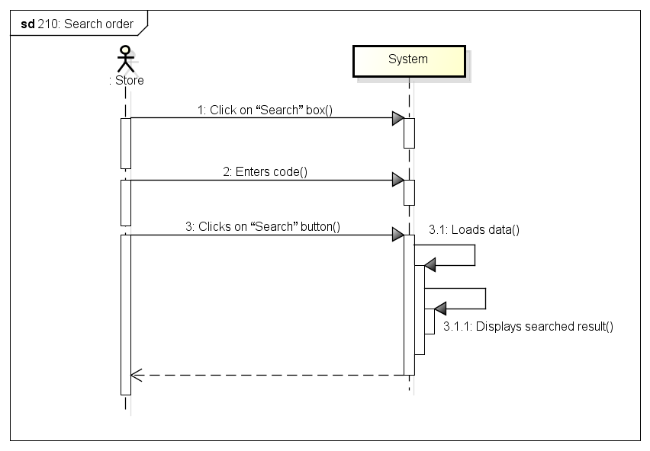

###### *UC-211:* *Cancel order*

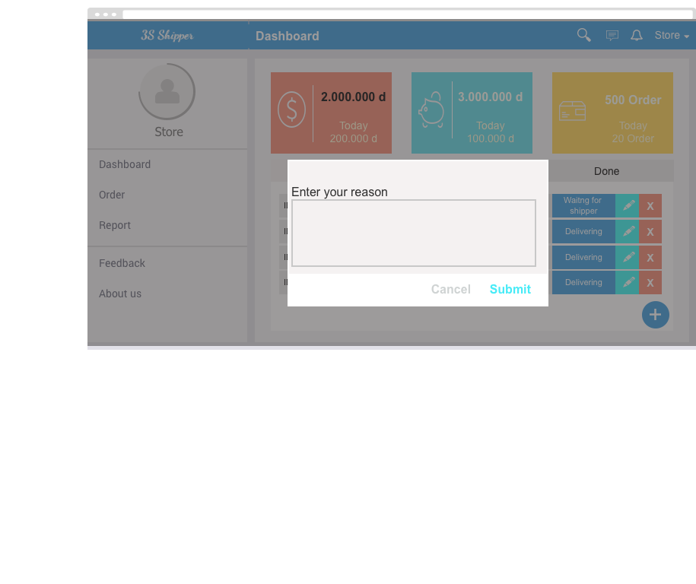

|  |  |  |  |  |
| --- | --- | --- | --- | --- |
| **Use Case ID:** | | UC-211 | | |
| **Use Case Name:** | | Cancel order | | |
| **Created By:** | | KhanhKC | **Last Updated By:** | KhanhKC |
| **Date Created:** | | 19/09/2015 | **Date Last updated:** | 20/09/2015 |
| **Actor:** | | Store | | |
| **Description:** | | Stores can cancel uncompleted orders. But Store has to enter cancel reason | | |
| **Triggering event:** | | Store wants to cancel orders. | | |
| **Preconditions:** | | Store are on “Order’s list” screen (Refer to UC-209: View order’s list) | | |
| **Post conditions:** | | - Order status has been changed to “Cancel”  - Order information has been updated to database. | | |
| **Priority:** | | Normal | | |
| **Frequency of Use:** | | Sometime | | |
| **Main flow** | | | | |
| Step | Actor | Action | | |
|  | Store | Clicks “X” button on the row contain order brief information. | | |
|  | System | Displays “Confirm Cancel” popup | | |
|  | Store | Enters cancel reason | | |
|  | Store | Clicks “Submit” button | | |
|  | System | Changes status of order to “Cancel” | | |
| **Alternative Flows:** | | N/A | | |
| **Exceptions:** | | | | |
| EC1 | At step 4, Store Clicks “Cancel” button | | | |
| Step | Actor | Action | | |
| 3.1 | System | Closes popup | | |
| EC1 | At step 3, Store enters nothing. | | | |
| Step | Actor | Action | | |
| 3.1 | System | Displays error message on “Confirm Cancel” popup: “Please enter your reason” | | |
| **Includes:** | | N/A | | |
| **Special Requirements:** | | N/A | | |
| **Notes and Issues:** | | N/A | | |

***Sequence Diagram***

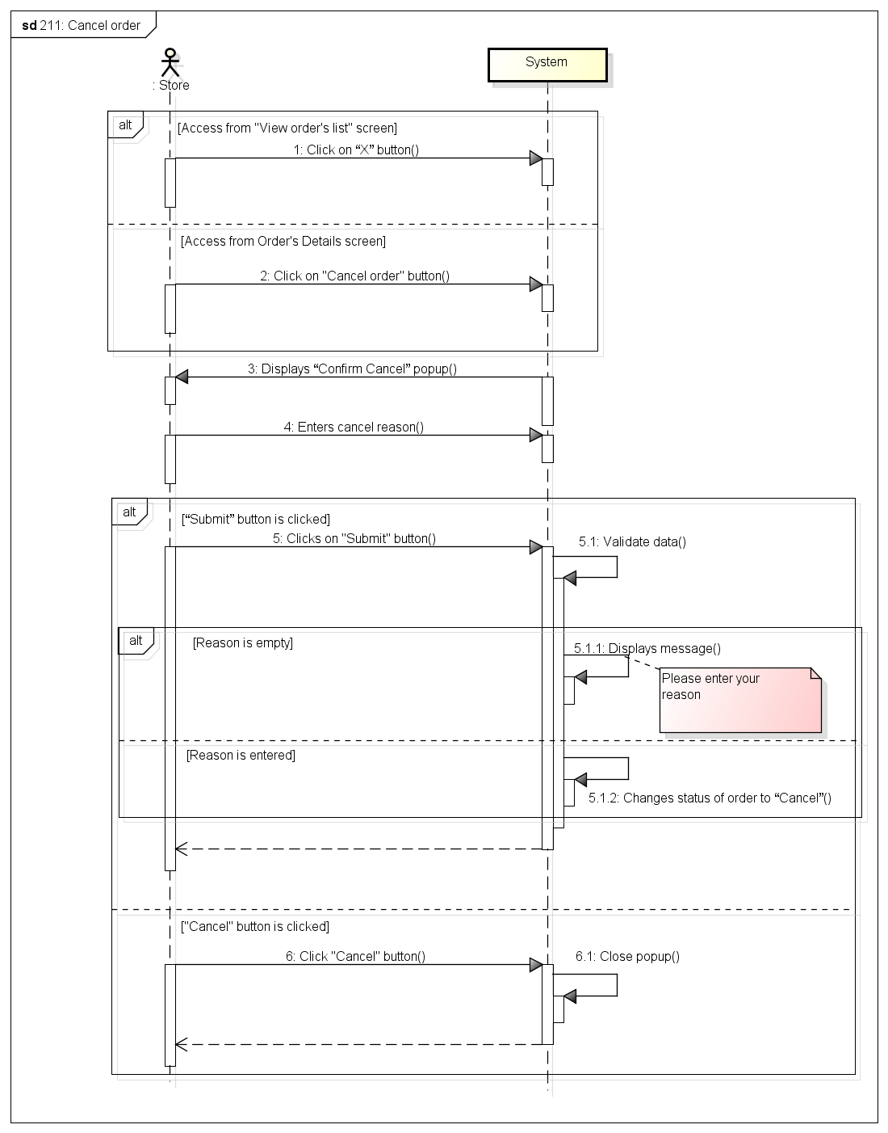

###### *UC-212:* *Edit Order*

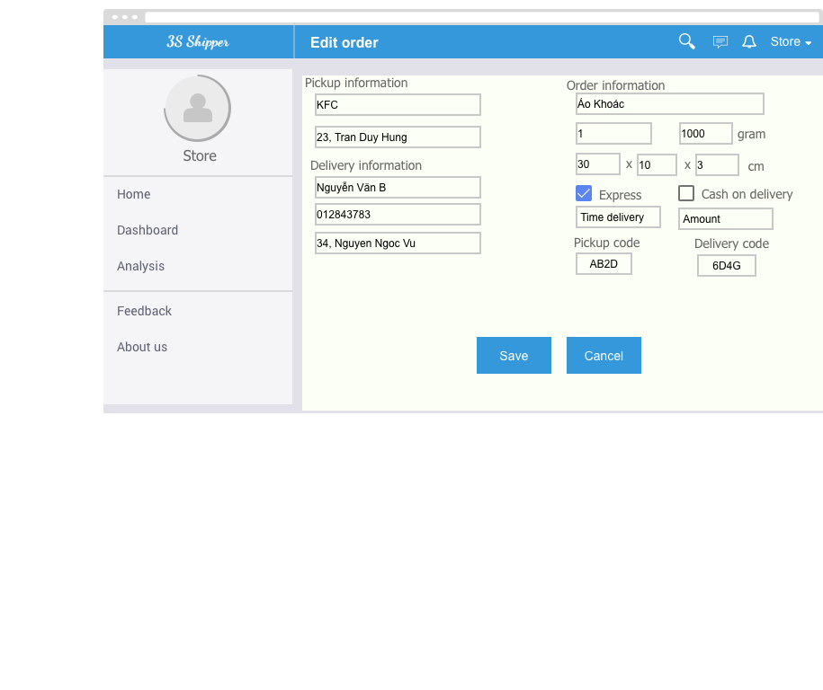

|  |  |  |  |  |
| --- | --- | --- | --- | --- |
| **Use Case ID:** | | UC-212 | | |
| **Use Case Name:** | | Edit Order | | |
| **Created By:** | | KhanhKC | **Last Updated By:** | KhanhKC |
| **Date Created:** | | 19/09/2015 | **Date Last updated:** | 20/09/2015 |
| **Actor:** | | Store | | |
| **Description:** | | Store can edits some information that Store entered when create orders. And these orders must be uncompleted. | | |
| **Triggering event:** | | Store wants to edits order | | |
| **Preconditions:** | | Store are on “Order’s list” screen or Store are on “Order details” screen. (Refer to UC-209: View order’s list) | | |
| **Post conditions:** | | New Order information have been displays on details screen and updated in database. | | |
| **Priority:** | | High | | |
| **Frequency of Use:** | | Often | | |
| **Main flow** | | | | |
| Step | Actor | Action | | |
|  | Store | Clicks “Edit” button on the row contain order information. | | |
|  | System | Displays “Order details” screen:  - “Start address” text box  - “Finish address” text box  - “Weight” text box  - “Size” text box  - “Vehicle” drop down list  - “Express” checkbox  - “Time delivery” text box  - “Submit” button | | |
|  | Store | Enters data in fields | | |
|  | Store | Clicks “Submit” button | | |
|  | System | Displays “Order details” screen with updated information. | | |
| **Alternative Flows:** | | | | |
| AT1 | At step 1, Store Clicks on “Edit” button on “Order details” screen. | | | |
| Step | Actor | Action | | |
| 1.1 | System | Changes fields on “Order details” to editable. | | |
| 1.2 | Go to “Step 2” | | | |
| **Exceptions:** | | | | |
| EC1 | At step 3, requires fields are empty | | | |
| Step | Actor | Action | | |
| 4.1 | System | Displays message: “* is require” | | |
| EC2 | At step 4, Store Clicks “Cancel” button | | | |
| Step | Actor | Action | | |
| 4.1 | System | Displays “Order details” screen (Refer to UC-213: Order details) | | |
| **Includes:** | | N/A | | |
| **Special Requirements:** | | N/A | | |
| **Notes and Issues:** | | N/A | | |

***Sequence Diagram***

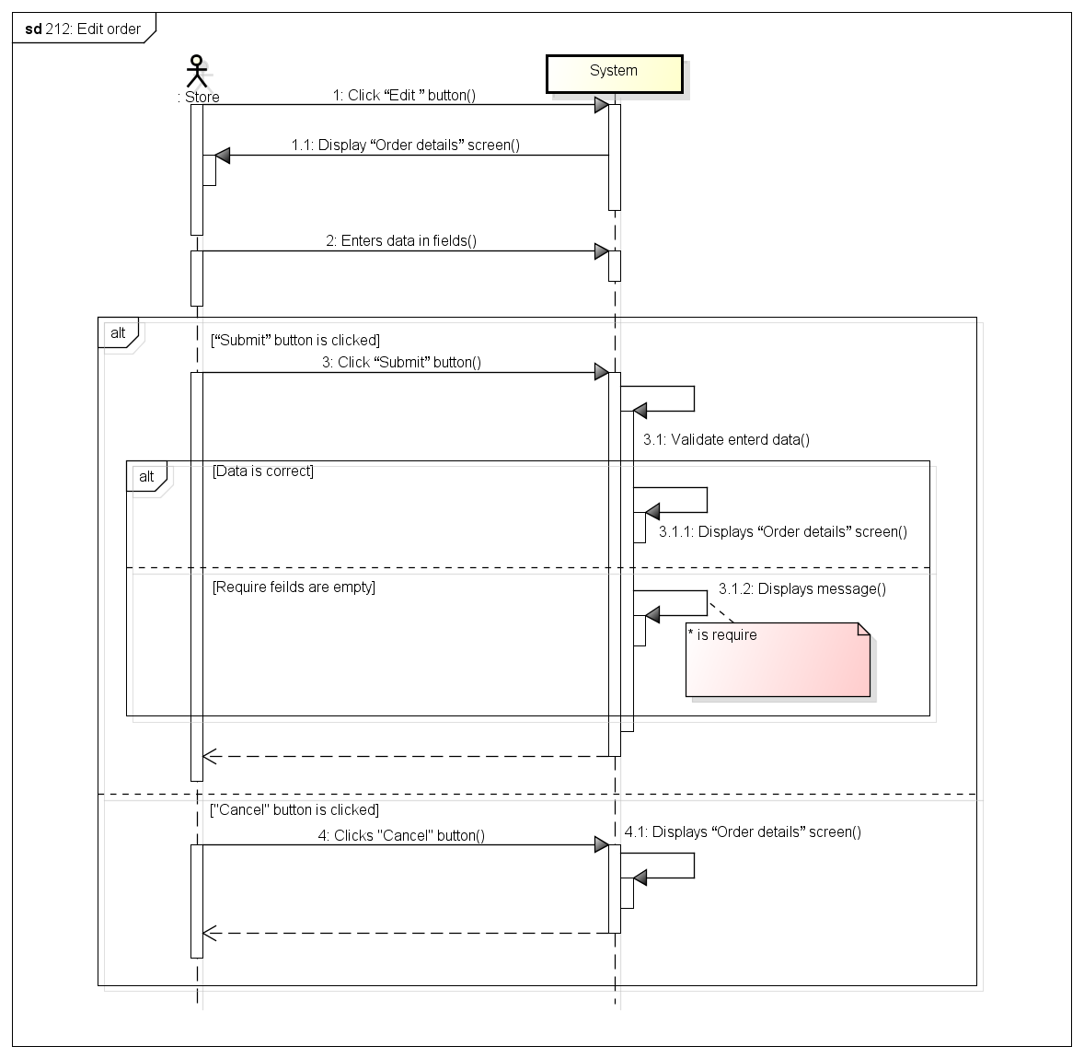

###### *UC- 213:* *Order’s details*

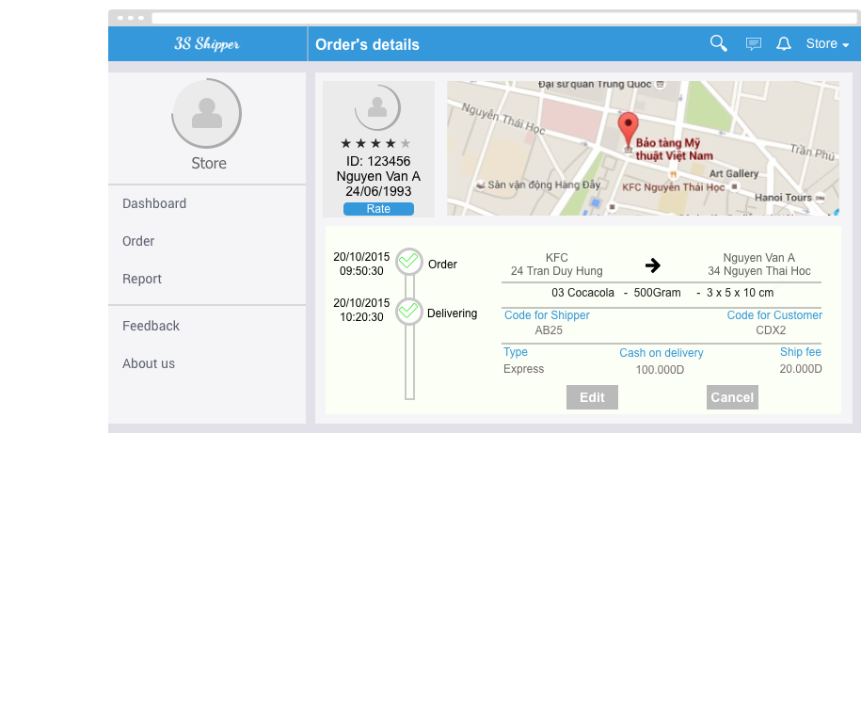

|  |  |  |  |  |
| --- | --- | --- | --- | --- |
| **Use Case ID:** | | UC-213 | | |
| **Use Case Name:** | | Order’ Details | | |
| **Created By:** | | KhanhKC | **Last Updated By:** | KhanhKC |
| **Date Created:** | | 19/09/2015 | **Date Last updated:** | 20/09/2015 |
| **Actor:** | | Store | | |
| **Description:** | | Displays details information of orders with a maps that help Store checking location of Shippers and a timeline that help Store checking status of Order. | | |
| **Triggering event:** | | Store wants to view order details | | |
| **Preconditions:** | | Store is on “Order’s list” screen. | | |
| **Post conditions:** | | “Order’s details” screen are displayed | | |
| **Priority:** | | High | | |
| **Frequency of Use:** | | Always | | |
| **Main flow** | | | | |
| Step | Actor | Action | | |
|  | Store | Clicks on row contain order brief information | | |
|  | System | Loads data | | |
|  | System | Displays “Order’s details” screen | | |
| **Alternative Flows:** | | N/A | | |
| **Exceptions:** | | N/A | | |
| **Includes:** | | N/A | | |
| **Special Requirements:** | | N/A | | |
| **Notes and Issues:** | | N/A | | |

***Sequence Diagram***

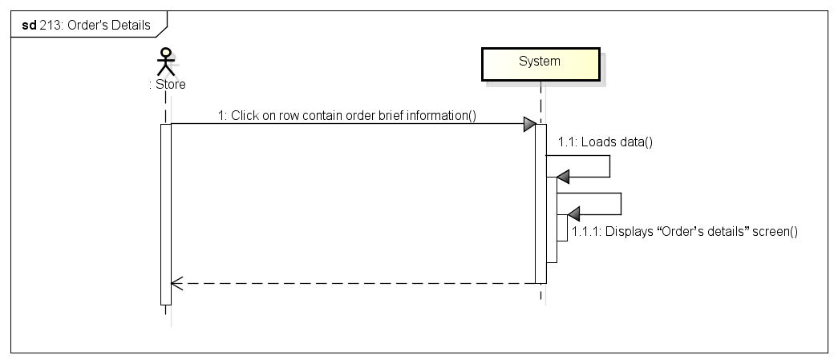

###### *UC-214:* *View payment history*

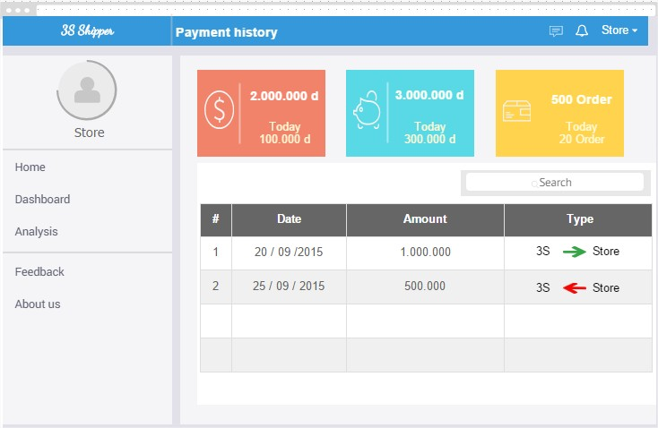

|  |  |  |  |  |
| --- | --- | --- | --- | --- |
| **Use Case ID:** | | UC-214 | | |
| **Use Case Name:** | | View payment history | | |
| **Created By:** | | KhanhKC | **Last Updated By:** | KhanhKC |
| **Date Created:** | | 19/09/2015 | **Date Last updated:** | 20/09/2015 |
| **Actor:** | | Store | | |
| **Description:** | | Displays payment history between Store and 3S Shipper | | |
| **Triggering event:** | | Store wants to view payment history | | |
| **Preconditions:** | | Store is on “Store” screen. | | |
| **Post conditions:** | | “Payment history” screen are displayed | | |
| **Priority:** | | Normal | | |
| **Frequency of Use:** | | Sometime | | |
| **Main flow** | | | | |
| Step | Actor | Action | | |
|  | Store | Clicks on “Payment history” menu item on “Navigation bar” | | |
|  | System | Loads data | | |
|  | System | Displays “Payment history” screen. | | |
| **Alternative Flows:** | | N/A | | |
| **Exceptions:** | | N/A | | |
| **Includes:** | | N/A | | |
| **Special Requirements:** | | N/A | | |
| **Notes and Issues:** | | N/A | | |

***Sequence Diagram***

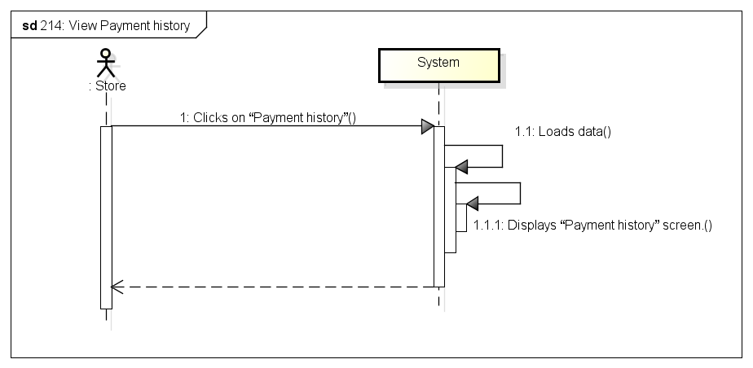

###### *UC-215:* *View notifications*

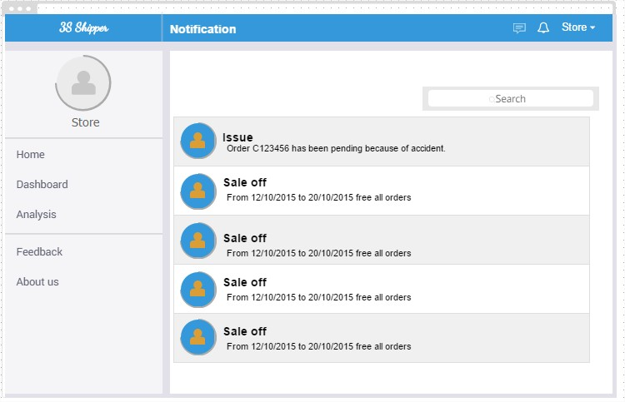

|  |  |  |  |  |
| --- | --- | --- | --- | --- |
| **Use Case ID:** | | UC-215 | | |
| **Use Case Name:** | | View notifications | | |
| **Created By:** | | HuyTDH | **Last Updated By:** | KhanhKC |
| **Date Created:** | | 19/09/2015 | **Date Last updated:** | 20/09/2015 |
| **Actor:** | | Store | | |
| **Description:** | | Store views notifications from system (promotion news, payment warning, etc…) | | |
| **Triggering event:** | | Store wants to view notification. | | |
| **Preconditions:** | | Store logged in, internet connection is on | | |
| **Post conditions:** | | All notifications will be listed out | | |
| **Priority:** | | Normal | | |
| **Frequency of Use:** | | Sometimes | | |
| **Main flow** | | | | |
| Step | Actor | Action | | |
|  | Store | Clicks on “Notification” icon | | |
|  | System | Display “Drop down menu” | | |
|  | Store | Clicks “View all notifications” | | |
|  |  | Loads data | | |
|  | System | Displays “Notifications” screen. | | |
| **Alternative:** | | N/A | | |
| **Exceptions:** | | N/A | | |
| **Includes:** | | N/A | | |
| **Special Requirements:** | | N/A | | |
| **Notes and Issues:** | | N/A | | |

***Sequence Diagram***

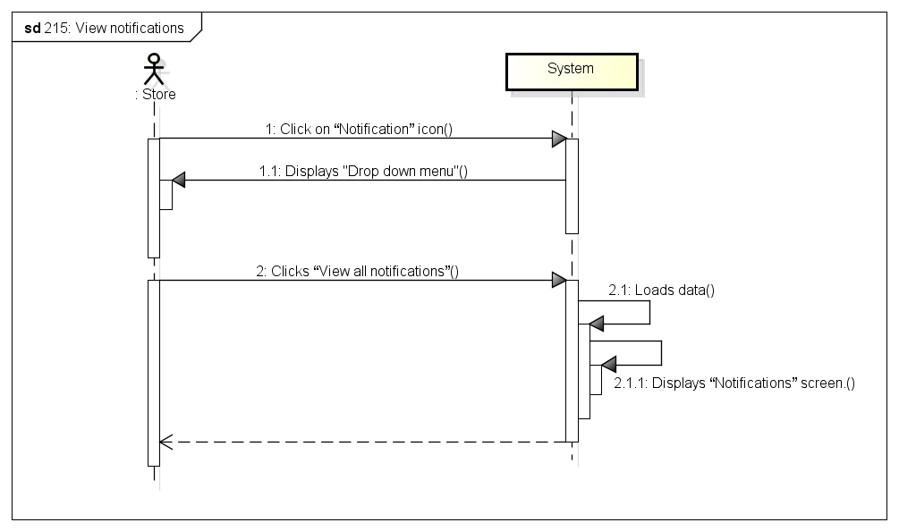

###### *UC-216:* *Rate shipper*

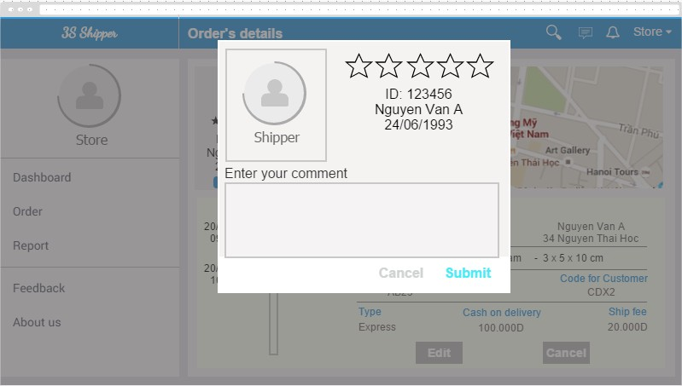

|  |  |  |  |  |
| --- | --- | --- | --- | --- |
| **Use Case ID:** | | UC-216 | | |
| **Use Case Name:** | | Rate shipper | | |
| **Created By:** | | HuyTDH | **Last Updated By:** | KhanHKC |
| **Date Created:** | | 19/09/2015 | **Date Last updated:** | 20/09/2015 |
| **Actor:** | | Store | | |
| **Description:** | | Store rates service quality of shipper for each order by chooses number of star and enters comment. | | |
| **Triggering event:** | | Store rates shipper. | | |
| **Preconditions:** | | Store logged in, there’s a shipper bears responsibility for shipping store’s order | | |
| **Post conditions:** | | Shipper rating send to system | | |
| **Priority:** | | Normal | | |
| **Frequency of Use:** | | Often | | |
| **Main flow** | | | | |
| Step | Actor | Action | | |
|  | Store | Goes to “Order List” | | |
|  | Store | Clicks on “Rate” button | | |
|  | System | Displays “Shipper Rating” pop-up | | |
|  | Store | Selects rate score (1-5 stars) | | |
|  | Store | Enters some content | | |
|  | Store | Clicks on “Send” button | | |
|  | System | Save data to database | | |
|  | System | Displays message “Thanks for your rating!” | | |
| **Alternative Flows:** | | | | |
| **Exceptions:** | | | | |
| EC1 | At step 9, Store Clicks “Cancel” button | | | |
| Step | Actor | Action | | |
| 4.1 | Store | Store Clicks “Cancel” button | | |
| 4.2 | System | Close popup. | | |
| **Includes:** | | N/A | | |
| **Special Requirements:** | | N/A | | |
| **Notes and Issues:** | | N/A | | |

***Sequence Diagram***

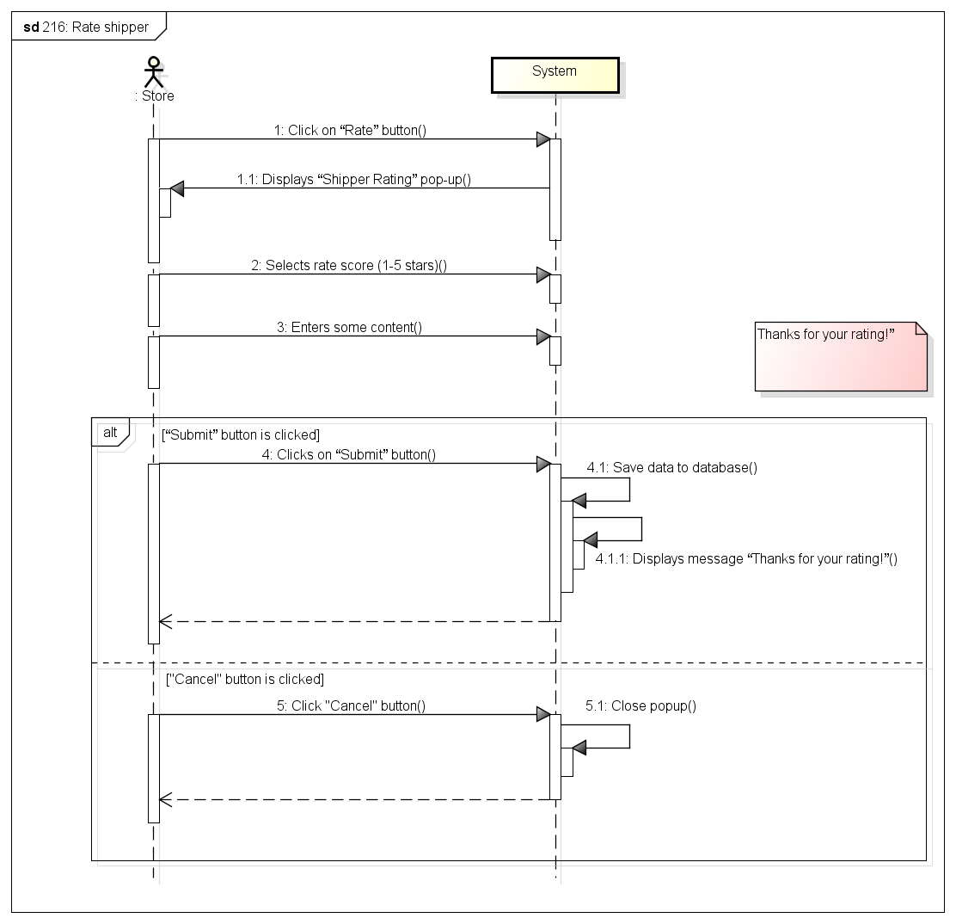

###### *UC-217:* *Send feedback*

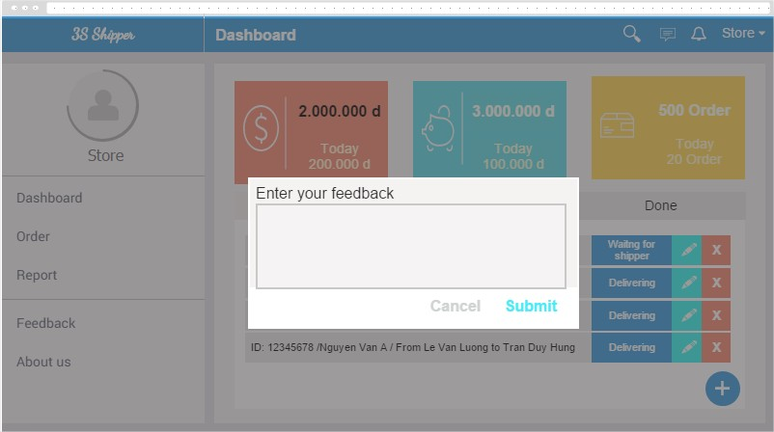

|  |  |  |  |  |
| --- | --- | --- | --- | --- |
| **Use Case ID:** | | UC-217 | | |
| **Use Case Name:** | | Send feedback | | |
| **Created By:** | | HuyTDH | **Last Updated By:** | KhanhKC |
| **Date Created:** | | 19/09/2015 | **Date Last updated:** | 20/09/2015 |
| **Actor:** | | Store | | |
| **Description:** | | Store send feedback about any service of system by enters some content. | | |
| **Triggering event:** | | Store send feedback about service to system | | |
| **Preconditions:** | | Store logged in  Internet connection is on | | |
| **Post conditions:** | | Feedback will be sent to system | | |
| **Priority:** | | Normal | | |
| **Frequency of Use:** | | Sometimes | | |
| **Main flow** | | | | |
| Step | Actor | Action | | |
|  | Store | Clicks on “Send feedback” on navigation bar | | |
|  | System | Displays “Send feedback” pop-up | | |
|  | Store | Enters some content | | |
|  | Store | Clicks on “Submit” | | |
|  | System | Validate content | | |
|  | System | Shows message “Thanks for your feedback!” | | |
| **Alternative Flows:** | | N/A | | |
| **Exceptions:** | | | | |
| EC1 | At step Store doesn’t enter content | | | |
| Step | Actor | Action | | |
| 4.1 | Store | Store Clicks “Submit” | | |
| 4.2 | System | System shows message “Please enter content of feedback!” | | |
| **Includes:** | | N/A | | |
| **Special Requirements:** | | N/A | | |
| **Notes and Issues:** | | N/A | | |

***Sequence Diagram***

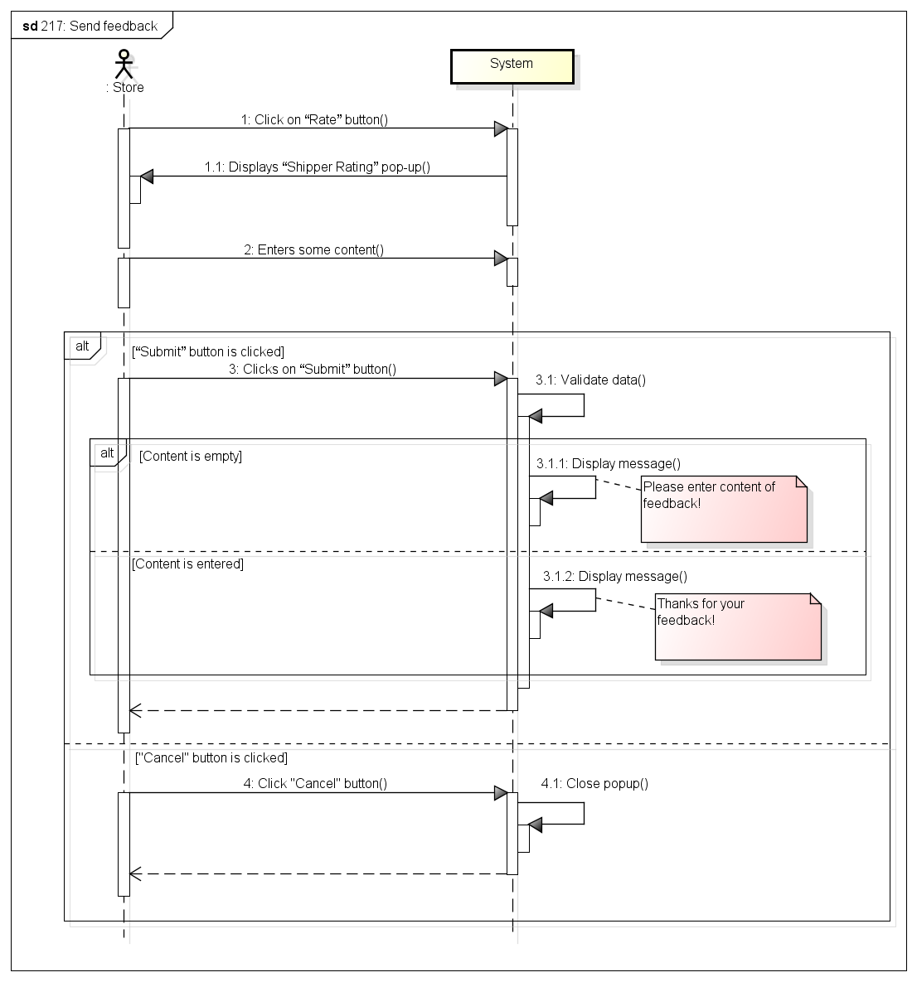

###### *UC-218:* *View Homepage*



|  |  |  |  |  |
| --- | --- | --- | --- | --- |
| **Use Case ID:** | | UC-218 | | |
| **Use Case Name:** | | View Homepage | | |
| **Created By:** | | KhanhKC | **Last Updated By:** | KhanhKC |
| **Date Created:** | | 20/09/2015 | **Date Last updated:** | 20/09/2015 |
| **Actor:** | | Store, Guest | | |
| **Description:** | | “Homepage” show information about 3S service, a “Login” box that help Store login system. Beside, “Homepage” also shows advertisement of system. | | |
| **Triggering event:** | | Store or Guest access to 3S website. | | |
| **Preconditions:** | | Store or Guest access to 3S website. | | |
| **Post conditions:** | | “Homepage” screen has been displayed. | | |
| **Priority:** | | High | | |
| **Frequency of Use:** | | Always | | |
| **Main flow** | | | | |
| Step | Actor | Action | | |
|  | Store, Guest | Access to 3S website. | | |
|  | System | Loads data | | |
|  | System | Displays “Homepage” screen. | | |
| **Alternative Flows:** | | N/A | | |
| **Exceptions:** | | N/A | | |
| **Includes:** | | N/A | | |
| **Special Requirements:** | | N/A | | |
| **Notes and Issues:** | | N/A | | |

***Sequence Diagram***

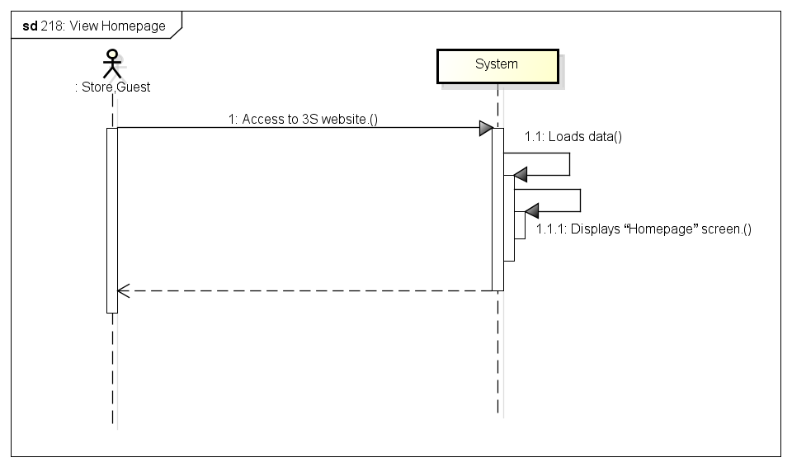

## 3.3. Mobile application for Shipper

### 3.3.1. User Case Diagram

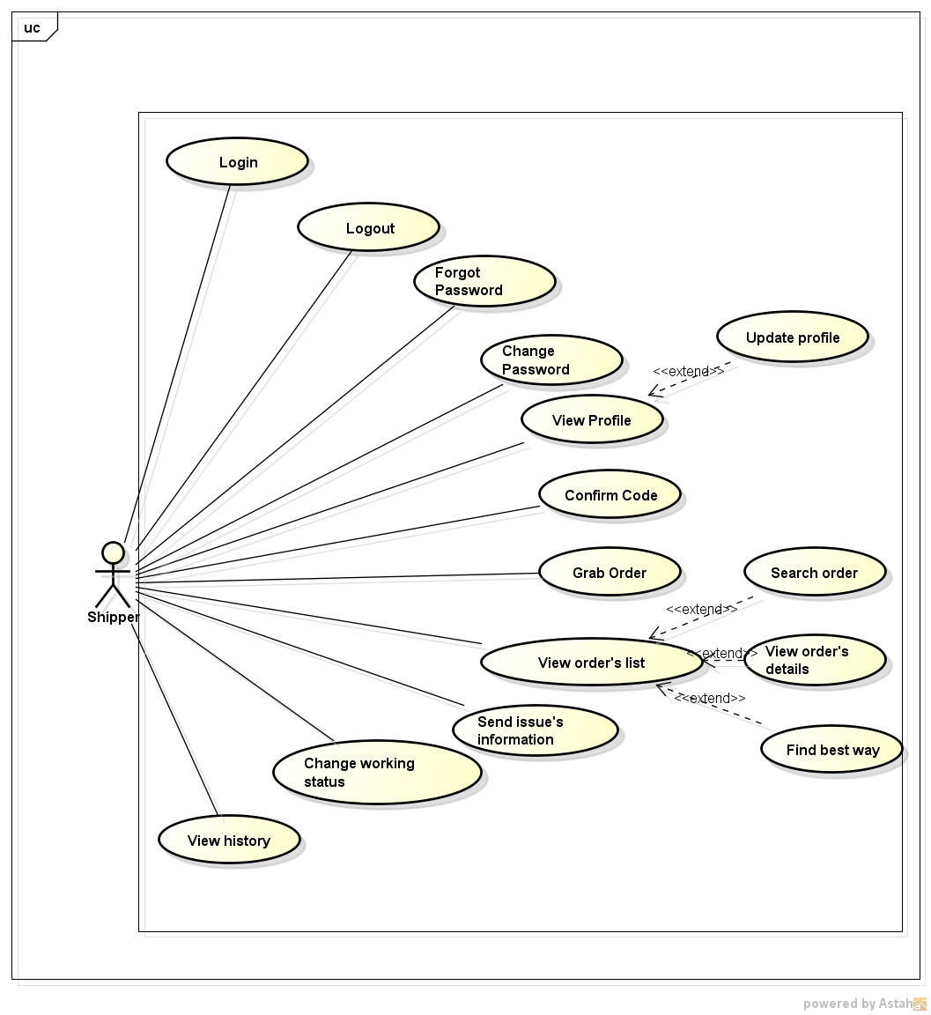

### 3.3.2. Function

###### *UC-301:* *Login*

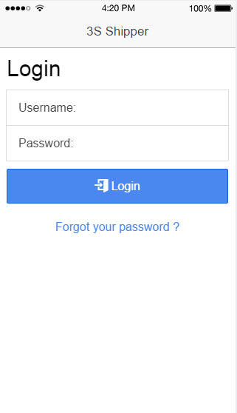

|  |  |  |  |  |
| --- | --- | --- | --- | --- |
| Use Case ID: | | UC-301 | | |
| Use Case Name: | | Login | | |
| Created By: | | QuyenNV | Last Updated By: | QuyenNV |
| Date Created: | | 19/09/2015 | Date Last Updated: | 30/09/2015 |
| Actor: | | Shipper | | |
| Description: | | System provides his or her access credentials in order to use system. | | |
| Triggering event | | Shipper wants to login to system. | | |
| Preconditions: | | - To be pre-registered in the System.  - Internet connection is established. | | |
| Post - conditions: | | The shipper’s session is stored. | | |
| Priority: | | High | | |
| Frequency of Use: | | Sometime | | |
| **Main flow** | | | | |
| Step | Actor | Action | | |
| 1 | Shipper | Tabs on application | | |
| 2 | System | Request the shipper input the following fields are available:  + Username  + Password | | |
| 3 | Shipper | Enter information (Username and Password). Shipper clicks on Log In. | | |
| 4 | System | The queries to shipper database | | |
| 5 | System | The system validates Username and Password to accept or rejects the login request. | | |
| 6 | System | Login successful into application. The login request is accepted shipper will be redirectsed to the Order’s list screen. | | |
| **Alternative Flows:** | | N/A | | |
| **Exceptions:** | | | | |
| EC1 | At step 4, If system cannot establish a connection to the database due to some reasons (ex: network failure). | | | |
| Step | Actor | | | |
| 4.1 | System | Display an error message “Your network connection failed. Please check your network connection and try again” will show up on screen to tell the shipper about the problem. | | |
| EC2 | At step 5, if account’s information is invalid | | | |
| Step | Actor | Action | | |
| 5.1 | System | Display an error message “ Username or Password is invalid. Try again.” on [Login] screen | | |
| **Includes:** | | N/A | | |
| **Special Requirements:** | | N/A | | |
| **Notes and Issues:** | | N/A | | |

**Sequence Diagram****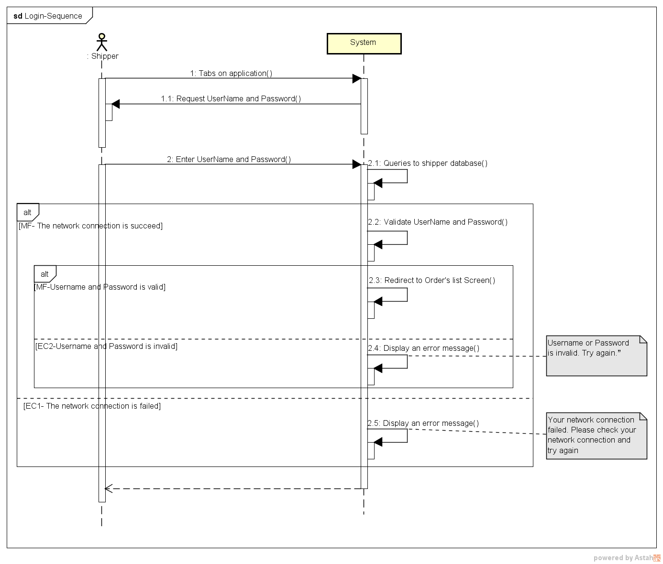**

###### *UC-302:* *Logout*

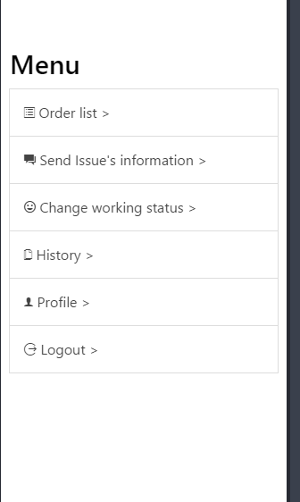

|  |  |  |  |  |
| --- | --- | --- | --- | --- |
| Use Case ID: | | UC-302 | | |
| Use Case Name: | | Logout | | |
| Created By: | | QuyenNV | Last Updated By: | QuyenNV |
| Date Created: | | 19/09/2015 | Date Last Updated: | 30/09/2015 |
| Actor: | | Shipper | | |
| Description: | | When shipper finish their work they will logout of the system. | | |
| Triggering event | | Shipper wants to logout of the system. | | |
| Preconditions: | | * To be logged in the system * Internet connection is established. | | |
| Post - conditions: | | * The connection to the server is terminated. | | |
| Priority: | | High | | |
| Frequency of Use: | | Sometime | | |
| **Main flow** | | | | |
| Step | Actor | Action | | |
|  | Shipper | Clicks “log out” button. | | |
|  | System | Terminates the connection. Local storage destroy login state. | | |
|  | System | Redirects to “Login” screen of application | | |
| **Alternative Flows:** | | N/A | | |
| **Exceptions:** | | N/A | | |
| **Includes:** | | N/A | | |
| **Special Requirements:** | | N/A | | |
| **Notes and Issues:** | | N/A | | |

* 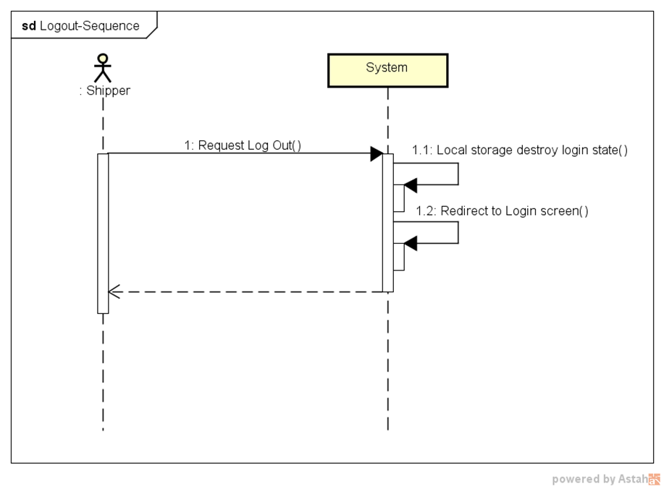**Sequence Diagram:**

###### *UC-303:* *Forgot password*

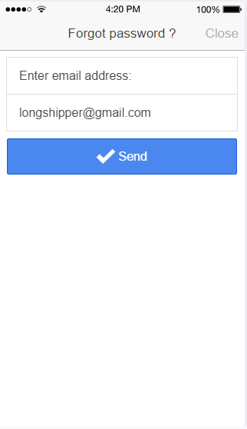

|  |  |  |  |  |
| --- | --- | --- | --- | --- |
| Use Case ID: | | UC-303 | | |
| Use Case Name: | | Forgot password | | |
| Created By: | | QuyenNV | Last Updated By: | QuyenNV |
| Date Created: | | 19/09/2015 | Date Last Updated: | 30/09/2015 |
| Actor: | | Shipper | | |
| Description: | | * When shipper wants to login into system but they forgot their password. Shipper wants reset their password. They will receive a new password via their email address. | | |
| Triggering event | | * Shipper forgot password and they wants to reset their password. | | |
| Preconditions: | | * To have internet connection through device. * Shipper haven’t logged in to the system yet. * On “Login” screen | | |
| Post - conditions: | | * New password is sent to email of shipper | | |
| Priority: | | High | | |
| Frequency of Use: | | Sometime | | |
| **Main flow** | | | | |
| Step | Actor | Action | | |
|  | Shipper | Clicks “Forgot password” | | |
|  | System | A new page ‘Forgot password’ appears. | | |
|  | Shipper | Enter email address used for registration. Shipper clicks the [Send] button. | | |
|  | System | Validate Email Address. | | |
|  | System | Send new password via email address of shipper | | |
|  | System | The page is refreshed. The message is displayed: “New passwords has been sent to your email” | | |
| **Alternative Flows:** | | N/A | | |
| **Exceptions:** | | | | |
| EC1 | At step 4, if email is invalid | | | |
| Step | Actor | Action | | |
| 4.1 | System | Notify in screen with error message “Your email is invalid. Please enter try again.” | | |
| **Includes:** | | N/A | | |
| **Special Requirements:** | | **Email Address:** A string from 1 to 244 characters in length, can contain any kind of characters, followed by “@gmail.com”. (Ex: longshipper@gmail.com). Cannot be null. | | |
| **Notes and Issues:** | | N/A | | |

**Sequence Diagram**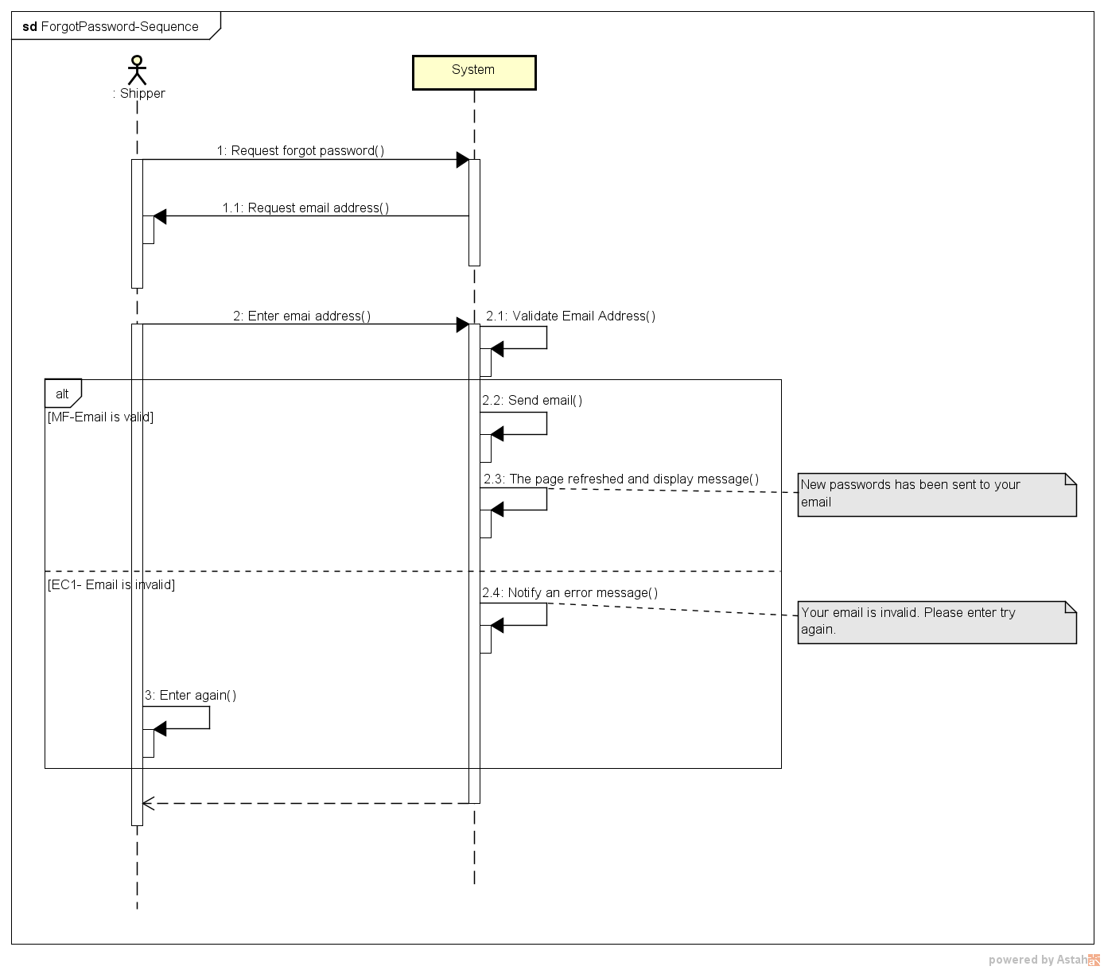

###### *UC-304:* *Change password*

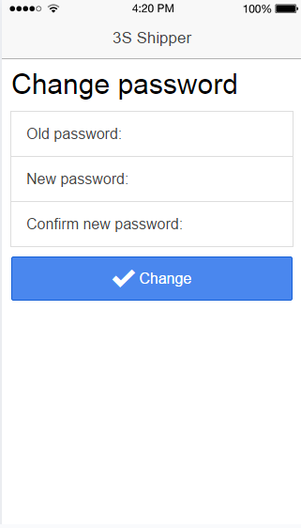

|  |  |  |  |  |
| --- | --- | --- | --- | --- |
| Use Case ID: | | UC-304 | | |
| Use Case Name: | | Change password | | |
| Created By: | | QuyenNV | Last Updated By: | QuyenNV |
| Date Created: | | 19/09/2015 | Date Last Updated: | 30/09/2015 |
| Actor: | | Shipper | | |
| Description: | | If shipper forgot their password and would like to change their password for security reasons. | | |
| Triggering event | | Shipper wants to change password. | | |
| Preconditions: | | * To have internet connection through device * To be logged in the system * Switch to “Profile” screen | | |
| Post - conditions: | | * New password stored in database. Shipper changes password is successfully | | |
| Priority: | | High | | |
| Frequency of Use: | | Sometime | | |
| **Main flow** | | | | |
| Step | Actor | Action | | |
|  | Shipper | Clicks “Change Password” button | | |
|  | System | “Change Password” screen shows up. | | |
|  | Shipper | Enter required information (Old Password, new password, confirm new password) and clicks “Change” button. | | |
|  | System | Validate input information. | | |
|  | System | Update new password of this account to database and redirects to the “Profile” screen. | | |
| **Alternative Flows:** | | N/A | | |
| **Exceptions:** | | | | |
| EC1 | At step 4, if any field is incorrect format or blank | | | |
| Step | Actor | Action | | |
| 4.1 | System | Notify in screen with a message “Please fill out all field” on “Change Password” screen. | | |
| EC2 | At step 4, if shipper provides new password doesn’t match the confirm password | | | |
| Step | Actor | Action | | |
| 4.1 | System | Display an error message “Password doesn't match the confirmation” on “Change password” screen. | | |
| **Includes:** | | N/A | | |
| **Special Requirements:** | | **Old Password:** Cannot be null.  **New Password:** Minimum of password is 7 character and needs at least one number.  **Re-Enter Password**: Cannot be null. | | |
| **Notes and Issues:** | | N/A | | |

Sequence Diagram:

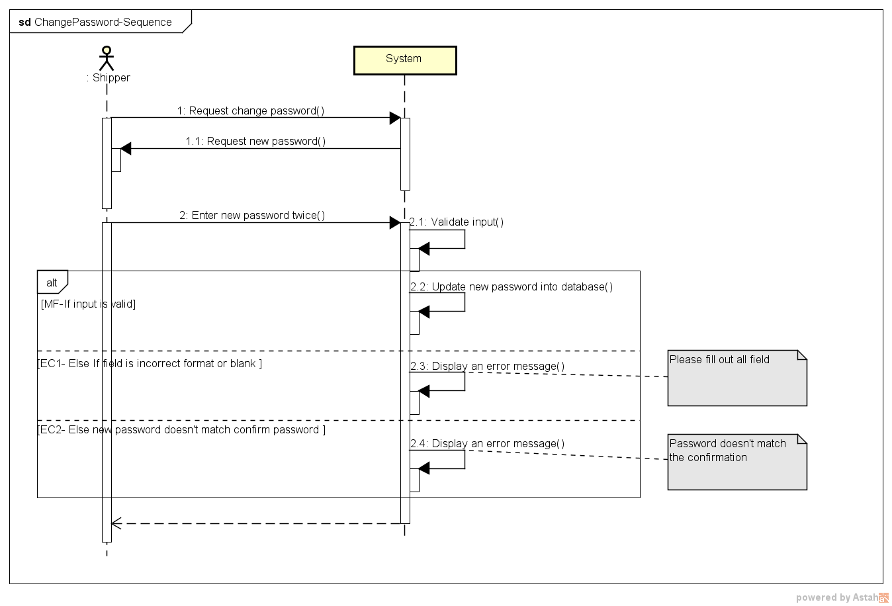

###### *UC-305:* *View Profile*

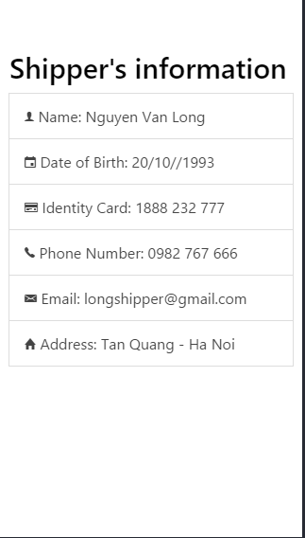

|  |  |  |  |  |
| --- | --- | --- | --- | --- |
| **Use Case ID:** | | UC-005 | | |
| **Use Case Name:** | | View Profile | | |
| **Created By:** | | QuyenNV | **Last Updated By:** | QuyenNV |
| **Date Created:** | | 19/09/2015 | **Date Last updated:** | 30/09/2015 |
| **Actor:** | | Shipper | | |
| **Description:** | | Shipper can view his/her information. Such as Name, Date of Birth, Identity Card, Phone Number, Email, Address. | | |
| **Triggering event** | | Shipper wants to view Profile | | |
| **Preconditions:** | | * To have internet connection through a device * To be logged in the system | | |
| **Post conditions:** | | The information of current logged in will appear in the [Profile] screen. | | |
| **Priority:** | | High | | |
| **Frequency of Use:** | | Sometime | | |
| **Main flow** | | | | |
| Step | Actor | Action | | |
| 1 | Shipper | Clicks “Profile” button in left navigate bar | | |
| 2 | System | Load information of shipper and Display “Profile” screen | | |
| **Alternative Flows:** | | **N/A** | | |
| **Exceptions:** | | | | |
| **Includes:** | | N/A | | |
| **Special Requirements:** | | N/A | | |
| **Notes and Issues:** | | N/A | | |

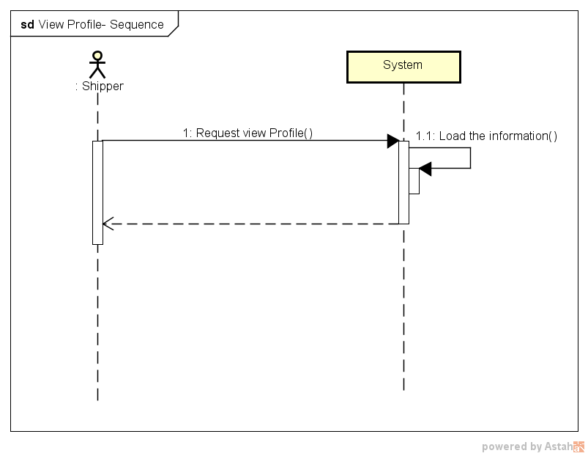**Sequence Diagram:**

###### *UC-306:* *Update Profile*

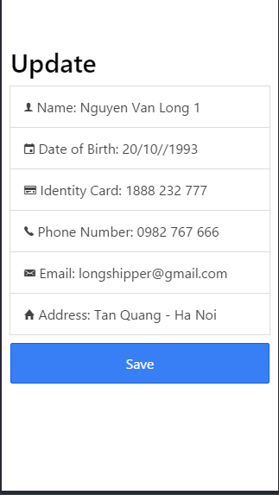

|  |  |  |  |  |
| --- | --- | --- | --- | --- |
| **Use Case ID:** | | UC-006 | | |
| **Use Case Name:** | | Update Profile | | |
| **Created By:** | | QuyenNV | **Last Updated By:** | QuyenNV |
| **Date Created:** | | 19/09/2015 | **Date Last updated:** | 30/09/2015 |
| **Actor:** | | Shipper | | |
| **Description:** | | When Shipper change personal information. They can modify their related information (Email, Date of Birth, Phone Number, Identity Card, Address) | | |
| **Triggering event** | | Shipper wants to update profile | | |
| **Preconditions:** | | * To have internet connection through a device * To be logged in the system * Switch to [Profile] screen. | | |
| **Post conditions:** | | Update new information in database. Update Profile is successfully. | | |
| **Priority:** | | Low | | |
| **Frequency of Use:** | | Sometime | | |
| **Main flow** | | | | |
| Step | Actor | Action | | |
| 1 | Shipper | Clicks [Edit Profile] button | | |
| 2 | System | Display [Edit profile] screen | | |
| 3 | Shipper | Enter required information (Name, Email, Phone Number, Identity Card, Date of Birth, Address) | | |
| 5 | System | Validate input | | |
| 6 | System | Store new information of Shipper into database | | |
| 7 | System | Display an success message “ Your profile has been updated successfully” | | |
| **Alternative Flows:** | | **N/A** | | |
| **Exceptions:** | | | | |
| EC1 | At step 5 | If any required field is not entered | | |
| Step | Actor | Action | | |
| 5.1 | System | Notify an error message “*is require” | | |
| **Includes:** | | N/A | | |
| **Special Requirements:** | | N/A | | |
| **Notes and Issues:** | | N/A | | |

Sequence Diagram:

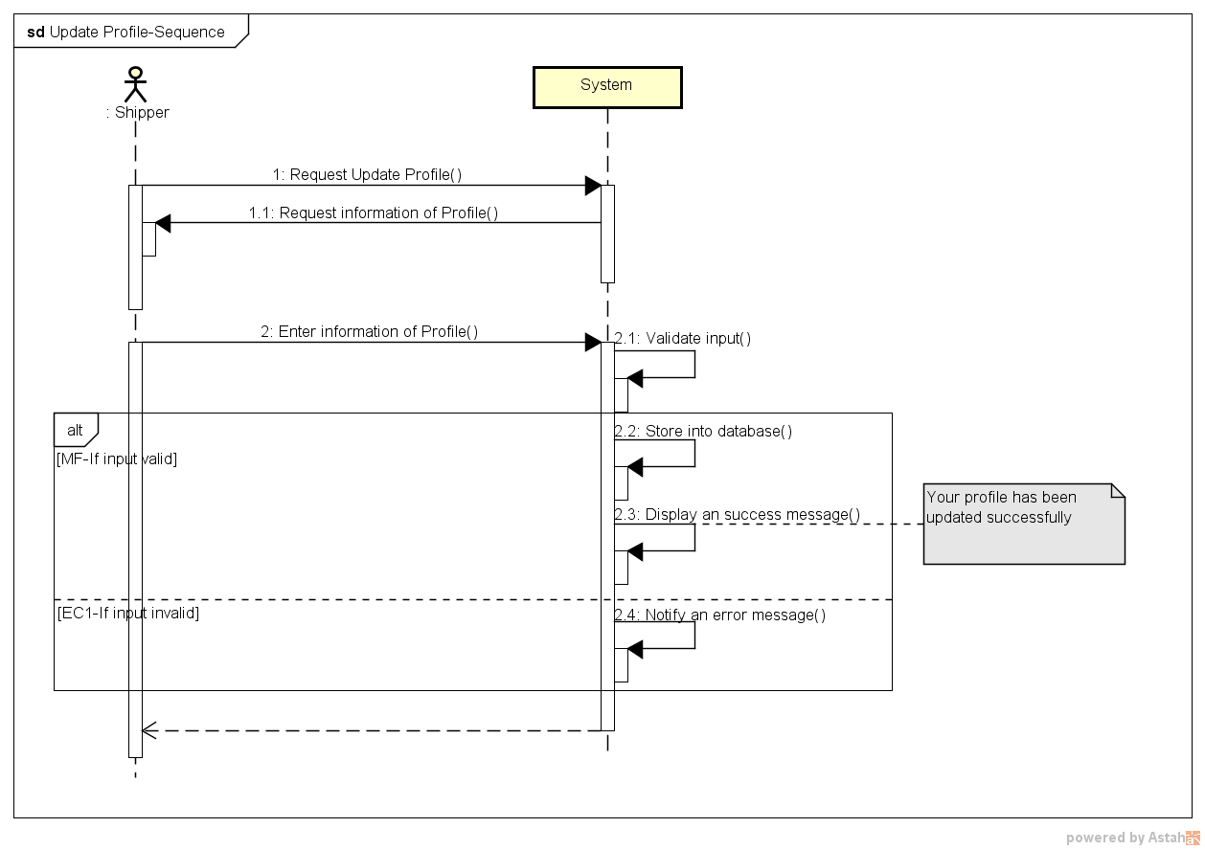

###### *UC-307:* *Confirm Code*

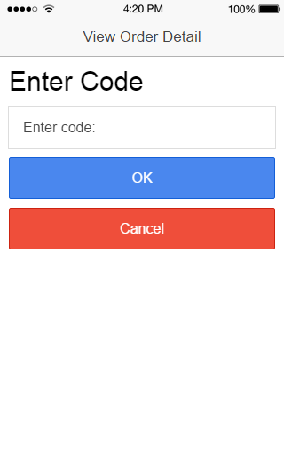

|  |  |  |  |  |
| --- | --- | --- | --- | --- |
| **Use Case ID:** | | UC-007 | | |
| **Use Case Name:** | | Confirm code | | |
| **Created By:** | | QuyenNV | **Last Updated By:** | HuyTDH |
| **Date Created:** | | 19/09/2015 | **Date Last updated:** | 30/11/2015 |
| **Actor:** | | Shipper | | |
| **Description:** | | When a task was given to a shipper, the shipper has responsibility to change order status at the end of each step in their task schedule.  In case when the shipper comes to pick up order, gives goods to customer or takes goods into or out from stock, he/she has to provide respective confirmation codes – which are automatically generated by system. These code are generated when the store creates an order.  Using a confirmation code to avoid mistakes in picking up, delivering, or checking in, out stock. | | |
| **Triggering event** | | Shipper wants to confirm with store, stock manager or customer that he has done a step in his task (picking up; check in, check out stock; giving goods to customer) | | |
| **Preconditions:** | | * To have internet connection through a device * To be logged in the system * Shipper is on [View Task’s Details] screen. | | |
| **Post conditions:** | | The order is moved to next step of task schedule | | |
| **Priority:** | | High | | |
| **Frequency of Use:** | | Always | | |
| **Main flow** | | | | |
| Step | Actor | Action | | |
| 1. | Shipper | Clicks [Check Code “ABC”] button, with “ABC” is the current status of order | | |
| 2. | System | Displays [Enter Code] pop-up | | |
| 3. | Shipper | Enters code which be provided by the store and clicks “Enter” button. | | |
| 4. | System | Queries the Order database to confirm that was right code for this status of this order and if this shipper is the one who has responsibility to this task. | | |
| 5. | System | Display an success message pop-up on [View Task’s Details] screen | | |
| **Alternative Flows:** | | **N/A** | | |
| **Exceptions:** | | | | |
| EC1 | At step 2, if Shipper doesn’t enter confirmation code. | | | |
| Step | Actor | Action | | |
| 2.1 | Shipper | Taps on “Cancel” button | | |
| 2.2 | System | Hide check code pop-up and displays “View Task’s Detail” screen | | |
| EC2 | At step 4, if code does not exist in database or the system cannot establish a connection to the database due to some reasons (ex: network failure). | | | |
| Step | Actor | Action | | |
| 4.1 | System | An error message “Wrong code” will be showed up on screen to tell the shipper about the problem. | | |
| 4.2 | Shipper | Tabs on [‘Ok’] button | | |
| 4.3 | System | Hides the message | | |
| EC3 | At step 4, Order cannot establish a connection to the database due to some reasons (ex: network failure). | | | |
| Step | Actor | Action | | |
| 4.1 | System | Display a popup message “Something went wrong! Try again” will show up on screen to tell the shipper about the problem. | | |
| **Includes:** | | N/A | | |
| **Special Requirements:** | | N/A | | |
| **Notes and Issues:** | | N/A | | |

**Sequence Diagram:**

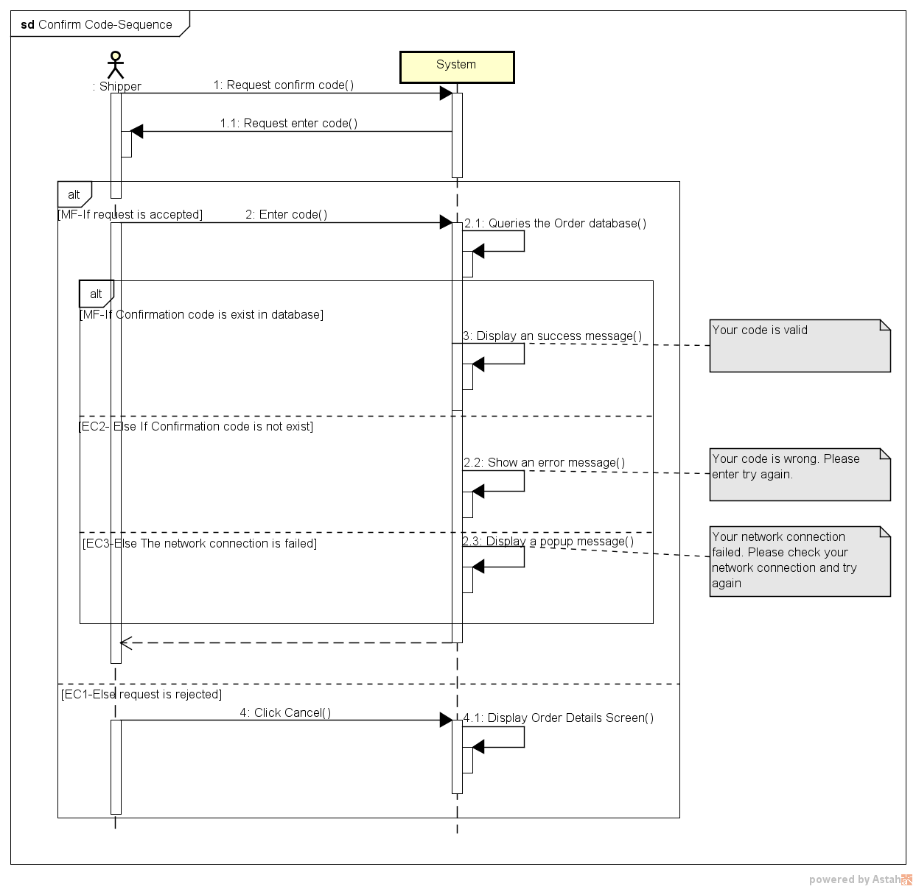

###### *UC-308:* *Grab order*

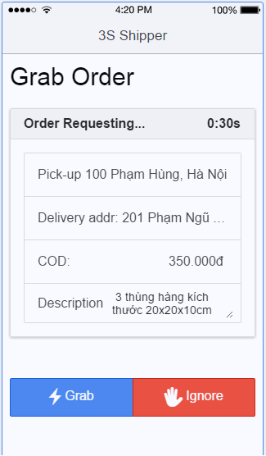

|  |  |  |  |  |  |  |
| --- | --- | --- | --- | --- | --- | --- |
| **Use Case ID:** | | | UC308 | | | |
| **Use Case Name:** | | | Grab order | | | |
| **Created By:** | | | HuyTDH | | **Last Updated By:** | HuyTDH |
| **Date Created:** | | | 19/09/2015 | | **Date Last updated:** | 08/12/2015 |
| **Actor:** | | | Shipper | | | |
| **Description:** | | | When the sever concurrently sends shipping order to 5 shippers, the shipper who grabs order at the earliest time will take that order into his in working list | | | |
| **Triggering Event:** | | | Server sends shipping request to that shipper | | | |
| **Pre-conditions:** | | | Shipper logged in, internet connection is on, shipper’s current active task less than 3, system is requesting to ship order | | | |
| **Post-conditions:** | | | The order has been added to shipper’s task list with status is active and task type is express. | | | |
| **Priority:** | | | High | | | |
| **Frequency of Use:** | | | Often | | | |
| **Main flow** | | | | | | |
| Step | Actor | | Action | | | |
|  | System | | Sends shipping request to shipper’s app | | | |
|  | Shipper | | Tabs on button “Grab” to take the order | | | |
|  | System | | Validates whether the shipping that request has been taken by another shipper or not | | | |
|  | System | | Displays message “You just grab a new order!” | | | |
|  | System | | Adds order to shipper’s task | | | |
|  | System | | Disables this request to other shippers | | | |
| **Alternative :** | | | | | | |
| N/A | | | | | | |
| **Exceptions:** | | | | | | |
| EC1 | | Shipper ignores request at step 2 | | | | |
| Step | | Actor | | Action | | |
| 2.1 | | Shipper | | Tabs on button “Ignore” | | |
| 2.2 | | System | | Shows confirm box | | |
|  | | Shipper | | Confirms to ignore | | |
|  | | System | | Shows warning “You have ignored x order(s) today!” | | |
| EC2 | | Shipper tabs on button “Grab” later than another shipper at step 2 | | | | |
| Step | | Actor | | Action | | |
| 2.1 | | Shipper | | Tabs on “Grab” | | |
| 2.2 | | System | | Shows message “Store STxxxxxx has found another shipper or canceled order” | | |
| **Includes:** | | | N/A | | | |
| **Special Requirements:** | | | Shipper who receives shipping request is in top 5 nearest available ones from the store of that order. | | | |
| **Notes and Issues:** | | | N/A | | | |

**Sequence Diagram**

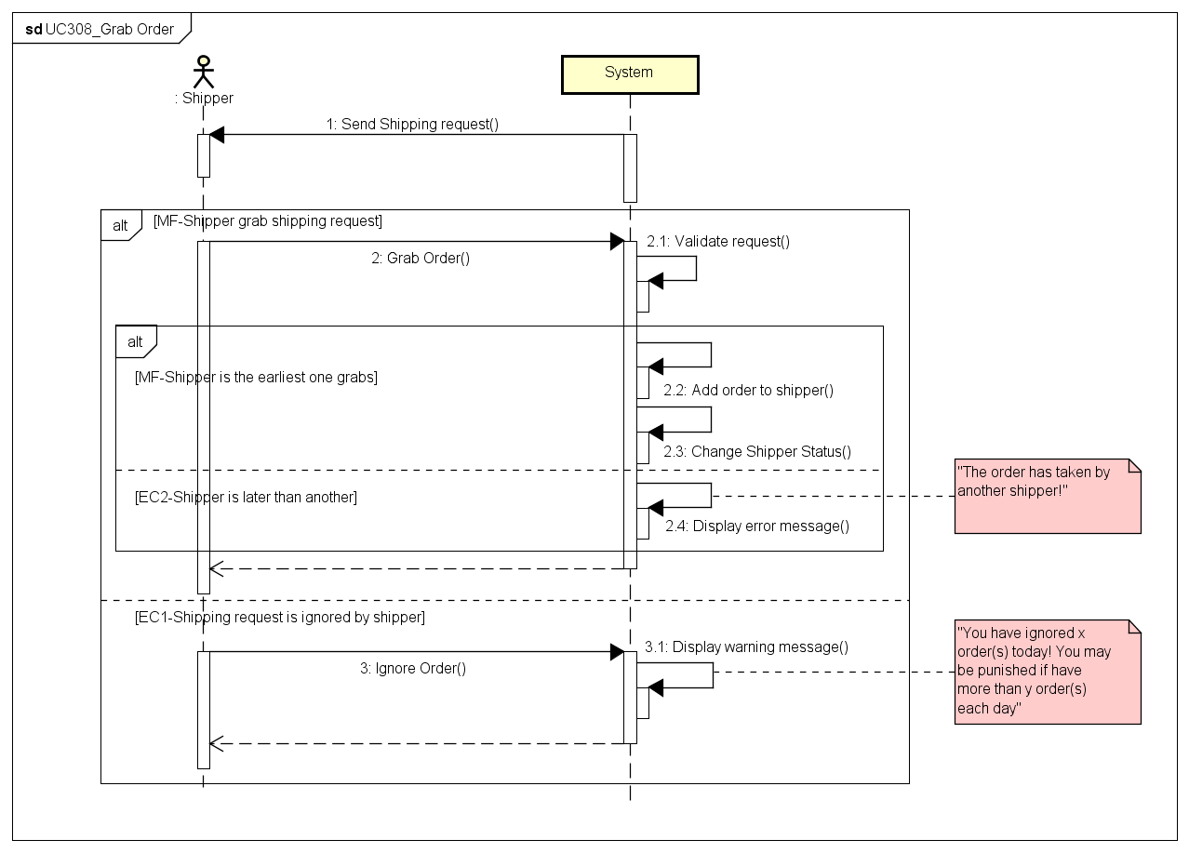

###### *UC309: View Orders List*

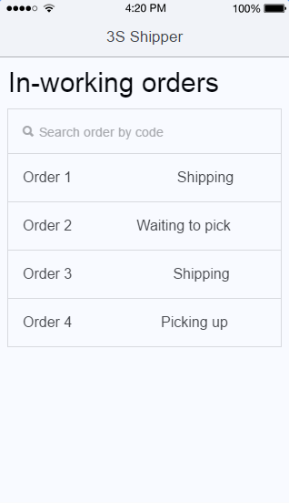

|  |  |  |  |  |  |  |
| --- | --- | --- | --- | --- | --- | --- |
| **Use Case ID:** | | | UC309 | | | |
| **Use Case Name:** | | | View orders list | | | |
| **Created By:** | | | HuyTDH | | **Last Updated By:** | HuyTDH |
| **Date Created:** | | | 19/09/2015 | | **Date Last updated:** | 25/09/2015 |
| **Actor:** | | | Shipper | | | |
| **Description:** | | | Shipper sees the list of his in-working orders (all of his undone orders will be displayed here) | | | |
| **Triggering Event:** | | | Shipper wants to see all orders that he has to do | | | |
| **Preconditions:** | | | Shipper logged in | | | |
| **Post conditions:** | | | List in-working orders of this shipper is showed | | | |
| **Priority:** | | | High | | | |
| **Frequency of Use:** | | | Always | | | |
| **Main flow** | | | | | | |
| Step | Actor | | Action | | | |
|  | Shipper | | expands menu bar and tabs on “In-working orders” | | | |
|  | System | | loads all data about in-working orders of that shipper | | | |
|  | System | | shows list in-working orders as a table, includes content:   * Order code * Current Status | | | |
| **Alternative Flows:** | | | | | | |
| N/A | | | | | | |
| **Exceptions:** | | | | | | |
| EC1 | | Current in-working orders of that shipper is empty at step 3 | | | | |
| Step | | Actor | | Action | | |
| 3.1 | | System | | Displays info message “You don’t have any order that have to work now!” | | |
| **Includes:** | | | N/A | | | |
| **Special Requirements:** | | | N/A | | | |
| **Notes and Issues:** | | | N/A | | | |

**Sequence Diagram**

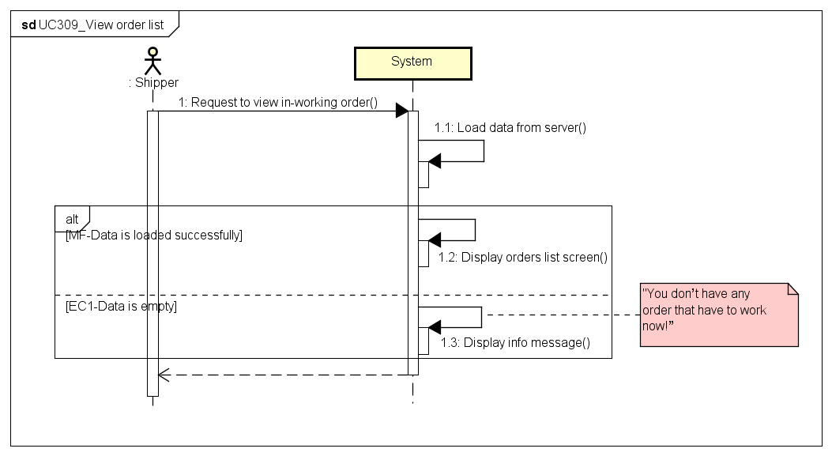

###### *UC310: Search Order*

|  |  |  |  |  |  |  |
| --- | --- | --- | --- | --- | --- | --- |
| **Use Case ID:** | | | UC310 | | | |
| **Use Case Name:** | | | Search order | | | |
| **Created By:** | | | HuyTDH | | **Last Updated By:** | HuyTDH |
| **Date Created:** | | | 19/09/2015 | | **Date Last updated:** | 25/09/2015 |
| **Actor:** | | | Shipper | | | |
| **Description:** | | | Shipper enters full or a part of order code to search order(s) from list of many orders. | | | |
| **Triggering Event:** | | | Shipper want to find a specific order(s) by code | | | |
| **Preconditions:** | | | Shipper on View Orders List: UC309 (See above) | | | |
| **Post conditions:** | | | Orders that match search condition will be displayed | | | |
| **Priority:** | | | Normal | | | |
| **Frequency of Use:** | | | Sometimes | | | |
| **Main flow** | | | | | | |
| Step | Actor | | Action | | | |
|  | Shipper | | Goes to “View orders list” screen (refer to UC309 View order list) | | | |
|  | Shipper | | Types order’s code to search box | | | |
|  | System | | Filters orders data from current list | | | |
|  | System | | Displays all in-working orders that match with search key | | | |
| **Alternative Flows:** | | | | | | |
| **Exceptions:** | | | | | | |
| EC1 | | There’s no order matches with code which is entered by shipper | | | | |
| Step | | Actor | | Action | | |
| 3.1 | | System | | Displays info message “There’s no order matches with your code” | | |
| **Includes:** | | | N/A | | | |
| **Special Requirements:** | | | Order code has format **3Sxxxxxx** but shipper no need to enter **3S** prefix of code Case insensitive search | | | |
| **Notes and Issues:** | | | Code format will be defined in the later phrase | | | |

**Sequence Diagram** 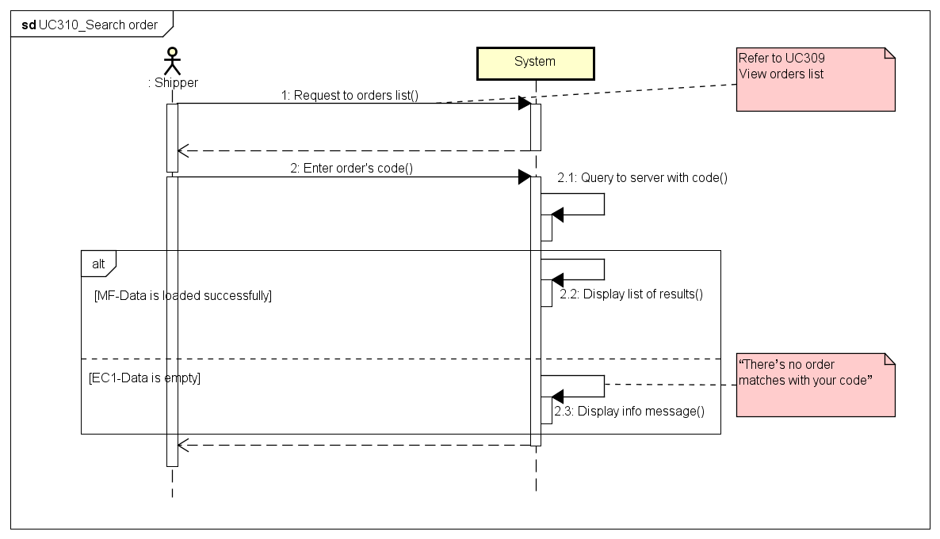

###### *UC311: View Task’s Detail*

**Mockup Design**

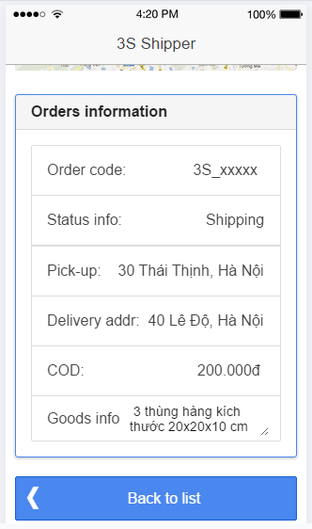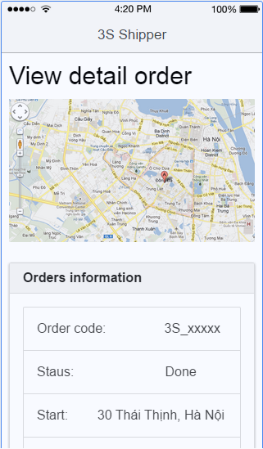

|  |  |  |  |  |
| --- | --- | --- | --- | --- |
| **Use Case ID:** | | UC311 | | |
| **Use Case Name:** | | View order’s detail | | |
| **Created By:** | | HuyTDH | **Last Updated By:** | HuyTDH |
| **Date Created:** | | 19/09/2015 | **Date Last updated:** | 08/12/2015 |
| **Actor:** | | Shipper | | |
| **Description:** | | Shipper views detail information of an order. This order could be selected from “Tasks List” screen or from “Working History” screen of the shipper. | | |
| **Triggering Event:** | | Shipper wants to see order’s detail information | | |
| **Preconditions:** | | Shipper is on list orders screen or working history screen | | |
| **Post conditions:** | | Detail information of that order is displayed | | |
| **Priority:** | | High | | |
| **Frequency of Use:** | | Always | | |
| **Main flow** | | | | |
| Step | Actor | Action | | |
|  | Shipper | Enters “**In-Working Tasks**” screen (Refer to UC309 above) | | |
|  | Shipper | Tabs on an task from the list | | |
|  | System | Loads detail info of that order from server | | |
|  | System | Displays the detail information of order, includes:   * Google Map * Task schedule progress bar * Order code * Order status * Recipient (name and phone) * Pick-up address * Pick-up date * Stock * Delivery address * Delivery date * COD (cast on delivery amount) * Fee (shipping fee) * Goods information * A button to change order status to next status in this task schedule   *Notes:*   * If task type is picking up, don’t show the delivery information (Recipient, Delivery address and date) * When the task is done, the button at the bottom of screen will be removed. | | |
| **Alternative Flows::** | | | | |
| AT1 | Shipper views detail from history: | | | |
| Step | Actor | Action | | |
| 1.1 | Shipper | Accesses “History” screen | | |
| 1.2 | Shipper | Tabs on an order from the list | | |
|  |  | Go to step 3 of main flow | | |
| **Exceptions:** | | | | |
| N/A | | | | |
| **Includes:** | | N/A | | |
| **Special Requirements:** | | N/A | | |
| **Notes and Issues:** | | N/A | | |

**Sequence Diagram**

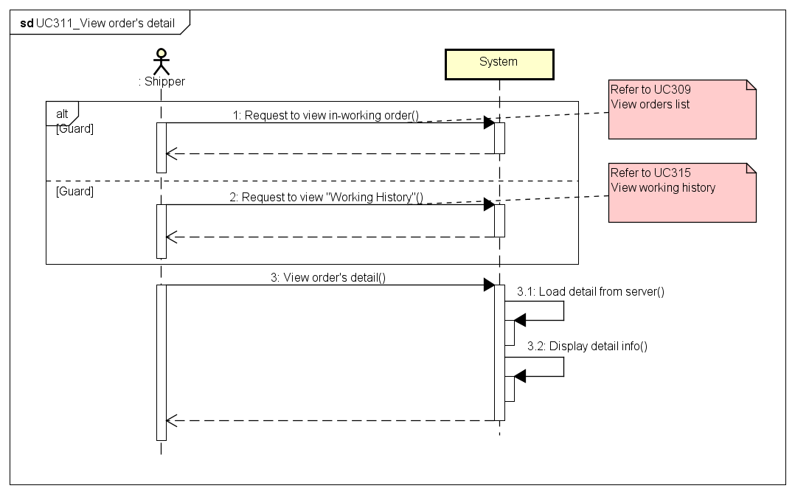

###### *UC312: Find Best Way*

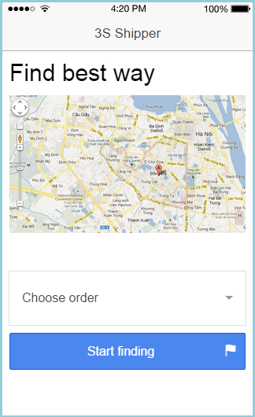

|  |  |  |  |  |
| --- | --- | --- | --- | --- |
| **Use Case ID:** | | UC312 | | |
| **Use Case Name:** | | Find best way | | |
| **Created By:** | | HuyTDH | **Last Updated By:** | HuyTDH |
| **Date Created:** | | 19/09/2015 | **Date Last updated:** | 25/09/2015 |
| **Actor:** | | Shipper | | |
| **Description:** | | Shipper uses 3S system to find out the shortest way to go to destinations. A path, which goes through all the selected descriptions and has least duration, will be drawn on the map. | | |
| **Triggering event:** | | Shipper wants to find best way to go for his in-working orders. | | |
| **Preconditions:** | | Shipper logged in  Internet connection is on  GPS is on | | |
| **Post conditions:** | | The shortest way that go through all selected destinations will be displayed on map. | | |
| **Priority:** | | High | | |
| **Frequency of Use:** | | Always | | |
| **Main flow** | | | | |
| Step | Actor | Action | | |
|  | Shipper | Selects “Find best way” from menu | | |
|  | System | Shows “Find best way” screen, includes:   * Google map * Destinations select box * “Find” button | | |
|  | Shipper | Chooses one or all destinations | | |
|  | Shipper | Tabs on “Find” | | |
|  | System | Call Google API to get the best way | | |
|  | System | Displays the shortest way to destinations on the map | | |
| **Alternative Flows:** | | N/A | | |
| **Exceptions:** | | | | |
| EC1 | At step 1 if GPS is off | | | |
| Step | Actor | Action | | |
| 1.1 | System | System displays message “Please turn on GPS and retry” | | |
| 1.2 | Shipper | Shipper turn on GPS | | |
|  | | Go to step 2 of main flow | | |
| **Includes:** | | N/A | | |
| **Special Requirements:** | | Shipper can choose <= 7 destinations | | |
| **Notes and Issues:** | | N/A | | |

**Sequence Diagram**

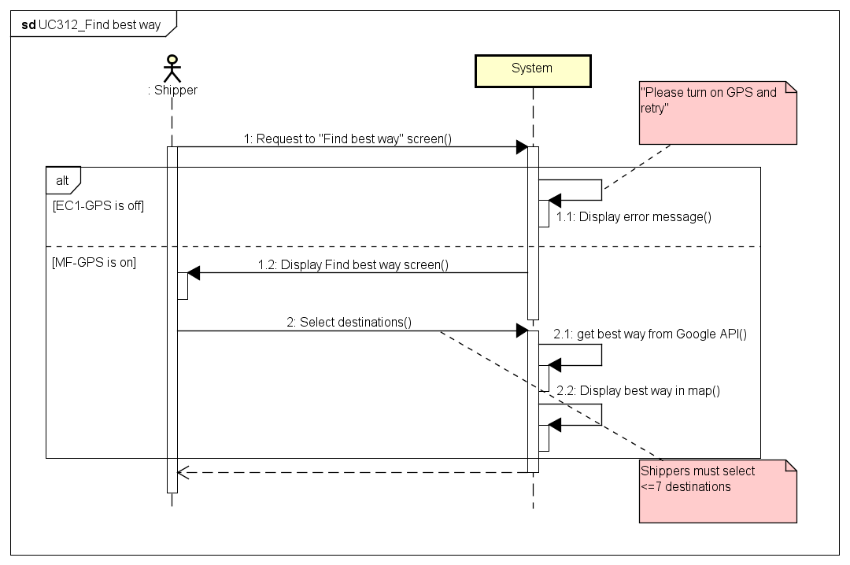

###### *UC313 Send Issue’s Information*

|  |  |  |  |  |
| --- | --- | --- | --- | --- |
| **Use Case ID:** | | UC313 | | |
| **Use Case Name:** | | Send issue’s information | | |
| **Created By:** | | HuyTDH | **Last Updated By:** | HuyTDH |
| **Date Created:** | | 19/09/2015 | **Date Last updated:** | 19/09/2015 |
| **Actor:** | | Shipper | | |
| **Description:** | | Shipper sends issues to Admin to solve. Issue’s content will contain the most important information such as category of issue, the orders which this issue influents and a short description from shipper. | | |
| **Triggering Event:** | | Shipper got issues and need to send to Admin | | |
| **Preconditions:** | | Shipper logged in | | |
| **Post conditions:** | | Issue has been sent to Admin  Notification about issue has been display in admin’s screen | | |
| **Priority:** | | High | | |
| **Frequency of Use:** | | Sometimes | | |
| **Main flow** | | | | |
| Step | Actor | Action | | |
|  | Shipper | Chooses “Send Issue” from Menu | | |
|  | System | Displays “Send Issue Box”, includes:   * “Issue Category” selected box (Vehicle, Time, Goods, Customer, Other) * “Order” multi-selected box | | |
|  | Shipper | Types “Description”, chooses “Issue Category”, and could select one or all of his in-working orders. | | |
|  | Shipper | Tabs on “Send” | | |
|  | System | Shows message “Issue has sent to system. Wait for Admin to solve” | | |
|  | System | Sends notification to admin about issue | | |
| **Alternative Flows:** | | N/A | | |
| **Exceptions:** | | | | |
| EC1 | At step 3, shipper doesn’t enter description | | | |
| Step | Actor | Action | | |
| 1.1 | System | System displays message “You must enter description” | | |
| 1.2 | Shipper | Shipper re-enter description | | |
|  | | Go to step 4 of main flow | | |
| **Includes:** | | N/A | | |
| **Special Requirements:** | | N/A | | |
| **Notes and Issues:** | | Issue description should have 30 - 250 characters | | |

**Sequence Diagram**

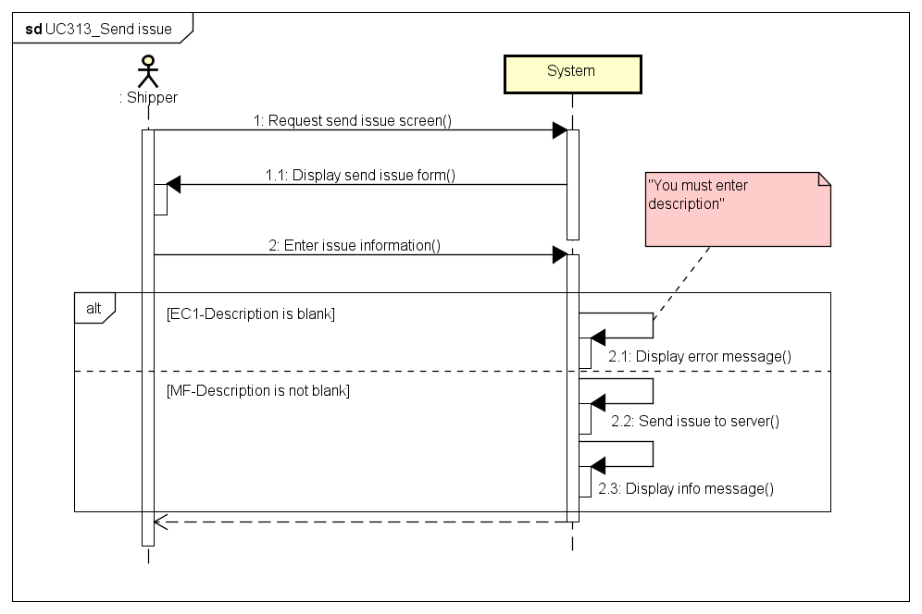

###### *UC314 Change Working Status*

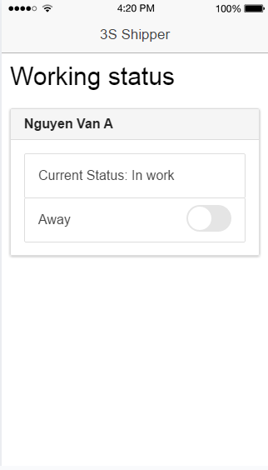

|  |  |  |  |  |
| --- | --- | --- | --- | --- |
| **Use Case ID:** | | UC314 | | |
| **Use Case Name:** | | Change working status | | |
| **Created By:** | | HuyTDH | **Last Updated By:** | HuyTDH |
| **Date Created:** | | 19/09/2015 | **Date Last updated:** | 20/09/2015 |
| **Actor:** | | Shipper | | |
| **Description:** | | Shipper changes his working status “On working” / “Away”. The system will depend on this status to decide to send shipping request to the shipper or not. | | |
| **Triggering Event:** | | Shipper want to switch his status between ready to work or not ready. | | |
| **Preconditions:** | | Shipper logged in  To have internet connection via device | | |
| **Post conditions:** | | Working status switched to “On” / ”Off” | | |
| **Priority:** | | Normal | | |
| **Frequency of Use:** | | Sometimes | | |
| **Main flow** | | | | |
| Step | Actor | Action | | |
|  | Shipper | Shipper expands menu bar | | |
|  | System | System displays current status as a menu item, includes “Change status” label and switch button is on if current status of the shipper is “On” and is off for the opponent case. | | |
|  | Shipper | Shipper switches status button | | |
|  | System | System shows confirm message “Confirm change your status to [ABC]” ([ABC] is “On” or ”Off”) | | |
|  | Shipper | Shipper tabs on “Confirm” | | |
|  | System | System changes the status | | |
| **Alternative Flows:** | | N/A | | |
| **Exceptions:** | | | | |
| EC1 | Shipper has some active tasks (the tasks he has to done as soon as possible) | | | |
| Step | Actor | Action | | |
| 1 | System | System displays current status “On” | | |
| 2 | Shipper | Shipper tabs on switch button “Change Status” | | |
|  | System | System shows message “You are having x active task(s). Complete them first or contact to Admin” | | |
| **Includes:** | | N/A | | |
| **Special Requirements:** | | N/A | | |
| **Notes and Issues:** | |  | | |

**Sequence Diagram**

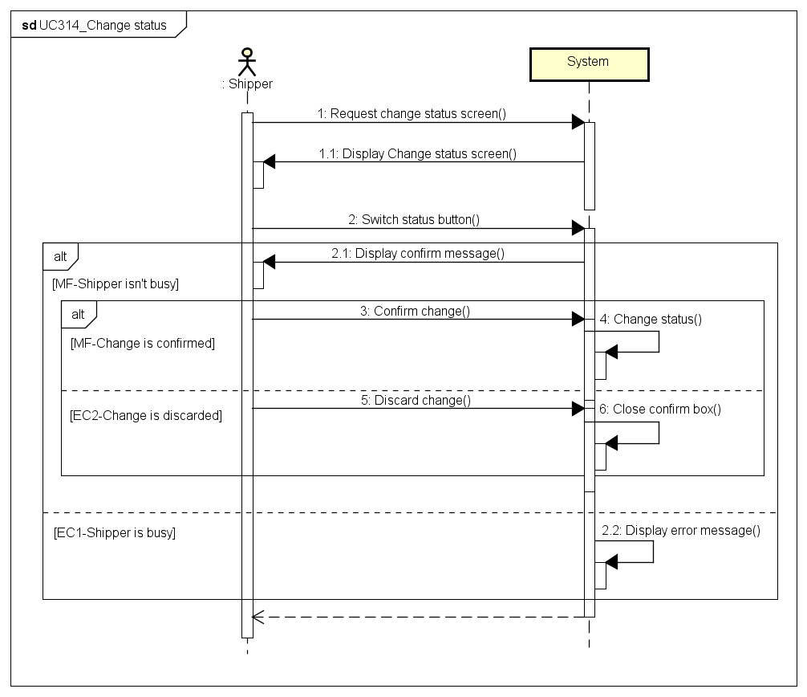

###### *UC315 View History*

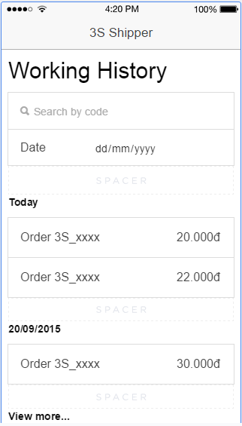

|  |  |  |  |  |
| --- | --- | --- | --- | --- |
| **Use Case ID:** | | UC315 | | |
| **Use Case Name:** | | View history | | |
| **Created By:** | | HuyTDH | **Last Updated By:** | HuyTDH |
| **Date Created:** | | 19/09/2015 | **Date Last updated:** | 09/12/2015 |
| **Actor:** | | Shipper | | |
| **Description:** | | Shipper views his working history to know how much salary and bonus money he will get base on amount of his done orders. | | |
| **Triggering Event:** | | Shipper wants to review history | | |
| **Preconditions:** | | Shipper logged in | | |
| **Post conditions:** | | Working history of that shipper will be displayed | | |
| **Priority:** | | High | | |
| **Frequency of Use:** | | Often | | |
| **Main flow** | | | | |
| Step | Actor | Action | | |
|  | Shipper | Shipper chooses “History” from menu | | |
|  | System | System load history saving in device memory | | |
|  | System | System displays working history of that shipper, also includes bellow feature:   * Date label to group working history by date * List of history orders * “View more” link if there more orders is not yet displayed | | |
| **Alternative Flows:** | | | | |
| AT1 | At step 2, working history local storage in device was cleared and shipper has to load from server | | | |
| Step | Actor | Action | | |
| 2.1 | System | System shows message “Can’t find working history. Reload from server?” | | |
| 2.2 | Shipper | Shipper tabs on “Reload” | | |
| 2.3 | System | Load history log from server and save to device | | |
|  |  | Go to step 3 of main flow | | |
| N/A | | | | |
| **Exceptions:** | | | | |
| EC1 | At step 2.2 of Alternative 1 history can’t be loaded from server | | | |
| Step | Actor | Action | | |
| 2.2.1 | System | Displays error message “"History could not be loaded. Retry!"” | | |
| **Includes:** | | N/A | | |
| **Special Requirements:** | | Default will display last 20 orders Clicks “See more” will load 20 more orders | | |
| **Notes and Issues:** | | History will be save in device memory Shipper don’t need internet to load history | | |

**Sequence Diagram**

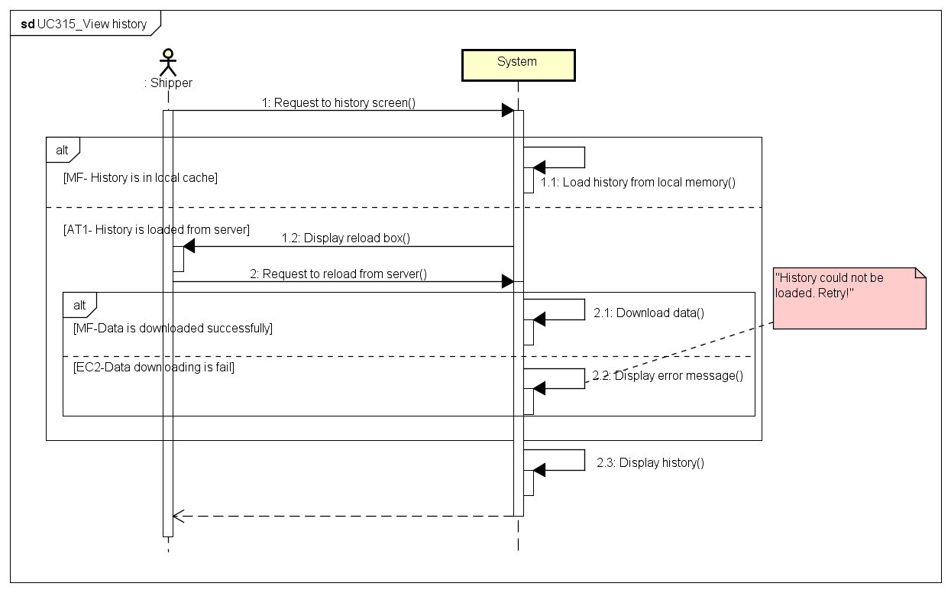

# NON – FUNCTIONAL REQUIREMENTS

## 4.1. Usability

User interface should be clear and easy to use.

* Use material design style with light colors
* User can complete each function in less than 10 actions

## 4.2 Performance

- Time delay for find shipper who nearest with place of delivery is less than 10s.

- Time delay on web application for tracking state of shipper on map is less than 5m.

- Server can handle least 2000 clients concurrently.

- Other functions of server perform well while have many order running on application.

## 4.3 Reliability

- The application is available 24/7.

- Find the way to go to places of receive and place of delivery are at least 90%.

## 4.4 Maintainability

- Web application is easily to maintain without any crashes. Source code is readability, organized into groups of skeleton (modules) and complies with coding convention.

- Android application is easily to be updated and synchronize with Web application without any crashes. Source code is readability, complies with coding convention.

- System’s architecture has to be design to be easy to extend.

## 4.5 Security

- Information of admin/ root admin / data on server is secured.

- Information of store and shipper on server is secured.